CDRL A009
Test Procedure for
Advanced Modular Manikin Project
Phase II Program
Contract # W81XWH-14-C-0101
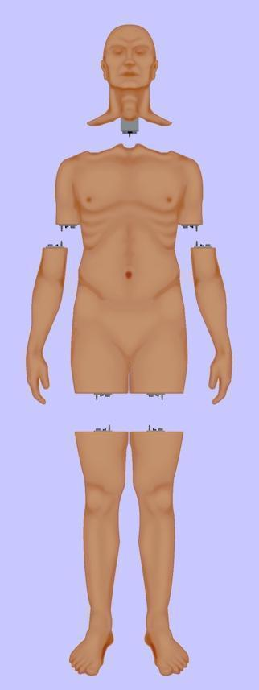

Date: February 03, 2020
Revision: Rev-2
Unclassified

PRINCIPAL INVESTIGATOR: ROBERT M. SWEET, MD, FACS
REGENTS OF THE UNIVERSITY OF MINNESOTA
OFFICE OF SPONSORED PROJECTS
200 OAK ST SE
MINNEAPOLIS MN 55455-2009

This document is unclassified, and APPROVED FOR PUBLIC RELEASE; DISTRIBUTION IS UNLIMITED

Revision History

Date of Revision | Description of Changes
25 Mar 2018 | Original Draft Submitted
25 Sep 2019 | Document Submitted
03 Feb 2020 | Distribution Updated

Distribution Statement

This document was created under contract funding W81XWH-14-C-0101 from:

DEPARTMENT OF THE ARMY
US ARMY MEDICAL RESEARCH ACQUISITION ACTIVITY
820 CHANDLER STREET
FORT DETRICK MD 21701-5014

It contains no proprietary information, trade secrets, copyrighted material or classified information. APPROVED FOR PUBLIC RELEASE; DISTRIBUTION IS UNLIMITED
.

Table of Contents
1 Scope 6
1.1 Identification 7
1.2 System overview 7
1.3 Document Overview 7
1.4 Origin of Test Requirements 8
2 Referenced Documents 9
2.1 Industry Documents 9
2.2 Government Documents 9
2.3 Related Contract Documents 9
3 Test Procedure 9
3.1 Medical Scenario Verification Tests (MSVTs) 9
3.1.1 Scenario 9
3.1.2 Purpose of the Test 10
3.1.3 Description to the Test Article 10
3.1.4 Test Requirements 12
3.1.5 Test Equipment 13
3.1.6 Test Procedure 13
3.1.6.1 Pre-Scenario AMM Platform Test 13
3.1.6.1.1 Step 1 – Assemble the manikin and booting up the system 13
3.1.6.1.2 Step 2 – Verify the technical user interface appears 13
3.1.6.1.3 Step 3 – Verify the AMM Core modules are running 14
3.1.6.1.4 Step 4 – Make sure that all connected modules competed startup successfully 14
3.1.6.1.5 Step 5 – Make sure that all virtual modules completed startup successfully 14
3.1.6.2 ACS Scenario Test 15
3.1.6.2.1 Scene 1: Point of Injury 15
3.1.6.2.1.1 Test Set-up Diagrams 16
3.1.6.3 Scene 2: Emergency Department Trauma Bay 18
3.1.6.4 Scene 3: Operating Room 21
3.1.7 Post-Scenario AMM Platform Test: 24
3.1.7.2 Step 1- Clean the system by flushing out all blood stimulant. 24
3.1.7.3 Step 2- Purge the fluidics system. 25
3.1.7.4 Step 3 - Shut down the system. 25
3.1.7.5 MSVTs Data Sheet 26
3.2 Engineering Verification Tests (EVTs) 27
3.2.1 Manikin System Level Tests 28
3.2.1.1 Total Manikin Weight 28
3.2.2 Module Interfaces Compliant with Standards 28
3.2.2.1 Purpose of Test 28
3.2.2.2 Description of Test Articles 28
3.2.2.3 Test Requirements 28
3.2.2.4 Test Equipment 29
3.2.2.5 Step by Step Procedure for Testing Standard Interfaces 29
3.2.2.6 Manikin Weight Test Verification Data Sheet 30
3.2.2.7 Manikin Standard Module Interface Verification Data Sheet 31
3.2.3 System Software Testing 31
3.2.3.1 Purpose of the Test 32
3.2.3.2 Description of the Test Article 32
3.2.3.3 Test Requirements 32
3.2.3.4 Test Equipment 32
3.2.3.5 Software Test Data Sheet 33
3.2.4 Component Tests 34
3.2.4.1 Connector Vibration – Mechanical, Electrical and Fluid Tests 34
3.2.5.1.1 Purpose of the Test 34
3.2.5.1.2 Description of the Test Article 34
3.2.5.1.3 Test Requirements 35
3.2.5.1.4 Test Equipment 35
3.2.5.1.5 Test Procedure 37
3.2.5.1.6 Vibration Mechanical, Electrical and Fluid Test Data Sheet 41
3.2.5.2 Connector Tensile (Bend Test) 43
3.2.5.2.1 Purpose of the Test 43
3.2.5.2.2 Description of the Test Article 43
3.2.5.2.3 Test Requirements 43
3.2.5.2.4 Test Equipment 43
3.2.5.2.5 Test Procedure 45
3.2.5.2.6 Test Data Sheet 49
3.2.5.3 Blood Simulant Testing 51
3.2.5.3.1 Purpose of the Test 51
3.2.5.3.2 Description of the Test Article 51
3.2.5.3.3 Test Requirements 51
3.2.5.3.4 Test Equipment 51
3.2.5.3.5 Test Procedure 52
3.2.5.3.6 Test Data SheetBlood Simulant Data Sheet 53

Figure 1: Functional Overview of AMM Platform 6
Figure 2: Origin and Flow Down of Test Requirements 8
Figure 3: Overview of the AMM Core integrated into the torso of a full-body manikin. 11
Figure 4: Physical segmentation of modules. 12
Figure 5: User interface home page. 14
Figure 6: Running AMM Core services. 14
Figure 7: Simulation Actions Page on the user interface. 25
Figure 8: Overview of the Manikin Interfaces 28
Figure 9: Overview of concept for Universal Tester for module level testing 29
Figure 10: AMM Processing Architecture Based on DDS 32
Figure 11: Drawing of AMM connector. 35
Figure 12: Entropic connector, second party vendor connector, and hybrid connector. 35
Figure 13: Electrodynamic Shaker Setup 36
Figure 14: left: CAD Model of Horizontal Fixture, right: CAD Model of Vertical Fixture. 36
Figure 15: Wiring Harness 37
Figure 16: Mounting Fixtures to Shaker Table 38
Figure 17: Pre-Test Setup 38
Figure 18: Pre-Test Setup 39
Figure 19: Preparing Fluid Test Setup 41
Figure 20: MTS Load Frame 43
Figure 21: 3D Printed Test Fixture 44
Figure 22: Wiring Harness 44
Figure 23: Connecter Mounted to Fixture 45
Figure 24: Mounting Fixture 46
Figure 25: Electrical Connector Mount 47
Figure 26: Electrical Test Setup 47
Figure 27: Attached Fluid Lines 48
Figure 28: Fluid Test Setup 49
Figure 29: Blood Simulants 51
Figure 30: Blood Simulate Test Setup 52

Table 1: Overview, Set-up, Operations, Inputs and Outputs of Scene 1 16
Table 2: Overview, Set-up, Operations, Inputs and Outputs of Scene 2 19
Table 3: Overview, Set-up, Operations, Inputs and Outputs of Scene 3 22

Scope
This document defines the standards for 1.0 release of the Advanced Modular Manikin (AMM) platform and its formal deliverables. The formal deliverables consist of the platform specification, an open source* Reference Implementation (RI) of the Computer Software Configuration Items (CSCIs), a reference implementation of the Universal Segment Connector (USC) and other hardware defined by the Hardware Configuration Items (HWCIs), the data models that ensure interoperability between the core and modules, and the documents that describe their design, operation, and extensibility through the addition of AMM Modules. Modules are defined as independent building blocks that provide incremental capabilities to the core, or provide training opportunities for different medical and trauma related conditions. The focus of this specification is on the platform, a much broader definition than a physical manikin, as illustrated in Figure 1, and on how it can be extended by medical simulation developers by adding:

- Modules that provide incremental capabilities to the core, including authoring tools, after action review tools, different physiology engines.
- Modules that add training opportunities, including IV/IO arms, intubation heads, laparotomy abdomens, virtual stethoscopes. These can be physical, virtual, or hybrid part task trainers.

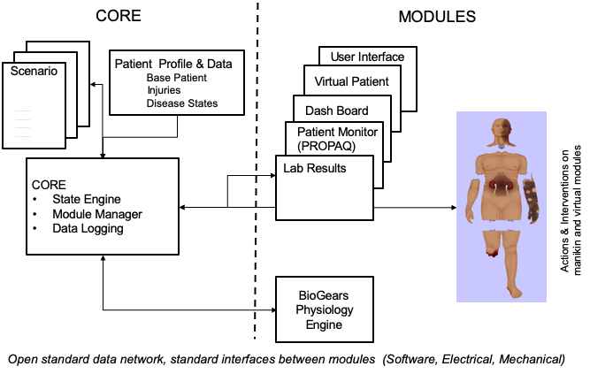
Figure 1: Functional Overview of AMM Platform

Identification

This is the Advanced Modular Manikin (AMM) Test Procedures CDRL Item A009 of Contract # W81XWH-14-C-0101, Phase II. This document defines the procedures used for testing all aspects of the platform performance during the development process.

This CDRL is formatted to the requirements of Data Item Description Number Data Item Description Number DI-NDTI-80603A.

System overview
The AMM platform is a modular, distributed, interoperable system that enables physical, virtual, augmented and hybrid modules to work together as an integrated system. The traditional “core”, i.e. computer and state engine, can be in any one of the traditional manikin segments, i.e. torso, leg etc., or external to the human form, as it would be if the system is only running a virtual instance or if the targeted scenario, i.e. patient case, does not allow them to be internal due to the set of interventions that have to be performed on the body. The platform is architected as a system of systems that allow modules to function either as part of an integrated, whole body simulation or as autonomous part task trainers.

The published AMM standards guide the development and integration of AMM compatible modules. The reference designs provided for the final demo including electronics and central supplies were created to demonstrate the operation of the platform and are published as a developer’s tool kit with sources to acquire them from.

The developers of the platform have agreed to publish the AMM platform and all related documentation under the following open source licensing option:

* Creative Commons Attribution 4.0 International (CC BY 4.0) https://creativecommons.org/licenses/by/4.0/deed.ast.
Share — copy and redistribute the material in any medium or format
Adapt — remix, transform, and build upon the material for any purpose, even commercially.
The licensor cannot revoke these freedoms as long as you follow the license terms.

This document does not cover modules that were created under separate funding and by other entities to demonstrate the functionality of the AMM Platform under separate funding and are not part of the Open Source agreement.

Document Overview
The test procedure has been divided into parts. In section 3.1 the AMM Medical Scenario Verification Tests (MSVTs) are defined. These are tests related to patient events and how well the manikin performs in relation to actual human data. In section 3.2 the Engineering Verification Tests (EVTs) are defined. These tests verify the engineering of the manikin as related to size, weight, construction workmanship, motion and electrical/software functionality. They also verify the reliability and usability in relevant environments.

The tests procedures provide the following information per Data Item Description Number DI-NDTI-80603A.

- Purpose of the test
- Description of the Test Article
- Test Requirements
- Test Equipment
- Step by Step Test Procedure
- Data Sheet

All tests described in this document relate to the AMM platform and not the individual modules that were used to demonstrate the operation of the platform. Module developers can use the Reference Design of AMM CORE as documented in CDRL A004, Section 3.1 both for development work but also to test for compatibility.

Origin of Test Requirements
The origin and flow down/traceability of test requirements is shown in Figure 2. The origin of the AMM requirements is shown in the top line of Figure 2. This line identifies 3 requirement sources which are Clinical Use Cases, Concept of Manikin Operation and Industry Open Standards. From these study cases and documents the next line down shows the specifications created and CDRL A008.
Figure 2: Origin and Flow Down of Test Requirements
Each consecutive level of documents identifies how the documents are derived from the top-level specifications. These requirements were captured in the Environmental Condition and A001, A002, A007, A011. Finally, at the lowest level in Figure 2, the test requirements were created and documented based on performance requirements selected to verify.

Referenced Documents

Industry Documents
Doc. No. | Title
802.3, IEEE 802.3bt | IEEE Standard for Ethernet  https://standards.ieee.org/content/ieee-standards/en/standard/802_3bt-2018.html
DDS v1.4 | Data Distribution Services (DDS)  https://www.dds-foundation.org/omg-dds-standard/

Government Documents
Document Number | Title
# W81XWH-14-C-0101 | AMM Phase II Contract, DOD
DI-NDTI-80603A | Data Item Description

Related Contract Documents
Document Number | Title
CDRL A001 | Software Design Description
CDRL A002 | Software Product Spec
CDRL A004 | Product Drawings
CDRL A007 | Interface Design Description (IDD)
MSVT | AMM Scenario Form (not a contract document, included in this document)

Test Procedure
This test procedure has been divided into parts. In section 3.1 the Medical Scenario Verification Tests (MSVTs) are defined. In section 3.2 the Engineering Verification Tests (EVTs) are defined.

For all tests in this procedure, the environmental conditions are standard lab conditions:
Temperature 70F + 10F
Relative Humidity 15% to 90%, no condensation
Electrical Power – Standard wall 120VAC, 60 Hz, 20 amps
Altitude – Under 5000 FT

Medical Scenario Verification Tests (MSVTs)

Scenario
A patient scenario was created by the American College of Surgeons (ACS) to evaluate the usability of the AMM platform when it is integrated into a full-body manikin. This physical manikin is an interpretation of how the AMM platform may be used for training purposes. In this section, it is important to distinguish the difference between the physical manikin and the AMM platform. Demonstration of the capabilities of the AMM platform necessitates tangible outputs through both anatomical segments and digital displays. In this scenario, participants interact with a simulated trauma patient to establish the interoperability and functionality of the AMM platform in an educational setting.

The AMM platform is verified with several modules developed by CREST Lab and third party companies. The scenario is broken into three scenes, transitioning the participants from the point of injury, to the emergency department trauma bay, and finally the operating room. The full-body manikin is not physically moved to new locations, as the scenario is to be conducted in a controlled environment. The AMM platform is to satisfy the unique modular requirements of each scene to provide education value to the participants.

The MSVTs are limited to the assumption that all modules are fully-functional, the technical actions are performed correctly, and the participants actions fulfill the requirements of the scenario. Only then can both successes and failures in performance be attributed to the AMM platform.

Purpose of the Test
The purpose of the MSVTs is to conduct a training exercise on the AMM platform. This is not a technical test, as described by other test procedures in this document. The MSVTs is a demonstration of how the AMM platform may be used to develop modular healthcare simulation tools for educational purposes.

Description to the Test Article
The complete system for the MSVT shall be setup as shown in Figure 3. The manikin on which medical procedures will be performed is physically connected to the power supply and fluids. The system is modular physically and digitally. The physical modules are contained to anatomical segments, being the head, torso, right and left arms, and right and left legs. Arrows indicate data transfer between modular components and the Core.

The AMM Core controls the AMM platform by producing data each module needs to function during the educational encounter. All modular outputs are dependent on data published by the Core and all inputs received by modules are relayed back to the Core. The changes in patient physiology are computed by the BioGear’s physiology engine. There is a user interface for technical support and subsequent windows for easy and quick setup, operation, and shut down. During the educational encounter the patient vitals are displayed on interactive tablet applications with real-time updates from the AMM Core.
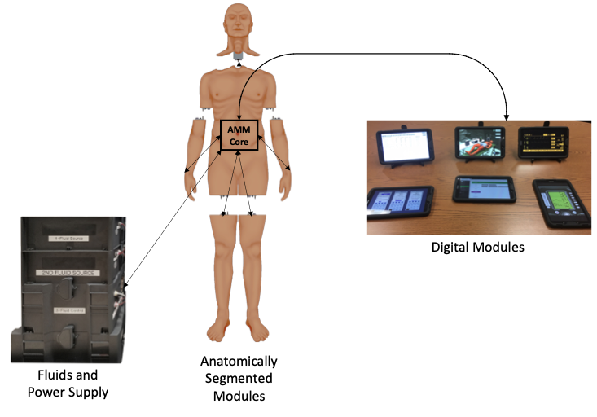
Figure 3: Overview of the AMM Core integrated into the torso of a full-body manikin.
For the planned scenario, the anatomical segments and the respective modules will be assembled as shown in Figure 4. The scenario demonstrates the modularity of the AMM platform by integrating a combination of modules that support specific educational objectives. Each module has unique capabilities, which output functions driven by data received from the AMM platform. Uniquely, the torso module has its own capabilities, such as chest rise, and it is also the foundation for a second level of modularity. Specifically, the capabilities of the airway (head segment), abdominal exam (torso segment), ultrasound (torso segment), and laparotomy (torso segment) require the capabilities of the Torso module itself. Physically, the airway, abdominal exam, and laparotomy modules are removable, while the ultrasound module is permanently integrated into this manikin’s torso.
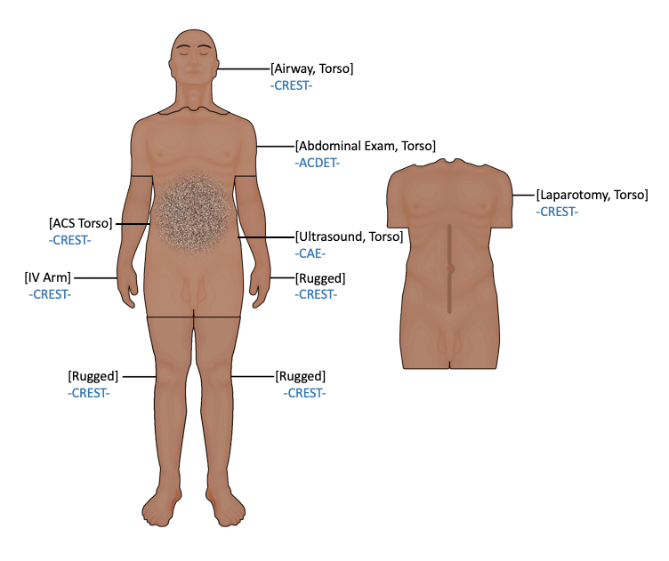
Figure 4: Physical segmentation of modules.
Digital modules include six tablet applications; Virtual Patient, Patient Monitor, Ventilator, Urine Meter, Labs, and an IV Pump. When clinically relevant, a combination of these modules are to be used during the scenario. Each module is connected to the AMM Core and requires the system’s physiology engine to output the appropriate patient vitals. This is another demonstration of modular integration to the AMM platform.

The AMM platform utilizes physical and digital modules to integrate a combination of clinical skills. This test is intended to examine the function of the AMM platform, not the function of the modules. However, it is necessary to integrate the aforementioned modules to test the AMM platform. Therefore, this test is to be performed under the assumption that the modules are fully functional and compatible with the AMM standards. Test failures are not attributed to a module alone, but rather the performance of the AMM platform.

Test Requirements
The following is a list of qualitative test requirements that follow the expectations of the educational scenario developed by the ACS. Each step will be evaluated under the objective performance parameters described in the data sheet.
- Initialize AMM platform
- Connect relevant modules
- Start IV fluids by inserting catheter and administering fluids
- Perform bag-valve mask ventilation
- Intubate the patient
- Perform abdominal palpation exam
- Perform abdominal ultrasound
- Perform a laparotomy
  - Splenectomy
  - Bladder repair
  - IVC repair
- Clean the system
  - Flush out blood simulant
  - Purge the fluidics system
  - Shut down the modules and platform

Test Equipment
No special test equipment is required, the manikin system is self-contained with built-in capability to record and store data throughout the scenario. Physical requirements include full assembly of the manikin, fluidics and power supply, six tablets, a laptop, and medical equipment described in the AMM Scenario Form document.

Test Procedure
Each step in the scenario test procedure assumes that the modules are functional. Testing is performed to evaluate the AMM platform, while errors attributed to the module, user, or participants are not considered. Additional user operations regarding the scenario and technical set-up are described in CDRL A006 User Manual.

Pre-Scenario AMM Platform Test
These steps are required to prepare the system to conduct the ACS scenario described in the AMM Scenario Form document.

Step 1 – Assemble the manikin and booting up the system
Connect the module segments, head, arms, and legs to the manikin torso with the standard connectors. Ensure that the umbilical is connected to the fluidics tower and power. Power up the system.

3.1.6.1.2 Step 2 – Verify the technical user interface appears
Connect a tablet or laptop to the AMM network. Enter the private IP address assigned to the network hardware to access the user interface to search for the user interface. The main dashboard will appear, as shown in Figure 5. If the AMM network is not running, this page and the subpages will not load.

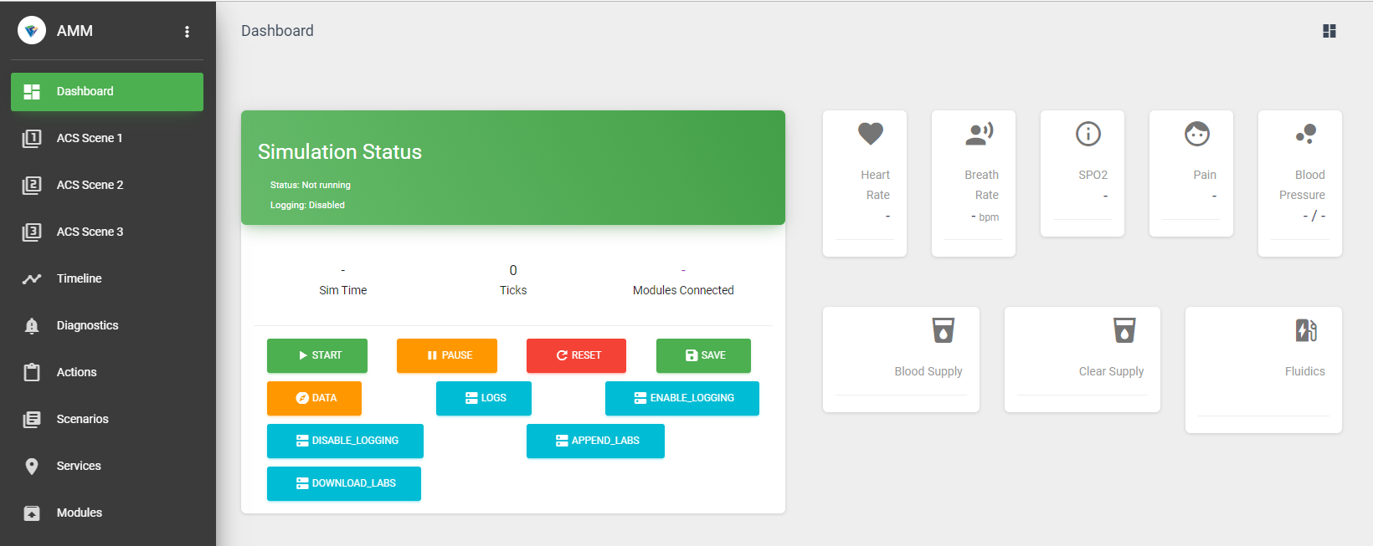
Figure 5: User interface home page.

Step 3 – Verify the AMM Core modules are running
The AMM Core Software modules must be powered on before other modules can connect to the AMM platform. The services tab on the user interface provides real time information regarding the core module status. Verify that every module is “running” in the first column on the screen, as shown in Figure 6. If a module is not running, either restart the individual module under the Actions column, or press the restart all button to restart all core modules.

Click on the Fluidics, Torso, IV Arm, and AbSim tabs to verify that the run time of these modules is shorter than the Core modules. This indicates that the Core modules were running and allowing other modules to connect appropriately with the publish-subscribe pattern.

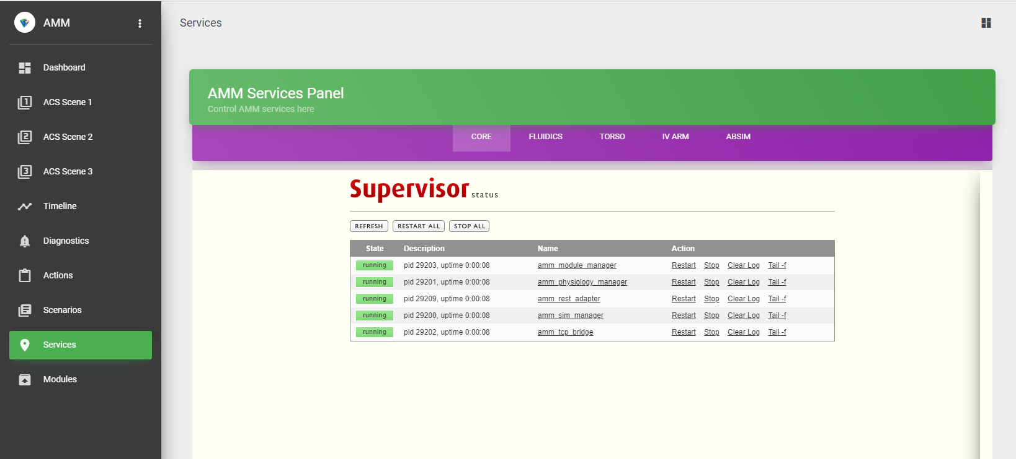

Figure 6: Running AMM Core services.

Step 4 – Make sure that all connected modules competed startup successfully
Once the core is running, identify if a module is successfully connected, indicating that it has shared its capabilities and is subscribed to the appropriate data. There are several test methods to verify module connection. Firstly, the module manager nominally tracks module capabilities. At this point, verification of a successful handshake between the module manager and an individual module is indicated on the main dashboard. If the number above “Modules Connected” is clicked, the user will be directed to the Modules page, which lists core modules and other modules in their respective tabs. If a module unexpectedly disconnects, a push notification will be displayed on the interface, the module name will turn red on the Modules page, and the number of modules connected will decrease.
Modules may connect to the incorrect network, even if they are powered on. To test that the module is running on the AMM specific network, utilize the web Admin Panel to identify if the module is a network client.

Step 5 – Make sure that all virtual modules completed startup successfully
Virtual modules include the tablet application modules. The tablets must all be connected to the AMM network. The applications begin with a start selector page. Verification that the module is in the AMM network can be found on the upper left corner, where the private IP address is published. If it is the correct address, select “Start”.

A successful publish-subscribe pattern between the Core and the digital modules can be tested with the same methodologies described in Step 4.

ACS Scenario Test
Completing the pre-scenario steps prepare the manikin for the ACS scenario. The following steps test whether the expected technical inputs and participant actions during the scenario yield the expected system outputs and function.

Scene 1: Point of Injury

Table 1 below describes step by step operations. Technical inputs are actions performed on the technical side, often from the user interface. User inputs are actions expected to be performed by the scenario participants. The system/modular outputs describe expected function.

Location: Point of Injury
Step | Modules | Capability | Technical Input | User Input | Learner Outcome | System/Module Output
1 | Patient Monitor | Monitoring | Load scene 1, load patient state 1. Start simulation. | Visual inspection,  initial assessment of the patient's state. | Observes noticeable injuries on left abdomen, head laceration that is not actively bleeding. | Patient vitals will worsen if untreated.
2 | Abdominal Exam, Torso, Virtual Patient | Monitoring | Enable splenic trauma and calibrate sensor pad on torso. | Abdominal palpation exam. | Feels guarding on the upper left quadrant, below the ribcage. Patient expresses pain during palpation. | Torso’s splenic bladder will inflate when initiated. Palpitations create pain sounds made by the Virtual Patient. Performance data is gathered by the Abdominal Exam module.
3 | IV Arm, Patient Monitor, Virtual Patient | Resuscitation | Initialize IV Arm. | IV catheter insertion, administering fluids. | Administration of fluids and initiation of peripheral IV. | System registers correct IV catheter placement when fluids begin flowing. Patient vitals change as fluids are administered. Virtual patient will display IV catheter.
4a | Airway, Torso, Patient Monitor, Virtual Patient | Ventilate and Oxygenate | Stop manikin breathing. | Perform BVM ventilation. | Chest rise is restored with BVM ventilation. | Patient vitals reveal that RR is 0 when breathing stops. Correct BVM will allow for RR to change, matching manual ventilation rate. Registration of correct BVM will output a BVM on the Virtual Patient. Patient vitals change throughout.
4b | Airway, Torso, Patient Monitor, Virtual Patient | Ventilate and Oxygenate | Continue from BVM step. | Intubate. | Patient is intubated prior to transportation to the ER. | Correct intubation, esophageal intubation, or right/left mainstem intubation will be registered by the system. Only correct intubation will allow for chest rise and for an ET tube to appear on the Virtual Patient. Patient vitals will reflect no breathing or breathing by intubation.
Table 1: Overview, Set-up, Operations, Inputs and Outputs of Scene 1

3.1.6.2.1.1 Test Set-up Diagrams
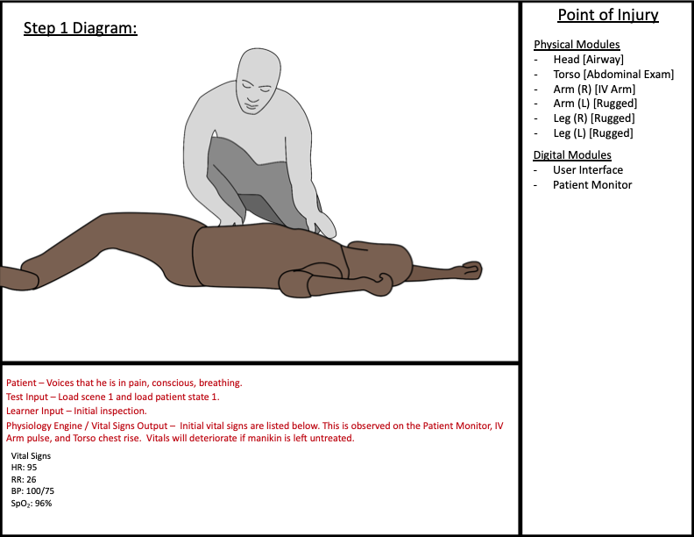
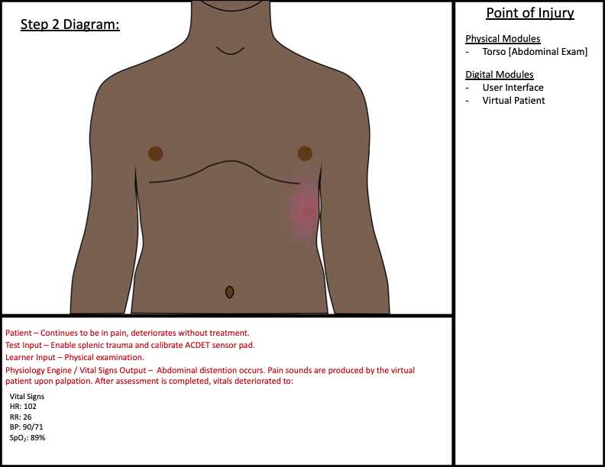
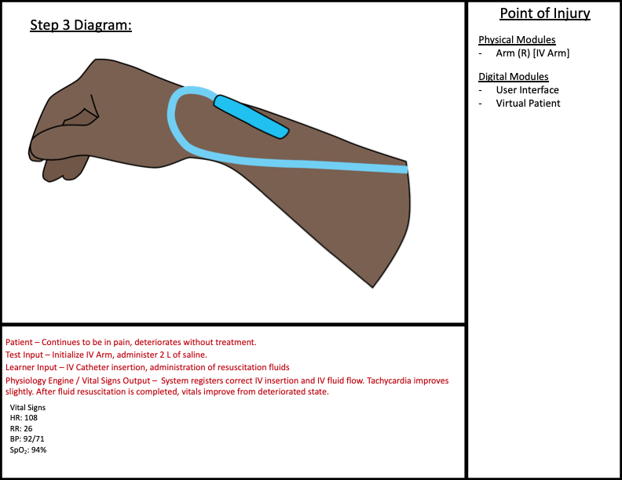
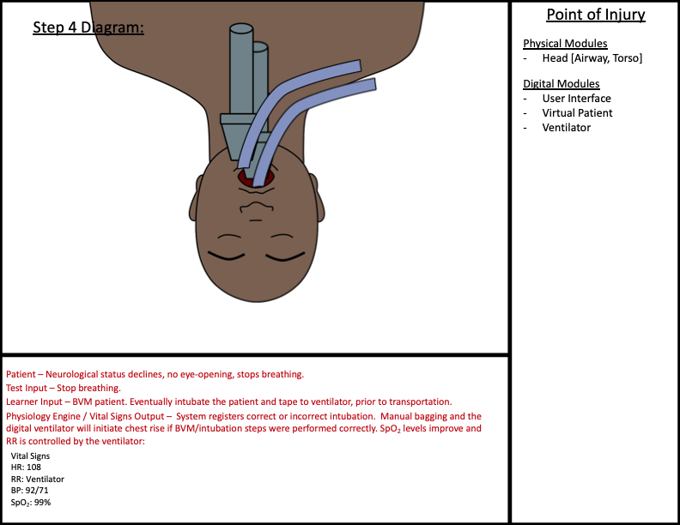

Scene 2: Emergency Department Trauma Bay

Table 2 below describes step by step operations. Technical inputs are test actions performed on the technical side, often from the user interface. User inputs are actions expected to be performed by the scenario participants. The system/modular outputs describe expected function.

Location: Emergency Room Trauma Bay
Step | Modules | Capability | Technical Input | User Input | Learner Outcome | System/Module Output
5a | Labs | Monitoring | Load scenario 2, load patient state 2. Connect Labs tablet to the AMM system. Start simulation. | Thorough assessment of patient state. | Participant receives patient data to help them stabilize the patient and diagnose the ailment. | Lab data will reflect patient state and change depending on actions performed by the learner.
5b | Abdominal Exam, Torso, Virtual Patient | Monitoring | Enable abdominal trauma and calibrate sensor pad on abdomen. | Abdominal palpation. | Abdomen is fully distended, and pain sounds will be made by the Virtual Patient upon palpitations. | Four quadrants of the ACDET bladders will inflate. Palpitations create pain sounds made by the Virtual Patient. Performance data is gathered by the Exam module.
6 | IV Arm, IV Pump, Patient Monitor, Virtual Patient | Resuscitation | Initialize IV puck. | IV catheter insertion, administering fluids. | Second IV placement by another participant in the ER scene. Fluids/blood/available medications may be administered by the IV Pump. | System registers correct IV catheter placement when fluids begin flowing. Patient vitals change as medications/fluids are administered. Virtual Patient will display IV catheter. System will register anything administered by the IV Pump.
7 | Ultrasound, Torso | Monitoring | CAE Vimedix software is running, probe is calibrated, scene configuration is loaded. | Perform FAST exam. | Assessment indicates that there is free fluid surrounding the spleen. Indication to take the patient to the OR. | Correct file loads onto the CAE Vimedix software, visible free fluid during FAST exam.
8 | Airway, Torso, Patient Monitor, Ventilator, Virtual Patient, IV Pump | Ventilate and Oxygenate | None. | Administer drugs through the IV Pump to stop breathing. Intubate and tape to ventilator. | Administer appropriate drugs first. Intubation in the ER is preparing the patient for the OR. Connect the patient to the ventilator to regulate respiration. | Paralyzed patient will be represented by a respiration rate of 0 and no movement from the Virtual Patient. Correct vs incorrect intubation will be registered by the system. Only correct intubation will allow for chest rise and for an ET tube to appear on the Virtual Patient. Patient vitals will reflect successful intubation. Correct use of the ventilator will reflect a ventilator tube on the Virtual Patient and the respiration setting will be reflected by chest rise on the manikin and vitals on the Patient Monitor.
Table 2: Overview, Set-up, Operations, Inputs and Outputs of Scene 2

Test Set-up Diagrams:
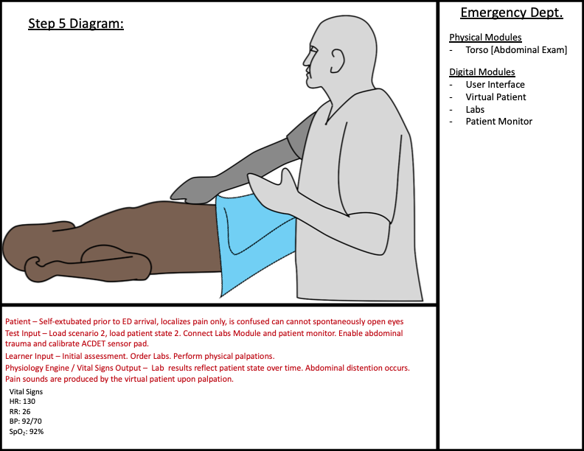
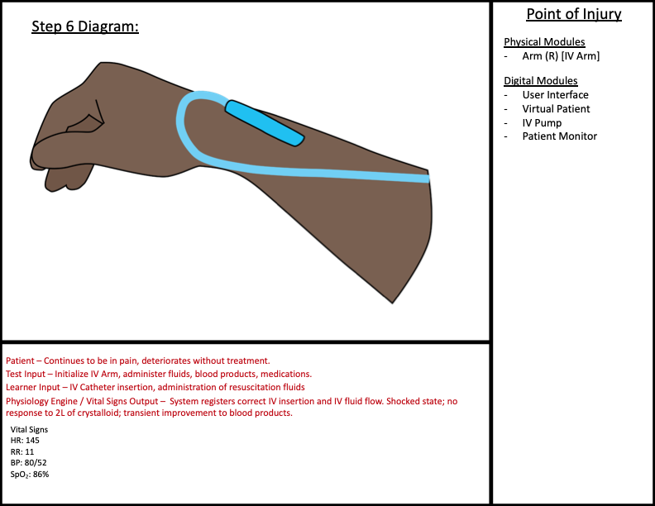
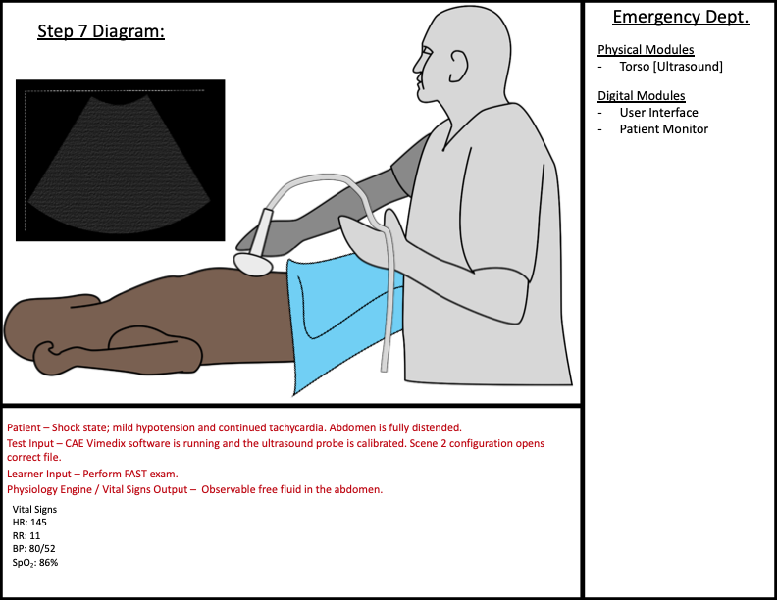
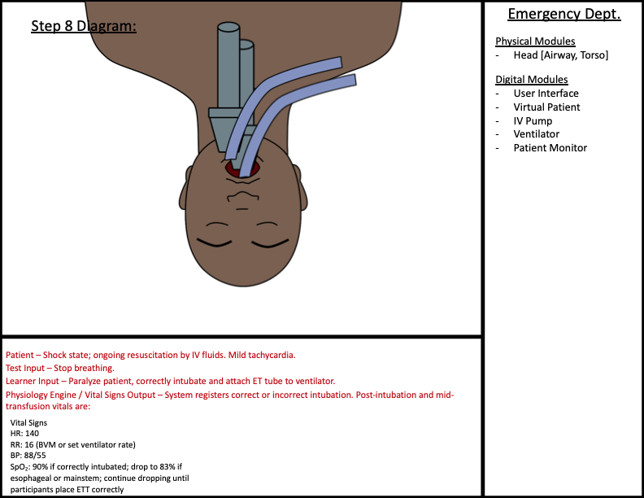

Scene 3: Operating Room

Table 3 describes step by step operations. Technical inputs are test actions performed on the technical side, often from the user interface. User inputs are actions expected to be performed by the scenario participants. The system/modular outputs describe expected function.

Location: Operating Room
Step | Modules | Capability | Technical Input | User Input | Learner Outcome | System/Module Output
9a | Torso, Patient Monitor, Ventilator | Respiratory | Tape and ventilate ET tube to Ventilator tablet. | Regulation of respiration in response to patient state. | Responses to changes in vitals to stabilize patient. | Changes made on the Ventilator will be verified by changes observed on the digital modules.
9b | Labs | Monitoring | Turn on and connect Labs tablet to the AMM system. | Thorough assessment of patient state. | Participant receives patient data to help them stabilize the patient. | Lab data will change depending on previous actions performed by the learner and patient state.
9c | IV Pump, Patient Monitor | Monitoring | Attach IV Pump to arm. | Prolonged administration of drugs/fluids/blood during surgery. | Administration of fluids, blood, and medications as a response to patient vitals. | Fluids/blood/medications administered will cause a change in patient vitals, as observed on the Patient Monitor.
9d | Urine Meter | Monitoring | Insert catheter. | Monitoring urine output throughout the surgical procedure. | Observation of fluids output, urine color, and monitoring when to flip or empty the urine bag. | Urine output is slow when patient is bleeding. Urine changes from yellow to orange-brown when blood is in urine.
9e | Torso, Laparotomy | Surgical Intervention | Insert laparotomy shell and fill. Connect vessels to laparotomy shell. Start spleen bleed. | Systematic searching for bleeding. Pack quadrants. | Exploratory laparotomy highlights surgical intervention skills and successful technique/decision making. Ongoing interventions to stabilize patient. | Flow rate of blood leaving each vessel may be tracked over time. Clamping the vessels will change the flow to zero. Patient state deteriorates as bleeding continues.
10 | Torso, Laparotomy | Surgical Intervention | Continued spleen bleed. | Find splenic injury and perform splenectomy. | Ongoing resuscitation. Stop bleeding, keep patient stable, remove spleen. | Registers if bleeding is successfully stopped. Vitals stabilize with correct interventions and successful splenectomy.
11 | Torso, Laparotomy, Urine Meter | Surgical Intervention | None. | Observe blood in urine, find bladder injury. | Ongoing resuscitation. Repair bladder and test for success. Observe normal urine outputs return. | Low urine output and visible blood in urine if the bladder is not repaired. Clamping lacerations on the bladder will allow the bladder to fully inflate with air.
12 | Torso, Laparotomy | Surgical Intervention | Start IVC bleed. | Observe blood pooling in laparotomy cavity, find injury to iliac vein. Repair IVC. | Ongoing resuscitation. Repair IVC. | Vitals rapidly deteriorate due to IVC injury. System registers when repair is successful and blood loss has stopped. Vitals stabilize.
Table 3: Overview, Set-up, Operations, Inputs and Outputs of Scene 3

Test Set-up Diagrams:
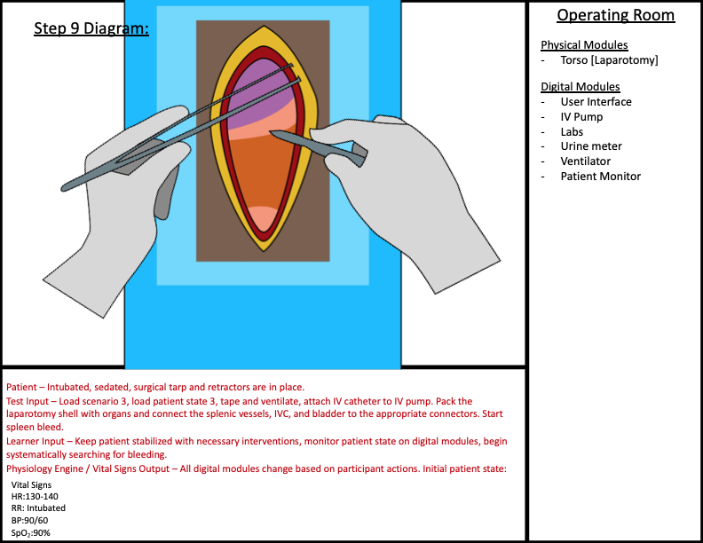

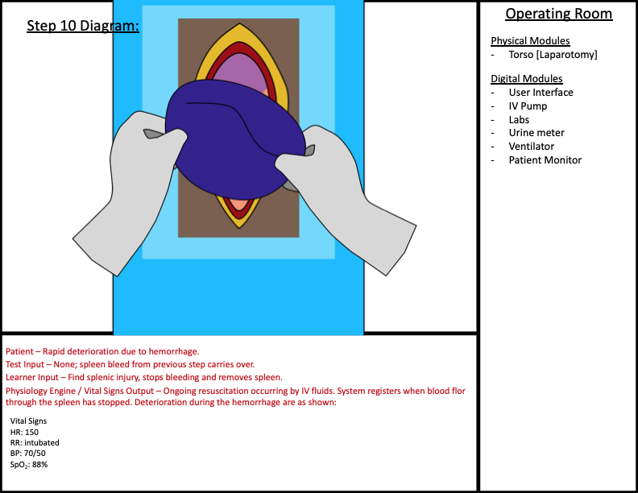
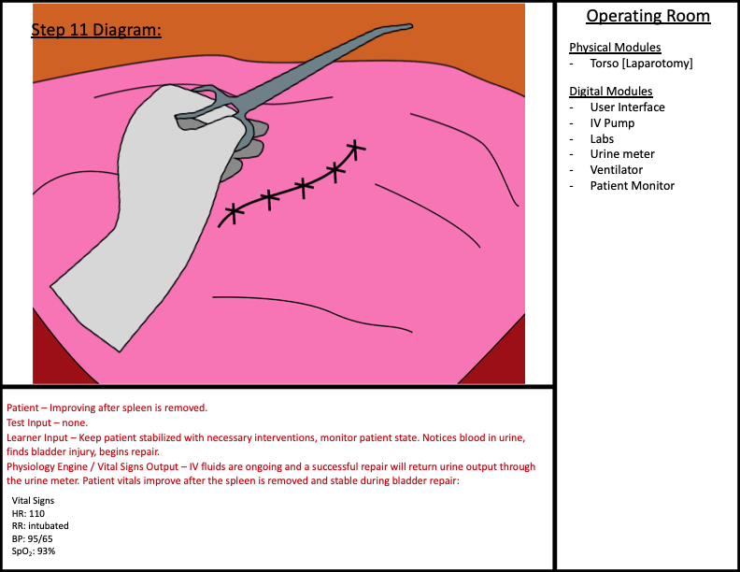
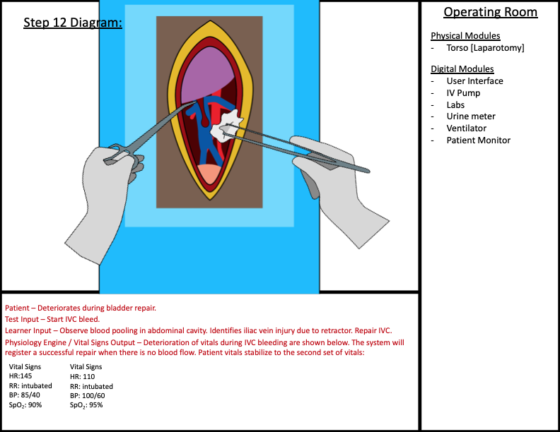

Post-Scenario AMM Platform Test:
After the participants complete the learner scenario, the manikin requires maintenance steps prior to shut down.

Step 1- Clean the system by flushing out all blood stimulant.
Disconnect the four blood bags from the fluidics tower. Replace with bags of water. First, clean the IV Arm plumbing by initializing the IV Arm with water to flush out the arm. Do this at least times to ensure all the blood stimulant is gone. Remove the arm. Use the purge connector to flush out the plumbing lines of the left arm and left leg. Simply click the connector in place to connect the fluids line to waste. If you wish to visualize the movement of fluids through the torso, remove the connectors from the connector caps and peel the skin away from the abdomen.
Flush each segment connector until only clear fluid is exiting the waste line.

Step 2- Purge the fluidics system.
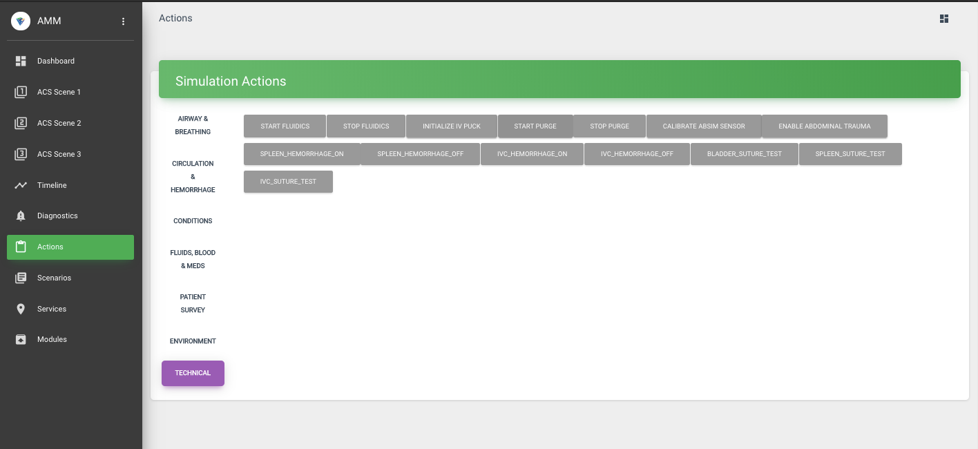
Now that all fluid lines are filled with water, prepare to purge the system with air to clear remaining fluids and dry the plumbing. Press the stop fluidics button on the actions page in Figure 7. Once the fluidics system is depressurized, reconnect the purge connector to either upper arm connector. Press the start purge button to begin. The purge is completed once there are no fluids leaving the waste line. Press the stop purge button to end.

Figure 7: Simulation Actions Page on the user interface.

Step 3 - Shut down the system.
Once the fluidics system is depressurized, enter the fluidics services page and stop fluidics service. Perform the same actions for the Torso and the Core modules. All connected modules should be in a “stopped” state. At this point, neither the IV Arm or AbSim modules will be connected.
All services should be stopped if the manikin is not going to be used for several hours. If the manikin will not be used for over a day, the power supply may be turned completely off. Lock tablet screens and charge the tablets for future usage.

MSVTs Data Sheet
Date:_______________ Person(s) Running Tests :______________________________ Location:__________________________________________________________________________
Start Time: _______________ End Time: _______________
Record System Part Numbers & Software Loads
Module | Part Number | Developer | Remarks/Status
Physical Modules:
Airway Head |  | CREST
ACS Torso |  | CREST
Abdominal Exam |  | ACDET
Ultrasound Torso |  | CAE
Laparotomy Torso |  | CREST
IV Arm |  | CREST
Digital Modules:
User Interface |  | VCOM3D
Patient Monitor |  | VCOM3D
Virtual Patient |  | VCOM3D
Ventilator |  | VCOM3D
Labs |  | VCOM3D
IV Pump |  | VCOM3D
Urine meter |  | VCOM3D

Test Step | Pass | Fail | Objective Performance | Remarks/ Measurement
Pre-Scenario Steps:
Step 1 |  |  | AMM platform receives power.
Step 2 |  |  | User interface is connected to the AMM network.
Step 3 |  |  | AMM core modules are running.
Step 4 |  |  | Stand alone modules connect to the AMM platform.
Step 5 |  |  | Virtual modules connect to the AMM platform.
ACS Scenario Steps:
Step 1 |  |  | Scene 1 patient state and scenario configurations publish to modules.
Step 2 |  |  | Abdominal palpation module inflates and sends pain sounds through the Virtual Patient.
Step 3 |  |  | IV Arm provides correct pulse, flash during IV catheterization, registration of fluid administration.
Step 4 |  |  | BVM/Intubation restores chest rise and improves patient vitals.
Step 5 |  |  | Scene 2 patient state and scenario configurations publish to modules. Abdominal palpation increases distention and pain sounds are sent through the Virtual Patient.
Step 6 |  |  | IV Arm provides correct pulse, flash during IV catheterization, registration of fluid administration. Attachment to IV Pump allows for administration of drugs.
Step 7 |  |  | FAST exam indicates free fluid in the abdomen.
Step 8 |  |  | Manikin stops breathing with medication. Intubate and attach to ventilator to restore controlled breathing.
Step 9 |  |  | Scene 3 patient state and scenario configurations publish to necessary modules. Modules output patient vitals.
Step 10 |  |  | Spleen bleeds from vessels until stopped. Patient vitals deteriorate during bleeding and recover after repair.
Step 11 |  |  | Urine levels are low and there is blood in the urine until bladder repair is successful. After, urine output is normal in volume and color.
Step 12 |  |  | IVC bleed deteriorates the patient vitals. Bleeding continues through the vessel until stopped. Vitals recover after a successful repair.
Post-Scenario Steps:
Step 1 |  |  | Clear fluid flushes out all blood stimulant into waste container.
Step 2 |  |  | Purge mechanism removes all remaining fluid.
Step 3 |  |  | Shut down stops the function of all modules.

Additional Comments:
If failure occurs, troubleshoot and record causes here. Add additional sheets if necessary.

Signature of Recorder: ______________________________ Date ________________________

Engineering Verification Tests (EVTs)

Manikin System Level Tests

Total Manikin Weight
The purpose of this test to weigh the modular manikin and determine the total weight. The goal weight for the manikin is 185 pounds. Use a calibrated weight scale to perform measurements. Weight each module and major organs separately and record weight. Determine the manikin total weight after all modules have been weighed. Refer to the Data sheet for the measurements to be made.

Module Interfaces Compliant with Standards

Purpose of Test
The purpose of this test is to verify the module interfaces meet the physical, electrical and fluid standards.

Description of Test Articles
The test articles are the standard modules used for the manikin. A drawing of the manikin configuration is shown on the left side of Figure 8. The interfaces are the module inter-connection for the head/torso, arms/torso and legs/torso. A standardized multi-functional hybrid connector is used. A close up the hybrid connector embedded in the arm is shown on the right side of the Figure 8.

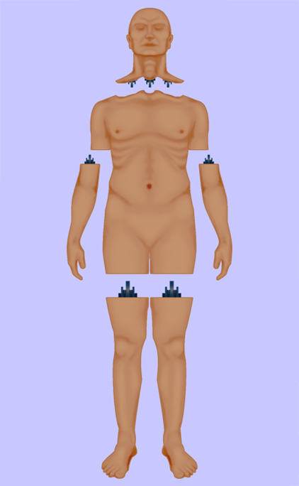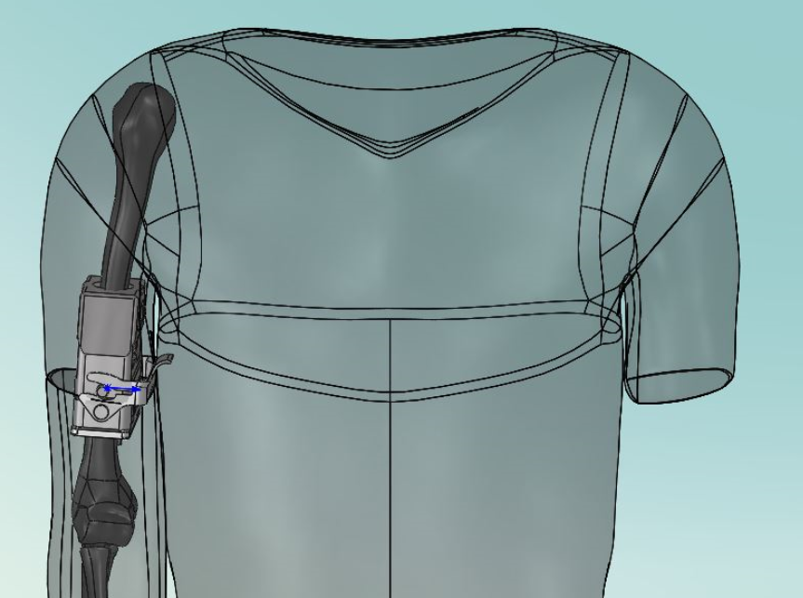
Figure 8: Overview of the Manikin Interfaces

Test Requirements
The system voltage is nominally 52VDC. The digital signals shall be based on IEEE standard 802.3, specifically, IEEE 802.3bt for the Power Over Ethernet (POE) implementation. The fluid and air sub-system shall provide the following capability over the interface.
Simulated Blood
Clear Fluid
Air
Waste

The requirements also provide for recirculation for all extremity lines for:
Cleaning, purging/drying
Fluid return (waste)
Double sided spill proof connectors at module interfaces (no/minimal leakage)
Decoupled complexity, meaning that all items that can be resolved locally are addressed at the local level, items that require systemic responses are pushed to the next level up
Reservoir refill via spill proof quick connect
Quiet operation pumps/valves/hoses/exhaust <=45 dB
Low pressure <75 psi air and fluids flow control via pump speed (flow starved circuit)

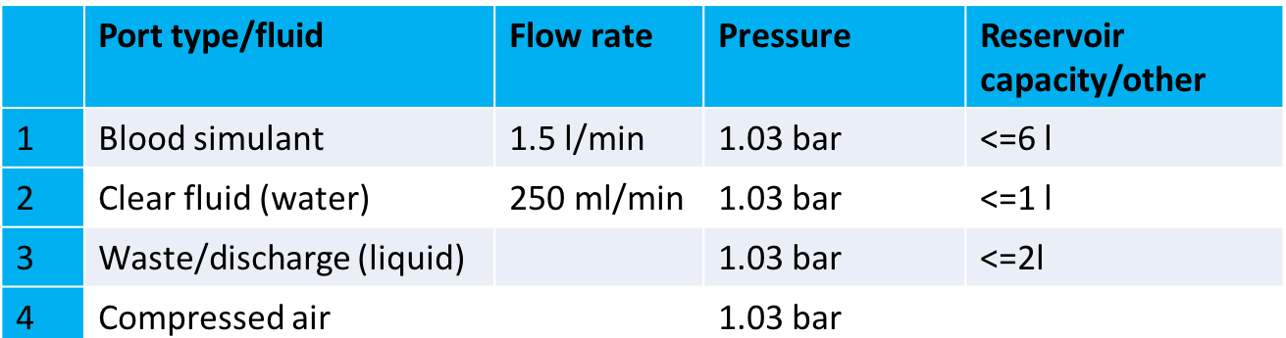

The reservoir capacities were determined by available space internal to segments, if there is a need for higher volumes, the developers may choose to use external reservoirs.

Test Equipment
The universal module tester will support this testing. An overview of the universal module tester is shown in Figure 9. The universal tester shall be capable of testing the individual modules. The currently developed AMM Central Operating REsources, or CORE, is a precursor for such a test system and is documented CDRL 004, Section 3.1. It can be used to connect any module and exercise it based on a scenario. To perform as the universal tester it would require a new software module to be created and additional sensors incorporated, to exercise different capabilities of a module, and generate a summary report on their performance.

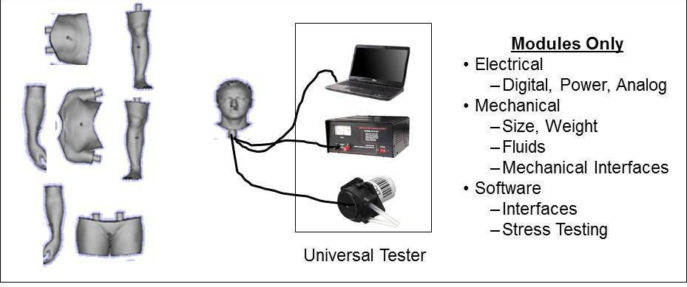
Figure 9: Overview of concept for Universal Tester for module level testing
Other standard test equipment includes a voltmeter, water and air pressure gauges.

Step by Step Procedure for Testing Standard Interfaces
For each module verify the electrical, mechanical, fluid and software interfaces.

Manikin Weight Test Verification Data Sheet
AMM Weight Verification Data Sheet
Date:_________________________________
Person Running Tests ___________________________________________________________________
Location:__________________________________________________________________________
Start Time: _______________ End Time: ________________________________________

Module | Part Number | Requirement Weight (Goal) | Measured Weight
Advanced Airway Trainer |  | 15 8%
Torso Ultra Sound |  | 85 46%
Torso Laparotomy |  | 85 46%
Left Arm |  | 10 10%
Right Arm |  | 10 10%
Left Leg |  | 32 17.5%
Right Leg |  | 32 17.5%
Total Weight
Ultra sound Manikin |  | 185
Laparotomy Manikin |  | 185

Additional Comments:
Weight specifications dependent on the target audience. Sim centers would prefer lighter manikins for easier setup/tear-down, while military users could prefer realistic weights for transport. Standard allows for both possibility for both. The demonstration implementation is close to the actual patient it was modeled on.

If failure occurs, troubleshoot and record causes here. Add additional sheets if necessary.

Signature of Recorder: _________________________________ Date ________________________

Manikin Standard Module Interface Verification Data Sheet
Date:_________________________________
Person Running Tests ___________________________________________________________________
Location:__________________________________________________________________________
Start Time: _______________ End Time: ________________________________________
Record System Part Numbers & Software Loads where applicable
Module | Part Number Software Load | Elect Power |  | Elect Dig |  | Fluid |  | Mechanical Fit
 |  | Pass | Fail | Pass | Fail | Pass | Fail | Pass | Fail
Advanced Airway Trainer Interface
Torso Ultrasound Interface
Abdominal Exam
Torso Laparotomy
IVC Repair
Splenectomy
Bladder Repair
IV Left Arm Interface
Rugged Right Arm Interface
Left Leg Interface
Right Leg Interface
Physiology Engine
Virtual Patient

Additional Comments:

If failure occurs, troubleshoot and record causes here. Add additional sheets if necessary.

Signature of Recorder: _____________________________ Date ________________________

System Software Testing

Purpose of the Test
The purpose of this test procedure is to test system software to make sure all bugs have been eliminated and operation of the system is as planned.

Description of the Test Article
The system architecture is shown in Figure 10. The architecture utilizes Data Distribution Services (DDS) operating over Ethernet at the lowest level (https://en.wikipedia.org/wiki/Data_Distribution_Service). All modules connect to the bus.

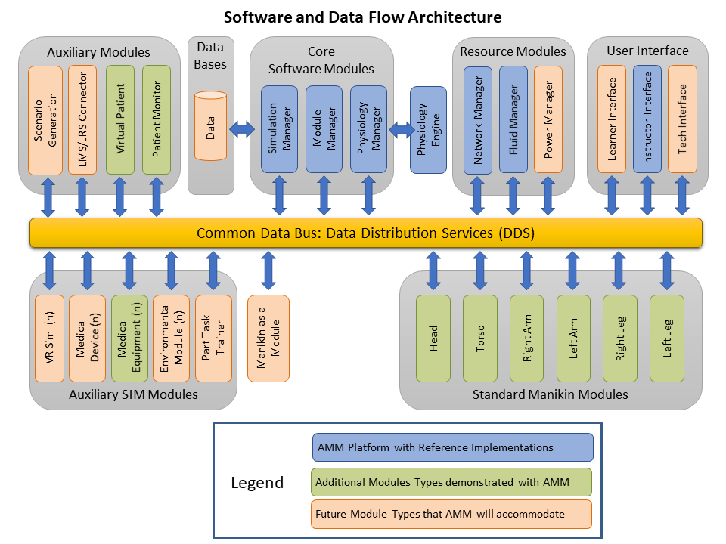
Figure 10: AMM Processing Architecture Based on DDS
The user interfaces with the system via the AMM User Interface. Control of the system is shared by two modules: Module Manager for startup, shutdown and exceptions, and the Simulator State Engine to run the AMM Scenario. This architecture is easily expandable to include other modules.

Test Requirements
Please refer to the Software User Manual, CDRL A005, for detailed software testing requirements and procedures. The details include information relating the AMM Core software unit and regression test plans and procedures as well as test methodology for non-core module development.

Test Equipment
No special test equipment is needed since the AMM manikin is a self-contained system. The system test will be run from the User Interface Module.

Software Test Data Sheet

Date:_________________________________
Person Running Tests ___________________________________________________________________
Location:__________________________________________________________________________
Start Time: _______________ End Time: ________________________________________
Record System Part Numbers & Software Loads
Module | Part Number | Module | Part Number
Advanced Airway Trainer |  | BioGears Software Version
Torso Ultra Sound |  | Laptop
Torso Laparotomy |  | Power Supply
IV Left Arm |  | Left Leg
Rugged Right Arm |  | Right Leg
Module Software Versions |  | Virtual Patient
Bladder repair
Splenectomy
Vessel repair

Test | Pass | Fail | Remarks/ Measurement
Step 1
Step 2
Step 3
Step 4
Step 5
Step 6
Step 7
Step 8
Step 9
Step 10
Step 11
Step 12
Step 13

Additional Comments:

If failure occurs, troubleshoot and record causes here. Add additional sheets if necessary.

Signature of Recorder: __________________________________ Date _______________________

Component Tests

Connector Vibration – Mechanical, Electrical and Fluid Tests
This test procedure describes the mechanical vibration testing to be conducted on the connector pair. The testing levels are expected worst case for helicopter transportation environment.

Purpose of the Test
This test can be divided into three main components: test for mechanical failure, test for electrical continuity, and test for fluid system operability. The criteria of success for each of these tests have been defined as follows.

MECHANICAL: The connector is able to experience vibrations of frequencies ranging from 10 Hz – 1.5 kHz without sustaining any mechanical failure or deformation. The peak amplitude which occurred at the resonant frequency of the fixture alone was 10 dB for the horizontal orientation fixture and 20 dB for the vertical orientation fixture. The peak amplitude which occurred at the resonant frequency when testing the connector inside the fixture was approximately 4 dB for the horizontal orientation and 6 dB for the vertical orientation.

ELECTRICAL: The electrical contacts inside the connector remain in contact and operational while connector is subjected to vibration with frequencies ranging from 10 Hz – 1.5 kHz

FLUID: Fluid can be run through the connector’s fluid lines without leakage while the connector is subjected to vibration with frequencies ranging from 10 Hz – 1.5 kHz

Description of the Test Article

A drawing of connector test article is shown in Figure 11. The connector is an integrated design containing both electrical and fluid line connections. The electrical connector is for power and Ethernet. There are four fluid lines with self-sealing connectors. A quick release push button is provided for disassembly.

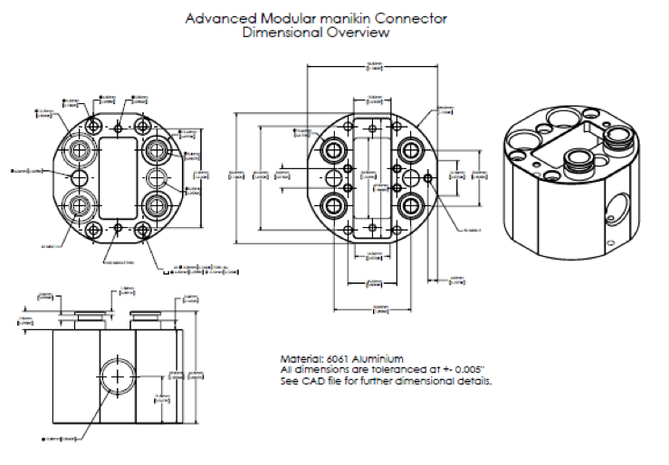

Figure 11: Drawing of AMM connector.
All tests to be performed on three sets of connectors: one connector manufactured by Entropic Engineering, one connector manufactured by a second party vendor, and a hybrid connector with one half manufactured by Entropic, and the other half manufactured by the second party vendor (Figure 12).

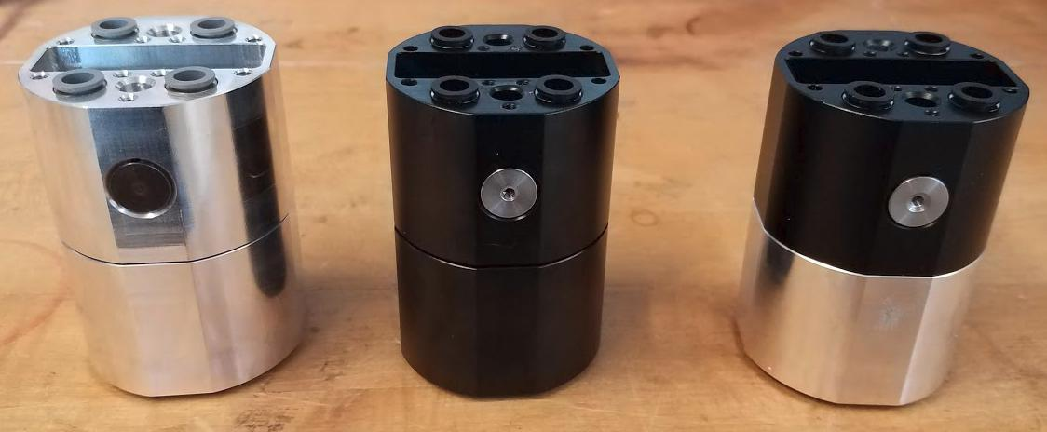
Figure 12: Entropic connector, second party vendor connector, and hybrid connector.

Test Requirements
The connector shall be able to experience vibrations of frequencies ranging from 10 Hz – 1.5 kHz without sustaining any mechanical failure or deformation.

Test Equipment
An electrodynamic shaker table located in the Aerospace Engineering senior design lab to be used for all vibration experiments. The apparatus is shown in Figure 13.

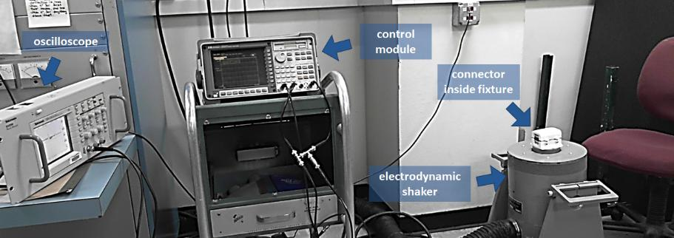
Figure 13: Electrodynamic Shaker Setup

Connector Test Fixture

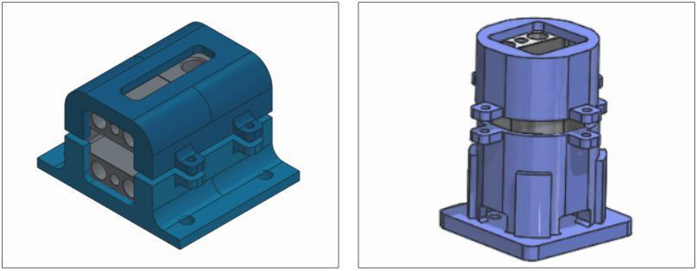
Two different fixtures were designed and 3D printed for the purpose of the vibration test (Figure 14). Two fixtures were necessary in order to test the connector at all three orientations.

Figure 14: left: CAD Model of Horizontal Fixture, right: CAD Model of Vertical Fixture.
For all electrical tests, a wiring harness provided by Entropic Engineering was used. The wiring harness provides electrical access via an Ethernet cable, as well as via several loose wires, as shown in Figure 15. As described in below, two different electrical protocols were followed. In one protocol the loose wires were used to make a simple LED circuit. In the other protocol, the Ethernet cables were used to connect a Linux laptop to a Raspberry Pi.

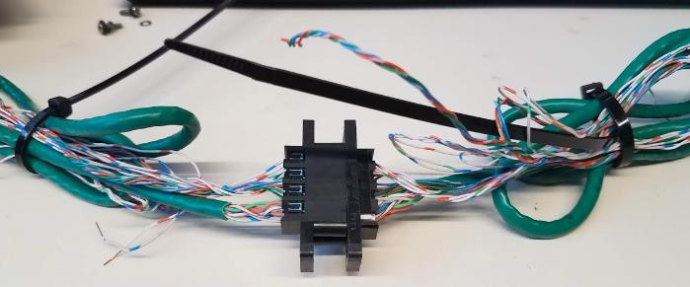
Figure 15: Wiring Harness

Test Procedure

The vibration test had three primary components, including tests to check for mechanical, electrical, and fluidic failure. As such, the test procedure can be split into three sections: mechanical test, electrical test, and fluidic test.

The vibration fixtures were specifically designed such that there was ~2 mm gap on either end of the connector. This gap existed to ensure that if the locking mechanism on the connector broke, the connector halves would separate, thus indicating failure of the locking mechanism. Thus, the fixture provided enough support to hold the connector in place during the test while providing enough space for the connector to exhibit failure. The fixture design was validated by demonstrating that, when depressing the button on the connector while the connector was in the fixture, the two halves of the connector would separate, but each half would still remain securely restrained within the fixture.

Mechanical Test Procedure

The criteria of success for the mechanical test was to ensure that the design could experience vibrations of frequencies ranging from 10 Hz – 1.5 kHz without unlatching or sustaining any damage or mechanical failure. In order to test to this specification, the following procedure was followed.

- Mount bottom half of 3D printed test fixture to the electrodynamic shaker table using the mounting screws included with shaker (Figure 16)
- Set connector inside fixture
- Place top half of 3D printed fixture on top of connector, and tighten fixture down with accompanying screws
- Mount accelerometer onto top face of the connector (Figure 17)

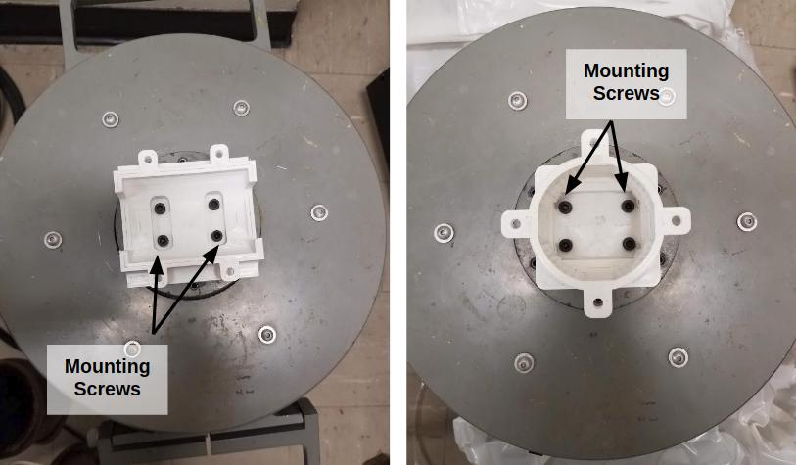
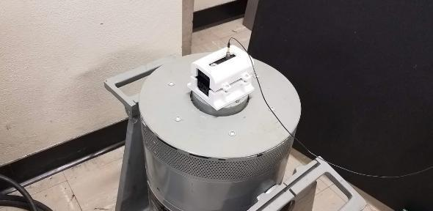
Figure 16: Mounting Fixtures to Shaker Table

Figure 17: Pre-Test Setup
  - Using the accompanying software, select “white noise” test

  - Set frequency spectrum to range from 10 Hz – 1.5 kHz

  - Set test to run for a duration of 60 seconds

  - Using the control console, run the test

  - Once test is completed, disassemble mount, and check for mechanical damage or failure

  - Check the plot generated on the oscilloscope to see the response recorded by the accelerometer. Note any peaks corresponding to resonant frequencies, and record for later reference.

  - Repeat the procedure until all three orientations have been tested. The first two tests can be performed in the horizontal fixture, rotating the fixture 90⁰ between tests 1 and 2. For the third test (vertical orientation), the vertical fixture is used instead of the horizontal fixture

Electrical Test Procedure

The criteria of success for the electrical test was to ensure that the electrical contacts within the connector remain in contact under operational vibration conditions (10 Hz – 1.5 kHz). The procedure used to test this criterion is outlined below. However, it must be noted that the procedure followed for testing the Entropic connector (labeled “a” below) differed slightly from the procedure followed for testing the other two connectors (labeled “b” below).

- Attach wiring harness to the connector using the screws provided

- Set connector inside fixture

- Place top half of 3D printed fixture on top of connector, and tighten fixture down with accompanying screws

- a Connect one end of the ethernet cables to the Raspberry Pi, and the other end to the Linux laptop’s ethernet port. Turn both the Raspberry Pi and the laptop on, and open a terminal in the Linux laptop (Figure 18, right)

- Create 3-6 LED circuits using the loose wire connections, and ensure LED’s are illuminated (Figure 18, left)
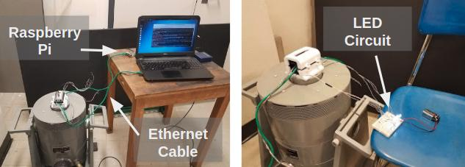
Figure 18: Pre-Test Setup

- Using the accompanying software, select “white noise” test

- Set frequency spectrum to range from 10 Hz – 1.5 kHz

- Set test to run for a duration of 60 seconds

- Using the control console, run the test

- While the test is running, do the following:

- Run the “dumpcap” command in the Linux laptop terminal, and set the duration option to 60 seconds. Once the task has completed, check to see how many packages were dropped.

    - Maintain visual contact with the LED circuit, record whether or not the LED’s remain on for the duration of the test

  - Repeat the procedure until all three orientations have been tested. The first two tests can be performed in the horizontal fixture, rotating the fixture 90⁰ between tests 1 and 2. For the third test (vertical orientation), the vertical fixture is used instead of the horizontal fixture

Fluidic Test Procedure

The criteria of success for the fluidic test was to ensure that the fluid system could remain operational under expected vibration conditions (10 Hz – 1.5 kHz) without any leakage inside the connector. In order to test this criterion, the following procedure was followed.

- Place protective plastic around equipment

- Attach ¼ inch fluid tubing to each fluid line fitting in each half of the connector

- Set connector inside fixture (Figure 19)

- Place top half of 3D printed fixture on top of connector, and tighten fixture down with accompanying screws

- Connect one of the four fluid lines to a DC motor pump, and submerge the two ends of the fluid circuit into a bucket of water

- Apply voltage to the DC motor pump using a power supply

- Using the accompanying software, select “white noise” test

- Set frequency spectrum to range from 10 Hz – 1.5 kHz

- Set test to run for a duration of 60 seconds

- Using the control console, run the test

- While the test is running, maintain visual contact with the fluid lines and ensure no leakage is occurring

- Once the test is completed, disassemble mount, and check connector and fixture to for any water that may have leaked

- Disconnect the fluid line from the pump, and connect the fluid line that is diagonal from the first line tested

- Repeat test with the new fluid line connected

- Repeat this procedure for the vertical orientation. This requires replacing the horizontal fixture with the vertical fixture on the electrodynamic shaker
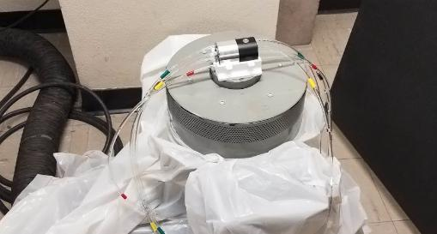
Figure 19: Preparing Fluid Test Setup

Vibration Mechanical, Electrical and Fluid Test Data Sheet

The following data sheet will be used for summarizing test results.

Connector Vibration Mechanical, Electrical and Fluid Test Data Sheet
Date:_________________________________
Person Running Tests ___________________________________________________________
Location:______________________________________________________________________

Test Performed | Connector | Test Spec. | Pass/Fail
 | Entropic | 10 Hz – 1.5 kHz
Mechanical | 2nd Party | 10 Hz – 1.5 kHz
 | Hybrid | 10 Hz – 1.5 kHz
 | Entropic | 10 Hz – 1.5 kHz
Electrical | 2nd Party | 10 Hz – 1.5 kHz
 | Hybrid | 10 Hz – 1.5 kHz
 | Entropic | 10 Hz – 1.5 kHz
Fluid | 2nd Party | 10 Hz – 1.5 kHz
 | Hybrid | 10 Hz – 1.5 kHz

Additional Comments:

If failure occurs, troubleshoot and record causes here. Add additional sheets if necessary.

Signature of Recorder: _______________________ Date ________________________

Connector Tensile (Bend Test)
This test procedure describes the axial load test which was performed on the Advanced Modular Manikin connector designed by Entropic Engineering. This procedure is divided into three main components: test for mechanical failure, test for electrical continuity, and test for fluid system operability.

Purpose of the Test
The purpose of this test procedure is to verify the connector does not separate, electrical contacts do not open and fluid connectors do not leak when the connectors are subjected to axial loads and cause bending. (Tensile loads).

Description of the Test Article
Refer to Section 3.2.5.1.2

Test Requirements

The criteria of success for each of these tests have been defined as follows.

MECHANICAL: The connector is able to withstand an axial load of at least 300 lbs.

ELECTRICAL: The electrical contacts inside the connector remain in contact under an axial load of 200 lbs.

FLUID: Fluid can be run through the connector’s fluid lines without leakage while the connector sustains an axial load of 200 lbs.

Test Equipment

An MTS load frame was used as the main test apparatus for all axial load tests. The load frame is held in the UMN CSE Anderson Student Shop, on the third floor of the UMN Civil Engineering building. Figure 20 depicts the test apparatus.
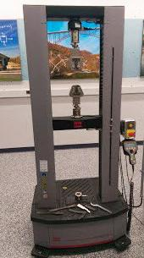
Figure 20: MTS Load Frame

Connector Test Fixture

A fixture was designed and 3D printed for the purpose of mounting the connector onto the MTS load frame. The fixture was designed to fit into the shaft of the MTS machine which would ordinarily hold the MTS machine jaws. Figure 21 depicts the 3D model of the test fixture, as well as the physical fixture.
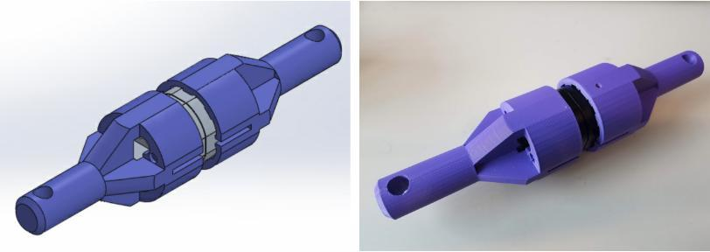

Figure 21: 3D Printed Test Fixture
Electrical Test Equipment

For all electrical tests, a wiring harness provided by Entropic Engineering was used. The wiring harness provides electrical access via an Ethernet cable, as well as via several loose wires, as shown in Figure 22. For the purpose of testing the electrical connection under the specified loading conditions, the loose wires were used to make a simple LED circuit, as can be seen in Figure 26.

Figure 22: Wiring Harness

FLUID SYSTEM TEST EQUIPMENT

For the purpose of fluid testing, 1/4 inch tubing was used to pump water through the fluidic connection within the connector. A DC motor pump was used to pump water through the fluidic system at a pressure of approximately (10-13 PSI).

Test Procedure

The axial load test had three primary components, including tests to check for mechanical, electrical, and fluidic failure. As such, the test procedure can be split into three sections: mechanical test, electrical test, and fluidic test.

MECHANICAL TEST

The criteria of success for the mechanical test was to ensure that the design could sustain a load of 300 lbs. without sustaining any damage or mechanical failure. In order to test to this specification, the following procedure was followed.

- Load each half of connector into 3D printed fixture, and attach to fixture using M3 screws (Figure 23).
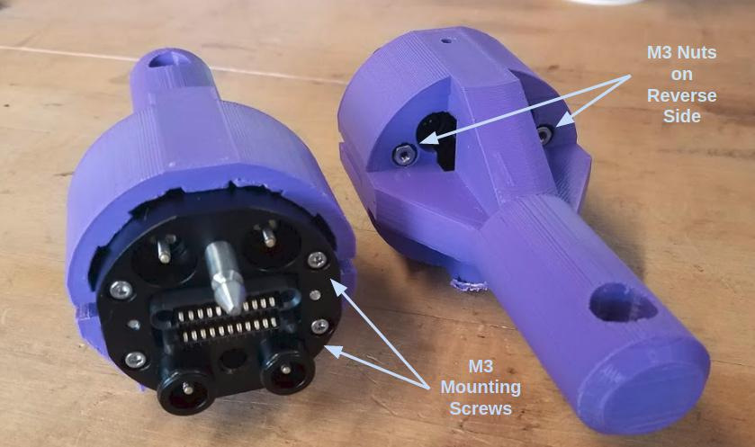
Figure 23: Connecter Mounted to Fixture

- Load fixture into MTS machine and secure in place using the metal pins ordinarily used for securing the MTS jaws in place (Figure 24)
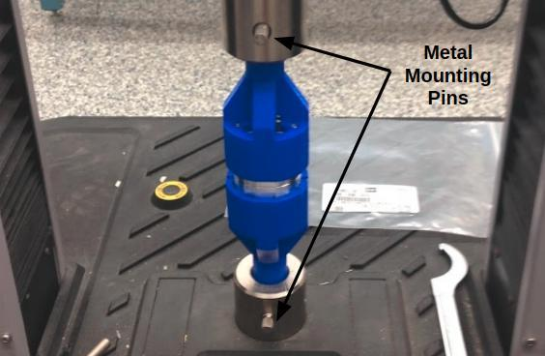
Figure 24: Mounting Fixture

- Using the MTS Test Suite software, open the sample tensile test template

- Click the “run" icon at the top of the software GUI, and open the live force-vs-time plot

- Once the load has exceeded the necessary force limit, click the “stop" icon, and return to zero loading conditions

- Remove fixture from MTS load frame, separate the two connector halves, and inspect for damage

- Repeat steps 2-6 twice (3 tests total)

ELECTRICAL TEST

The criteria of success for the electrical test was to ensure that the electrical contacts within the connector remain in contact under operational loading conditions (200 lbs). In order to test this criteria, the following procedure was followed.

- Attach wiring harness to the connector using the screws provided

- Load each half of connector into 3D printed fixture, threading the wiring harness ether-net cables and loose wires through the provided holes (figure 3.3)

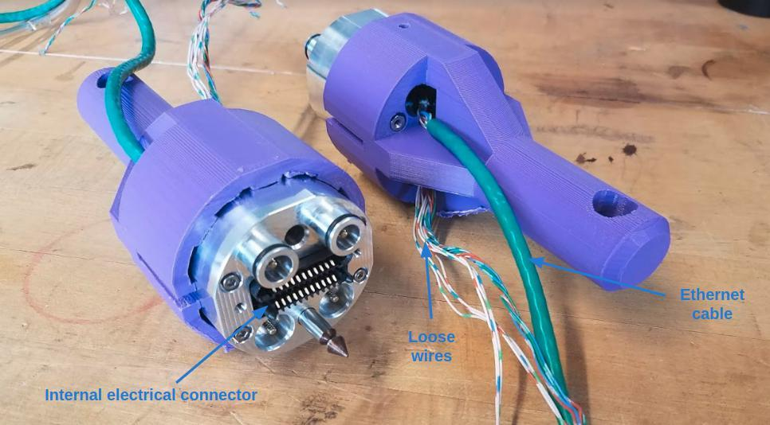
Figure 25: Electrical Connector Mount

- Load fixture into MTS machine and secure in place using the metal pins ordinarily used for securing the MTS jaws in place

- Create 4-6 LED circuits using the loose wire connections, and ensure LED’s are illuminated (Figure 26)
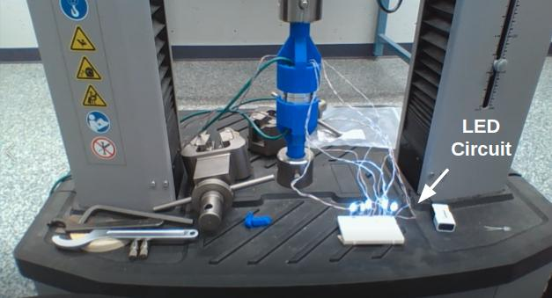
Figure 26: Electrical Test Setup

  - Using the MTS Test Suite software, open the sample tensile test template

  - Click the “run" icon at the top of the software GUI, and open the live force-vs-time plot

  - As the load is being applied, maintain visual contact with the LED circuit to ensure the LED’s remain lit

  - Once the load has reached the necessary force limit, click the “pause" icon. Hold the loading conditions for approximately ten seconds while checking to ensure that the LED’s remain lit

  - After 10 seconds have passed, click the “stop" icon, and return to zero loading conditions

FLUIDIC TEST

The criteria of success for the fluidic test was to ensure that the fluid system could remain operational under expected loading conditions (200 lbs.) without any leakage inside the connector. In order to test this criterion, the following procedure was followed.

- Attach 1/4-inch fluid tubing to each fluid line fitting in each half of the connector

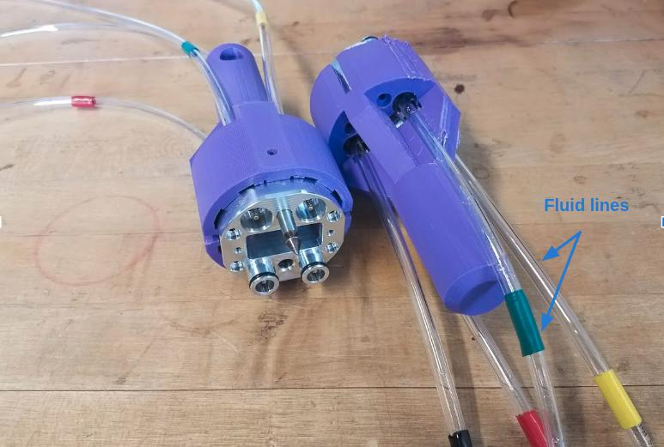
- Load each half of connector into 3D printed fixture, threading the tubing through the provided holes (Figure 27)

Figure 27: Attached Fluid Lines

- Load fixture into MTS machine and secure in place using the metal pins ordinarily used for securing the MTS jaws in place

- Place protective plastic covering around base of MTS load frame

- Connect one of the four fluid lines to a DC motor pump, and submerge the two ends of the fluid circuit into a bucket of water (Figure 28)
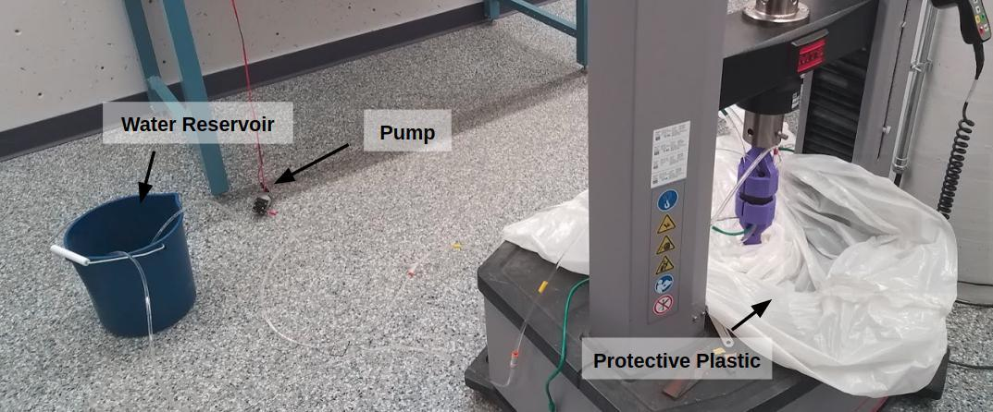
Figure 28: Fluid Test Setup

- Apply voltage to the DC motor pump using a power supply

- Using the MTS Test Suite software, open the sample tensile test template

- Click the “run" icon at the top of the software GUI, and open the live force-vs-time plot

- As the load is being applied, maintain visual contact with fluid system to check for water leakage

- Once the load has reached the necessary force limit, click the “pause" icon. Hold the loading conditions for approximately ten seconds while checking to ensure that fluid system is running without leakage

- After 10 seconds have passed, click the “stop" icon, and return to zero loading conditions

- Remove the ends of the fluid circuit from the bucket of water, allowing air to purge the system

- Repeat steps 4-11 until all four fluid lines have been tested

Test Data Sheet

The following data sheet will be used for summarizing test results.

Connector Load and Bending Data Sheet
Date:_________________________________
Person Running Tests ___________________________________________________________
Location:______________________________________________________________________

Test Performed | Sub-Test | Connector | Test Spec. | Pass/Fail
 |  | Entropic | 300 lbs
 | Mechanical | 2nd Party | 300 lbs
 |  | Hybrid | 300 lbs
 |  | Entropic | 200 lbs
Axial Load | Electrical | 2nd Party | 200 lbs
 |  | Hybrid | 200 lbs
 |  | Entropic | 200 lbs
 | Fluid | 2nd Party | 200 lbs
 |  | Hybrid | 200 lbs
 |  | Entropic | 100 ft-lbs
 | Mechanical | 2nd Party | 100 ft-lbs
 |  | Hybrid | 100 ft-lbs
 |  | Entropic | 100 ft-lbs
Bending | Electrical | 2nd Party | 100 ft-lbs
 |  | Hybrid | 100 ft-lbs
 |  | Entropic | 100 ft-lbs
 | Fluid | 2nd Party | 100 ft-lbs
 |  | Hybrid | 100 ft-lbs
Additional Comments:

If failure occurs, troubleshoot and record causes here. Add additional sheets if necessary.

Signature of Recorder: _______________________ Date ________________________

Blood Simulant Testing
This procedure describes the methods to testing the blood simulants.

Purpose of the Test
The purpose of the test is measure various blood simulants properties and determine the best ones to use in the manikin.

3.2.5.3.2 Description of the Test Article
Three different blood simulants are to be analyzed and compared for operation in the AMM Manikin. The Blood simulates are shown in Figure 29. The blood simulants used were: (1) “stage blood” formula by New Rule FX, (2) a SimuLab arterial blood simulant, and (3) a blood simulant by Laerdal.

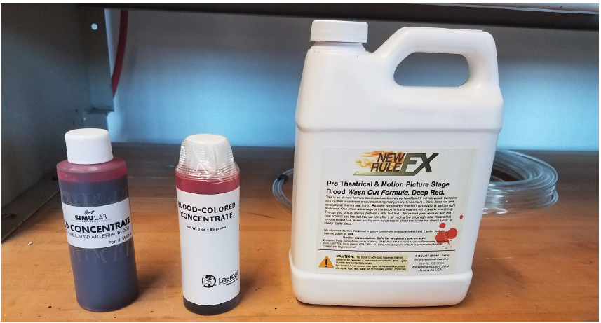
Figure 29: Blood Simulants

3.2.5.3.3 Test Requirements
The test requirements are to compare the properties of blood simulants. These include:
- Viscosity
- Shelf Life
- Cost per ounce
- Cleaning Solution
- Cleaning Fluid Blood
- Manufacturer Info

3.2.5.3.4 Test Equipment

The test setup is shown in Figure 30. The major components are: solenoid valve, tubing and pump and check valve.
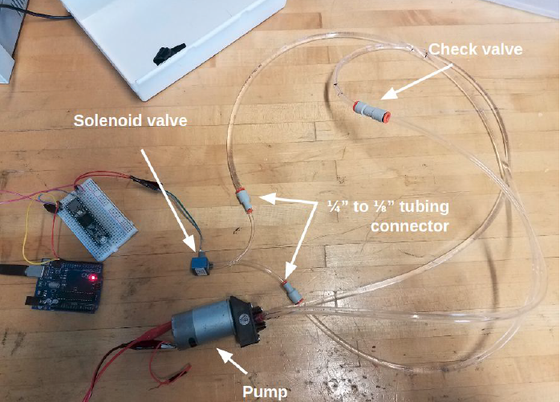
Figure 30: Blood Simulate Test Setup

3.2.5.3.5 Test Procedure
- Run the blood through the system and the flow and effect on the tubing, solenoid valve, pump and check valve. Check for clogging and flow properties. The individual valves, pump etc. are not part of the standard. We used the items that were in the demonstration system to run the tests.
- Clean the lines out and determine the amount of flushing required
- Measure the viscosity for each fluid was measured using a Ford 4 viscosity cup at room temperature.
- Store fluids in an airtight container for 17 days. After 17 days had elapsed, the Ford cup viscosity test was repeated for each fluid
- Note any noticeable changes in appearance or texture for any of the fluids.

3.2.5.3.6 Test Data SheetBlood Simulant Data Sheet
Date:_________________________________
Person Running Tests ___________________________________________________________
Location:______________________________________________________________________

 | Stage Blood | SimuLab Blood | Laerdal Blood | Water | Real Blood
Viscosity after 17 days
Shelf Life
Change in color of blood
Clogging in system
Cost /Ounce
Cleaning Solution
Amount of clean fluid needed
Manufacturer
Info

Additional Comments:

If failure occurs, troubleshoot and record causes here. Add additional sheets if necessary.

Signature of Recorder: _______________________ Date ________________________

