CDRL A003
Commercial Drawings and
Associated Lists for
Advanced Modular Manikin Project
Phase II Program
Contract # W81XWH-14-C-0101
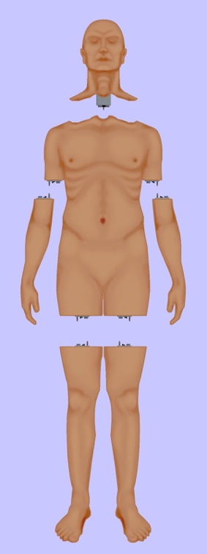

Date: February 3, 2020
Revision: Rev - 2
Unclassified

PRINCIPAL INVESTIGATOR: ROBERT M. SWEET, MD, FACS
REGENTS OF THE UNIVERSITY OF MINNESOTA
OFFICE OF SPONSORED PROJECTS
200 OAK ST SE
MINNEAPOLIS MN 55455-2009

This document is unclassified, and APPROVED FOR PUBLIC RELEASE; DISTRIBUTION IS UNLIMITED

Revision History

Date of Revision | Description of Changes
24 Dec 2018 | Original Draft Submitted
25 Sep 2019 | Document Submitted
03 Feb 2020 | Distribution Updated

Distribution Statement

This document was created under contract funding W81XWH-14-C-0101 from:

DEPARTMENT OF THE ARMY
US ARMY MEDICAL RESEARCH ACQUISITION ACTIVITY
820 CHANDLER STREET
FORT DETRICK MD 21701-5014

It contains no proprietary information, trade secrets, copy righted material or classified information. This document is unclassified, and APPROVED FOR PUBLIC RELEASE; DISTRIBUTION IS UNLIMITED

Table of Contents
1. Scope 4
1.1. Identification 4
1.2. System Overview 5
1.3. Document Overview 5
2. Referenced Documents 6
2.1 Industry Documents 6
3. Document Deliverables 6
3.1 Drawing Reference Document 6
3.2 Commercial Item Drawings 9

Figure 1: Functional Overview of AMM Platform 4

Scope
This document defines the standards for 1.0 release of the Advanced Modular Manikin (AMM) platform and its formal deliverables. The formal deliverables consist of the platform specification, an open source* Reference Implementation (RI) of the Computer Software Configuration Items (CSCIs), a reference implementation of the Universal Segment Connector (USC) and other hardware defined by the Hardware Configuration Items (HWCIs), the data models that ensure interoperability between the core and modules, and the documents that describe their design, operation, and extensibility through the addition of AMM Modules. Modules are defined as independent building blocks that provide incremental capabilities to the core or provide training opportunities for different medical and trauma related conditions. The focus of this specification is on the platform, a much broader definition than a physical manikin, as illustrated in Figure 1, and on how it can be extended by medical simulation developers by adding:

- Modules that provide incremental capabilities to the core, including authoring tools, after action review tools, different physiology engines.
- Modules that add training opportunities, including IV/IO arms, intubation heads, laparotomy abdomens, virtual stethoscopes. These can be physical, virtual, or hybrid part task trainers.

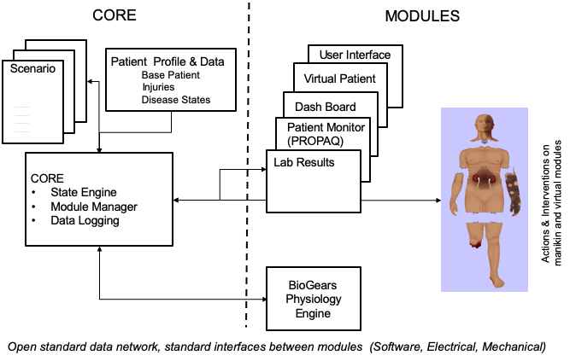
Figure 1: Functional Overview of AMM Platform

Identification
This Advanced Modular Manikin (AMM) Commercial Drawings and Associated Lists CDRL Item A003 of Contract # W81XWH-14-C-0101, Phase II contains drawings and list of commercial products used in the platform.

This CDRL is formatted to the requirements of Data Item Description Number DI-Sess-81000E as required. This DID is applicable to acquisitions of military systems, equipment, and components. It is intended for acquiring drawings and associated lists for commercial products at the end of the System Development and Demonstration Phase and during subsequent phases of the DoD materiel life cycle.

System Overview
The AMM platform is a modular, distributed, interoperable system that enables physical, virtual, augmented and hybrid modules to work together as an integrated system. The traditional “core”, i.e. computer and state engine, can be in any one of the traditional manikin segments, i.e. torso, leg etc., or external to the human form, as it would be if the system is only running a virtual instance or if the targeted scenario, i.e. patient case, does not allow them to be internal due to the set of interventions that have to be performed on the body. The platform is architected as a system of systems that allow modules to function either as part of an integrated, whole body simulation or as autonomous part task trainers.

The published AMM standards guide the development and integration of AMM compatible modules. The reference designs provided for the final demo including electronics and central supplies were created to demonstrate the operation of the platform and are published as a developer’s tool kit with sources to acquire them from.

The developers of the platform have agreed to publish the AMM platform under the following open source licensing option:

* Creative Commons Attribution 4.0 International (CC BY 4.0) https://creativecommons.org/licenses/by/4.0/deed.ast.
Share — copy and redistribute the material in any medium or format
Adapt — remix, transform, and build upon the material for any purpose, even commercially.
The licensor cannot revoke these freedoms as long as you follow the license terms.

This document does not cover modules that were created under separate funding and by other entities to demonstrate the functionality of the AMM Platform under separate funding and are not part of the Open Source agreement.

Document Overview
CDRL A003 is intended for acquiring drawings and associated lists for commercial products at the end of the System Development and Demonstration Phase and during subsequent phases of the DoD materiel life cycle. The outline and subject matter content are based on DI-SESS-81000E as required by the contract. The DID has been tailored as appropriate. The commercial drawings and associated lists are contractor format.

All drawings and lists included in this document are either required components of the core AMM system that for compliance purposes must be included in the system or components included as part of a reference implementation to demonstrate the functionality of AMM platform. For instance, components of the fluidics system may not be required for modules being developed for the platform as long as the connectors are AMM compatible. Contact the Technical Director <dhananel@uw.edu> for further information.

The drawing reference document (Dwg. No. 100100) includes the system schematic design documents and an indented bill of materials for the mechanical assembly. Drawing reference items with 6-digit numerical part numbers are contractor assemblies and manufactured parts. All commercial items are referenced with drawing number indicating OEM in short form and OEM part number. Commercial items are further documented in this document. Contractor assemblies are documented in CDRL A004.

Referenced Documents

Industry Documents
Doc. No. | Title
MLL-STD-31000 | Technical Data Package
W81XWH-14-C-0101 | AMM Phase II Contract, DOD
DI-SESS-81000E | Data Item Description

Document Deliverables

Drawing Reference Document
Starting on following page.
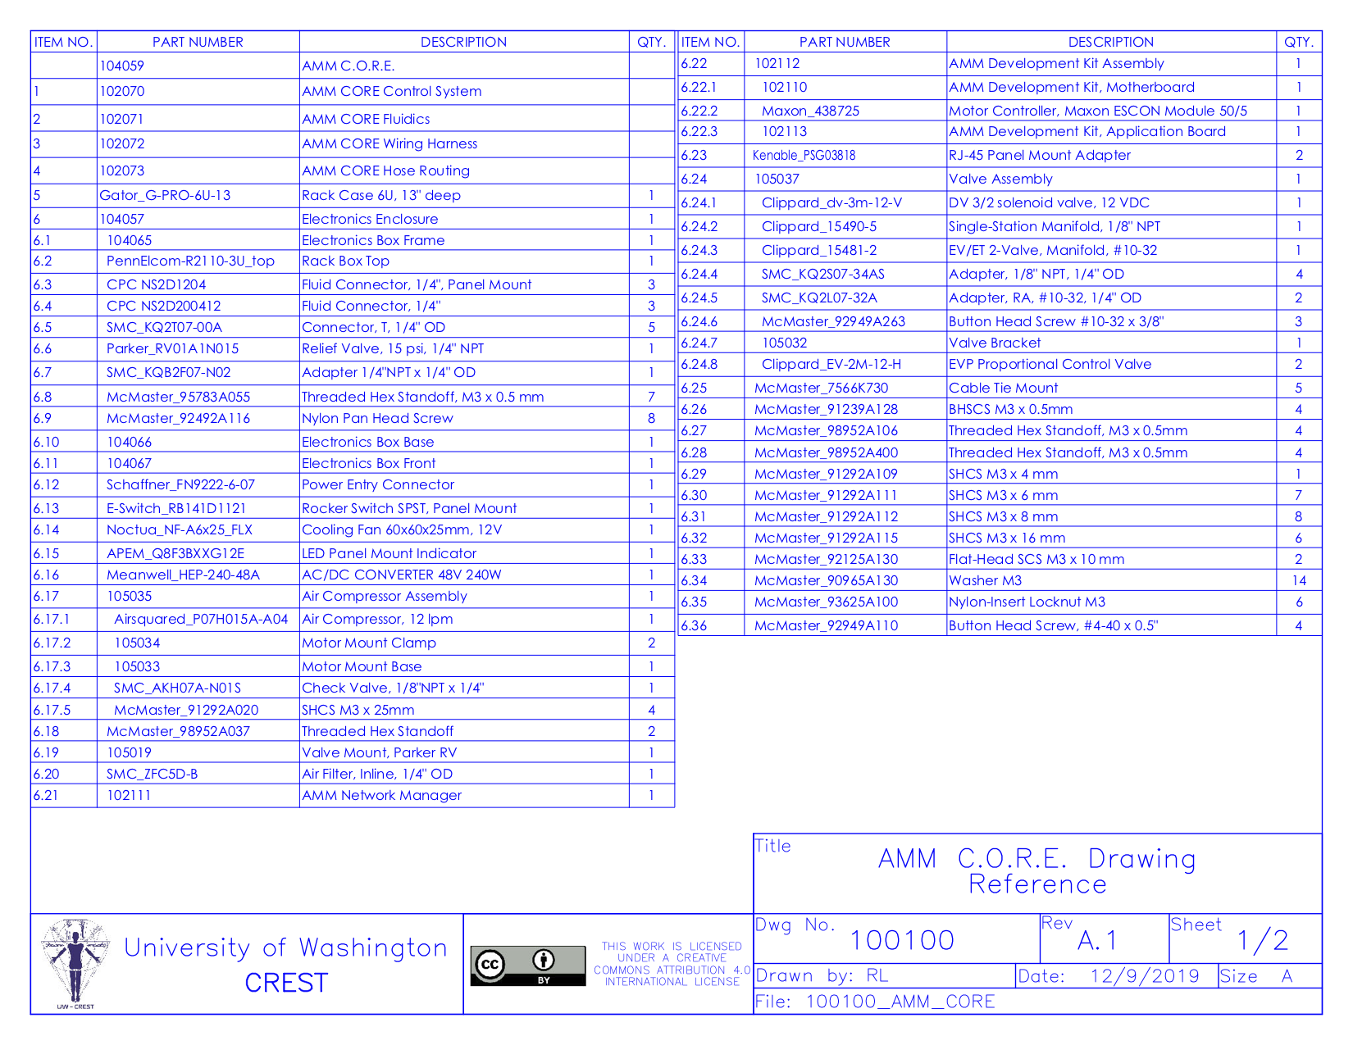
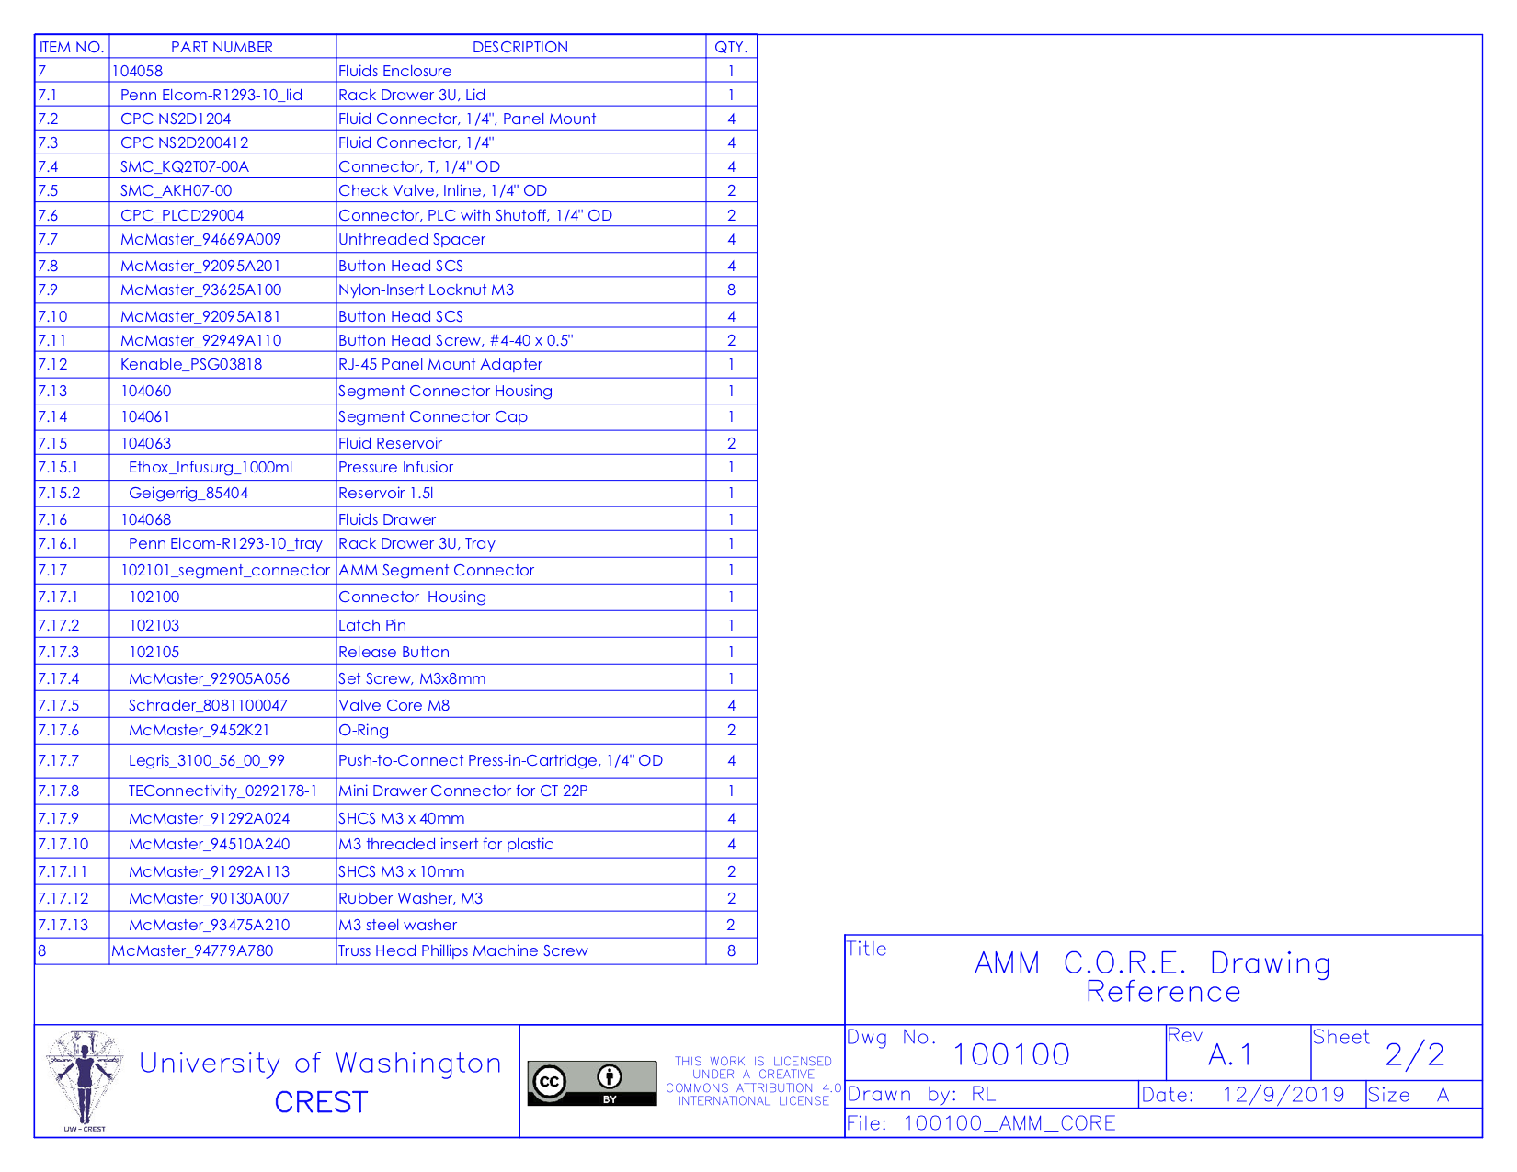

Commercial Item Drawings
Drawings are ordered alpha-numerically by drawing number, starting on following page.
