CDRL A007
Interface Design Description (IDD) for Advanced Modular Manikin Project
Phase II Program
Contract # W81XWH-14-C-0101

Date: February 03, 2020
Revision: Rev - 2
Unclassified

PRINCIPAL INVESTIGATOR: ROBERT M. SWEET, MD, FACS
REGENTS OF THE UNIVERSITY OF MINNESOTA
OFFICE OF SPONSORED PROJECTS
200 OAK ST SE
MINNEAPOLIS MN 55455-2009

This document is unclassified, and APPROVED FOR PUBLIC RELEASE; DISTRIBUTION IS UNLIMITED

Revision History

Date of Revision | Description of Changes
21 Apr 2017 | Original Draft Submitted
17 Oct 2017 | Added references to OPB, FMA, MCIS, RTPS; several IDL revisions
25 Jan 2018 | Replaced TBDs in SSS Doc Number, Section 3.2.8 and deleted TBD 3.1.2.9
25 Sep 2019 | Document Submitted
03 Feb 2020 | Distribution Updated

Distribution Statement

This document was created under contract funding W81XWH-14-C-0101 from:

DEPARTMENT OF THE ARMY
US ARMY MEDICAL RESEARCH ACQUISITION ACTIVITY
820 CHANDLER STREET
FORT DETRICK MD 21701-5014

It contains no proprietary information, trade secrets, copyrighted material or classified information. APPROVED FOR PUBLIC RELEASE; DISTRIBUTION IS UNLIMITED

Table of Contents
1 Scope 5
1.1 Identification 6
1.2 System Overview 6
1.3 Document Overview 6
2 Referenced Documents 7
2.1 Industry Documents 7
2.2 Government Documents 8
2.3 Related Contract Documents 8
3 Interface design 9
3.1 Data Interfaces 9
3.1.1 Data Interface identification and diagrams 9
3.1.2 Standard Data Definitions 11
3.1.2.1 Simulation Control 11
3.1.2.2 Diagnostic Logging 13
3.1.2.3 Simulation Data 15
3.1.2.4 Event Records 17
3.1.2.5 Omitted Events 20
3.1.2.6 Event Fragment Protocol 21
3.1.2.7 Physiology Modifications 25
3.1.2.8 Render Modifications 26
3.1.2.9 Learner Performance Assessments 28
3.1.2.10 Configuration data model 29
3.2 Physical Segment Interfaces 34
3.2.1 Segment Definitions 34
3.2.2 Universal Segment Connector 35
3.2.3 Electrical Power Interface Description 36
3.2.4 Fluid Interface Description 37
3.2.5 Segment Geometry Requirements 38
3.3 Human Interfaces 39
3.3.1 Command Line Interface 39
3.3.2 Dashboard 39
3.3.3 Data Logging 39
4 Requirements Traceability 39

Figures
Figure 1: Functional Overview of AMM Platform 5
Figure 2: AMM Processing Architecture Based on DDS Common Data Bus 9
Figure 3: IDL for Simulation Control messages 13
Figure 4: IDL for Log messages 15
Figure 5: IDL for Physiology Data messages 17
Figure 6: IDL for Event Record messages 20
Figure 7: IDL for Omitted Event messages 21
Figure 8: IDL for Event Fragment messages 23
Figure 9: IDL for Fragment Amendment Request messages 25
Figure 10: IDL for Physiology Modification messages 26
Figure 11: IDL for Render Modification messages 27
Figure 12: IDL for Performance Assessment messages 29
Figure 13: IDL for Operational Description messages 31
Figure 14: IDL for Module Configuration messages 32
Figure 15: IDL for Capability Status message 34
Figure 16: AMM Manikin Segments 35
Figure 17: Fluid layout of torso-side USC (Left Leg) 36
Figure 18: Example of an AMM systems showing standard connector for the arms and legs. 36
Figure 19: Potential implementation of segment connector locations. 38
Figure 20: Origin and Flow Down of Test Requirements 40

Tables
Table 1: Electrical Interfaces 37
Table 2: Detailed pinout of electrical connector (TE Connectivity 292178-1) 37
Table 3: Fluid Interfaces 38

Scope
This document defines the standards for 1.0 release of the Advanced Modular Manikin (AMM) platform and its formal deliverables. The formal deliverables consist of the platform specification, an open source* Reference Implementation (RI) of the Computer Software Configuration Items (CSCIs), a reference implementation of the Universal Segment Connector (USC) and other hardware defined by the Hardware Configuration Items (HWCIs), the data models that ensure interoperability between the core and modules, and the documents that describe their design, operation, and extensibility through the addition of AMM Modules. Modules are defined as independent building blocks that provide incremental capabilities to the core or provide training opportunities for different medical and trauma related conditions. The focus of this specification is on the platform, a much broader definition than a physical manikin, as illustrated in Figure 1, and on how it can be extended by medical simulation developers by adding:

- Modules that provide incremental capabilities to the core, including authoring tools, after action review tools, different physiology engines.
- Modules that add training opportunities, including IV/IO arms, intubation heads, laparotomy abdomens, virtual stethoscopes. These can be physical, virtual, or hybrid part task trainers.

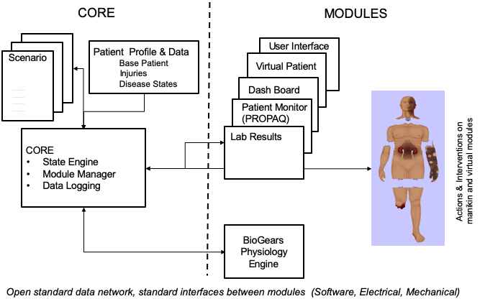

Figure 1: Functional Overview of AMM Platform

Identification
This Advanced Modular Manikin (AMM) Interface Design Document (IDD) CDRL Item A007 of Contract # W81XWH-14-C-0101, Phase II describes the AMM Core Software interface characteristics of the modules, segments, and core components of the AMM architecture.

This CDRL is formatted to the requirements of Data Item Description Number DI-IPSC-81436A.

System Overview
The AMM platform is a modular, distributed, interoperable system that enables physical, virtual, augmented and hybrid modules to work together as an integrated system. The traditional “core”, i.e. computer and state engine, can be in any one of the traditional manikin segments, i.e. torso, leg etc., or external to the human form, as it would be if the system is only running a virtual instance or if the targeted scenario, i.e. patient case, does not allow them to be internal due to the set of interventions that have to be performed on the body. The platform is architected as a system of systems that allow modules to function either as part of an integrated, whole body simulation or as autonomous part task trainers.

The published AMM standards guide the development and integration of AMM compatible modules. The reference designs provided for the final demo including electronics and central supplies were created to demonstrate the operation of the platform and are published as a developer’s tool kit with sources to acquire them from.

The developers of the platform have agreed to publish the AMM platform, including this document under the following open source licensing option:

* Creative Commons Attribution 4.0 International (CC BY 4.0) https://creativecommons.org/licenses/by/4.0/deed.ast.
Share — copy and redistribute the material in any medium or format
Adapt — remix, transform, and build upon the material for any purpose, even commercially.
The licensor cannot revoke these freedoms as long as you follow the license terms.

This document does not cover modules that were created under separate funding and by other entities to demonstrate the functionality of the AMM Platform under separate funding and are not part of the Open Source agreement.

Document Overview
This document is the AMM Interface Design Document (IDD) CDRL A007 of Contract # W81XWH-14-C-0101, Phase II. The outline and subject matter content are based on DID DI-IPSC-81436A, as required by the contract. The DID has been tailored to describe an open platform and open-source reference software that can be run on either the AMM reference computer hardware, or other user-selected computer systems. This document is unclassified and contains no proprietary information, trade secrets, copyrighted material or classified information and is available for unlimited distribution.

The Interface Design Document (IDD) describes the interface standards that enable the interoperability of AMM modules, segments, and core components that may be provided by different organizations; and commonality of human interfaces for operating AMM systems that may be differently configured.
The AMM interfaces are designed to support several types of modular interoperability and commonality of operation, including:
- Functional Modularity. AMM Modules provide simulation and support capabilities. They communicate with each other by publishing and subscribing to AMM messages distributed via the AMM Common Data Bus. These messages shall comply with a standard data model and protocol defined in this IDD.
- Physical Segment Modularity. AMM Segments provide a physical manikin interface to the simulated patient. In order to interoperate, these segments must share a common attachment design, must provide power and fluid at specified levels using common connector designs, and must comply with geometry specifications that assure the segments connect without gaps or overlaps.
- User Interface Commonality. AMM Systems must enable the operator to start, stop, control, and diagnose simulations using standardized User Interfaces.

Referenced Documents

Industry Documents
Doc. No. | Title
OMG  formal/ 2015-04-10 | Data Distribution Service version 1.4
OMG  formal/ 2019-04-03 | The Real-time Publish-Subscribe Protocol (RTPS) DDS Interoperability Wire Protocol Specification version 2.3
RFC 768 | User Datagram Protocol
RFC 791 | Internet Protocol
RFC54 24 | The Syslog Protocol
802.11 | IEEE Standard for Information technology — Telecommunications and information exchange between systems Local and metropolitan area networks — Part 11: Wireless LAN Medium Access Control (MAC) and Physical Layer (PHY) Specifications [WiFi]
FMA | Rosse, C., and Mjino, J. The Foundational Model of Anatomy Ontology, accessed from sigpubs.biostr.washington.edu/archive/00000204/01/FMA_Chapter_final.pdf
ICD-10 | International Statistical Classification of Diseases and Related Health Problems, accessed from http://www.who.int/classifications/icd/en/
MCIS | Combat injury coding: A review and reconfiguration, accessed from  www.google.com/url?sa=t&rct=j&q=&esrc=s&source=web&cd=3&cad=rja&uact=8&ved=0ahUKEwjf0 oS409nWAhUDQCYKHTpVCCkQFgg2MAI&url=http%3A%2F%2Fwww.dtic.mil%2Fget-trdoc%2Fpdf%3FAD%3DADA614654&usg=AOvVaw0jU1KoujA_Ti-4ENpzCalu
OPB | Ontology of Physics for Biology, accessed from  sig.biostr.washington.edu/projects/biosim/opb-intro.html

Government Documents
Document Number | Title
#W81XWH-14-C-0101 | AMM Phase II Contract, DOD
DI-IPSC-81436A | Data Item Description: Interface Design Specification
Data Item No. A007 | CDRL Data Item: Interface Design Description (IDD)

Related Contract Documents
Document Number | Title
AMM_SSS_A008 | System/Subsystem Specification (SSS) for Advanced Modular Manikin
AMM_DWG_A004 | Product Drawings/Models and Associated Lists

Interface design
The system interfaces are documented in three sections, data, physical and user interface definitions.

Data Interfaces

Data Interface identification and diagrams
Figure 2 shows the overall AMM data architecture. This architecture provides for:
- A Common Data Bus, based on the Data Distribution Services (DDS) standard, for communication between manikin modules, virtual patients, virtual and blended reality simulations, simulated medical equipment, physiology models, user interfaces, and performance assessment.
- Core software services, including Simulation Manager, Module Manager, and Physiology Manager.
- Standardized requirements for module configuration and communication.
- Physical mechanical, power, fluid, and data connectors between the torso and the head, arms, and legs.
- Power, network and fluid distribution and management among physical modules.
- Standard male and female patient anatomy and physiology and its digital representation.
- Standard representations of scenarios in support of authoring tools that should be developed.
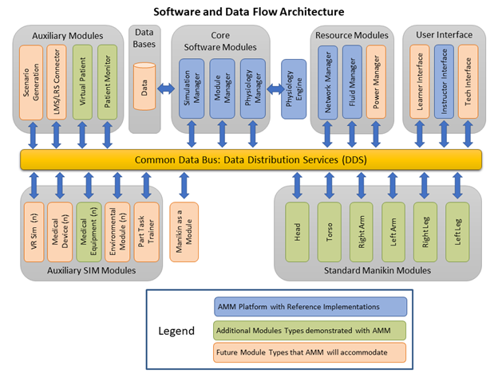
Figure 2: AMM Processing Architecture Based on DDS Common Data Bus

In order to present a typical use case of the AMM Architecture, three types of components are shown with color coding:
- AMM Platform Core, Resource, and User Interface modules (in blue) provide required services. Open Source Reference Implementations are included for each of these modules. The Computer Software Configuration Items (CSCIs) for these modules are further described in Section 4.1 of this document. Note that, although a Reference Implementation is provided for each CSCI, it is not necessary to use this implementation to be AMM compatible. AMM adopters are free to develop modules or core components from scratch or to derive them from the Reference Implementations, under the Creative Commons 4.0 License, with only the requirement to provide appropriate attribution to their authorship. Compliance is assured through adherence to the data models.
- Additional Module Types that have been demonstrated as part of the AMM project (in green) include:
  - Standard Manikin Modules for each of the six AMM segments. Head, Torso, Right/Left Arm, and Right/Left Leg Modules were provided by the University of Washington; with an abdominal skills plug-in provided by ACDET and an ultrasound simulator provided by CAE Healthcare.
  - Auxiliary Modules demonstrated as part of the project included commercial Virtual Patient and Virtual Patient Monitor apps provided by Vcom3D, Inc.
  - Auxiliary Simulation Modules that support interaction with the patient through means other than the physical modular manikin. As part of the AMM project, the following auxiliary simulation modules from Vcom3D were demonstrated: Virtual Infusion Pump, Virtual Ventilator, Virtual Urine Gauge, and Virtual Labs.
These non-platform modules are commercial products or are technology proprietary to the individual vendors and are not provided as part of the reference implementation.
- Future Module Types also fall into the categories of Core, Resource, User Interface, Auxiliary, and Auxiliary Simulation modules:
  - Future Auxiliary Modules that have been anticipated as part of the AMM Architecture include Scenario Generation and Learning Management System (LMS) or Learning Reference Store (LRS) Interface:
    - Currently, AMM Scenarios are created by configuring modules and loading the desired initial Medical Treatment Environment, Ambient Environment, and Patient Physiological State. A future Scenario Generation capability would author a Scenario File that includes this data.
    - An Assessment data type has been defined to support recording specified events and potentially creating corresponding Experiential Application Programmer’s Interface (xAPI)
statements.
  - Future Auxiliary
Simulation Modules that have been anticipated include:
    - Virtual Reality (VR) or Augmented Reality (AR).
    - Virtual Medical Devices, such as an instrumented tourniquet, blood pressure cuff, or syringe.
    - Environment Modules that might simulate the changing ambient temperatures, gas pressures, or humidity of a Point of Injury or Medical Treatment Facility.
    - Part Task Trainers (PTTs) that might simulate a specific portion of the human anatomy.
    - A “Manikin as a Module” that uses the AMM data architecture but does not implement segmentation of the manikin into segments.
Although these Future Model Types have not yet been demonstrated, the AMM Architecture is designed to support them in the same way that it supports standard, segmented manikins.

Data Protocols
Advanced Modular Manikin (AMM) shall use Data Distribution Service Interoperability Real-Time Publish-Subscribe (DDSI-RTPS) wire protocol, version 2.3, for communication among all AMM modules. RTPS uses UDP (RFC 768) over IP (RFC791) as its transport protocol. AMM Torso Modules shall provide IP connectivity via Ethernet or WiFi (802.11).

Detailed information regarding the selection of DDS is provided in CDRL A001 section 4.2.1.

Standard Data Definitions
Concepts and ideas underlying the data definitions below are detailed in CDRL A001, sections 5.1 and 5.2. A brief overview is given below, as well as the technical data structure as expressed in the Interface Definition Language (IDL).

Simulation Control
These messages are used to control the state of the simulation. All modules must subscribe to this Topic and behave appropriately in order for the simulation to function correctly. Control of the simulation has been distilled down to four explicit commands: RUN, HALT, RESET, and SAVE. Further 'load scenario' control functionality is implicitly provided by publishing to the ModuleConfiguration Topic, as described further in the Configuration Data Model, section 3.1.2.10. While the names of the Simulation Controls are designed to be as clear as possible, further detailed descriptions of required Module behavior are provided described below.
RUN
The RUN control indicates that the simulation shall begin or resume, if currently paused. Prior to the RUN control, Modules should not simulate any patient action or movement, but may render systemic or initial/current patient (or environmental) state.

HALT
The HALT control indicates that the simulation shall cease progressing in time, freezing scenario state, including patient & environmental state. Modules shall maintain this state until further control is received.
Modules shall also enter this state after receiving updated Configuration, via the ModuleConfiguration Topic.
RESET
The RESET control indicates that simulation of a given scenario has completely ceased and all Modules shall reset their state to default, including resetting their stored educational_encounter value to null. Modules shall HALT immediately after resetting.
SAVE
The SAVE control indicates that Modules shall publish their current configuration and state data to the appropriateModuleConfiguration topic. This configuration may then be loaded at a later time to ‘reload’ a given scenario from saved state. Even if a Module has no internal state to save, it shall update the timestamp field of the appropriateModuleConfiguration topic to indicate compliance with this control.
SimulationControl Topic Fields
timestamp
Real-world timestamp of when the SimulationControl was issued, in milliseconds since UTC Unix epoch.
type
One of: RUN, HALT, RESET, or SAVE.
educational_encounter
Generated and assigned by the Module Manager (or equivalent) when a Scenario is loaded. This value is used to uniquely identify the instance of a Scenario being run.
This field is used as a DDS Topic Key.

enum ControlType {
RUN
,HALT
,RESET
,SAVE
};
struct SimulationControl
/** QoS:
* Reliability: Reliable
* Durability: Transient Local
* Liveliness: Automatic, 1 second lease
* Partition: AMM
*/
{
unsigned long long timestamp;
ControlType type;
@key UUID educational_encounter;
};
Figure 3: IDL for Simulation Control messages

Diagnostic Logging
Modules may publish logging messages during operation which may be collected and presented to end users or saved for later review. Log messages should not be used to generate alerts or notifications for the main manikin UI. Capability Status(es) are the correct source for these UI alerts, which should be generated by the Core Software (Module Manager in the reference implementation). However, additional interface (e.g. technician’s view) may wish to leverage logging data directly.
For consistency, AMM defines six log levels, with specific meanings and behavior expectations attached. They are listed here from 'most' to 'least' severe:
FATAL
This indicates the Module must cease normal operations and will shut down, or enter a non-recoverable error state. Modules publishing FATAL log messages shall also publish Capability Status updates of INOPERATIVE as appropriate.
ERROR
Error messages the Module cannot operate as expected, but may be able to recover. If the cause of the Error messages also causes a change in Module functionality, the Module shall update its Capability Statuses appropriately, usually to INOPERATIVE.
ERROR message publication frequency shall be limited to approximately 1 Hz.
WARN
Warnings usually caused by a Module receiving unexpected data or entering an undesired state, but still able to function. If the warning requires time-critical action to avoid a loss of functionality, the Module shall also update the appropriate Capability Status value(s) to EXIGENT.
INFO
These are informational messages that do not indicate any problems but provide additional insight into Module functionality. These are usually messages about changes in connectivity, Module operation, sensing user actions, etc.
INFO message publication frequency shall be limited to approximately 1 Hz.
DEBUG
These messages shall be disabled during 'normal' Module operation. Commercial/Production Modules shall not publish DEBUG messages unless specifically enabled via configuration value.
DEBUG messages, if specifically enabled via configuration, may be published more frequently than 1 Hz, but Module developers should take care not to flood the network. A limit of approximately 10 Hz is generally recommended.
TRACE
Trace messages are included in the AMM standard only for Module developer convenience. Commercial/Production Modules shall never publish TRACE level messages.
Log Topic Fields
timestamp
Real-world timestamp of the Log message, in milliseconds since UTC Unix epoch.
module_id
Generated by the Module and shall be unique per module instance. Used to uniquely identify Module in AMM system.
This field is used as a DDS Topic Key.
level
One of FATAL, ERROR, WARN, INFO, DEBUG, or TRACE. See above for usage details.
message
The content of the Log message, usually a short phrase or sentence
enum LogLevel {
FATAL
,ERROR
,WARN
,INFO
,DEBUG
,TRACE
};
struct Log
/** QoS:
* Reliability: Reliable
* Durability: Transient Local
* Partition: AMM
*/
{
unsigned long long timestamp;
@Key UUID module_id;
LogLevel level;
string message;
};
Figure 4: IDL for Log messages

Simulation Data
AMM version 1 relies on the BioGears Common Data Model (CDM) for simulation data. Data element names are the same as those in the BioGears CDM.
BioGears data can be accessed by a module using two different modes: low frequency Physiology Values and high frequency Physiology Waveforms. Physiology Values are sent on a best-effort basis, and are not necessarily sent for every BioGears frame. Physiology Waveforms are delivered reliably and are sent for every BioGears frame. Both Physiology Values and Waveforms have the same format; their only difference is in their respective Quality of Service (QoS) settings for DDS-RTPS.
PhysiologyValue & PhysiologyWaveform Topic Fields
educational_encounter
Generated and assigned by the Module Manager (or equivalent) when a Scenario is loaded. This value is used to uniquely identify the instance of a Scenario being run.
simulation_time
Value of the simulated clock, in milliseconds since UTC Unix epoch. Because this is tightly coupled to the simulated physiology, the simulated clock must be managed by the physiology engine. When a scenario is loaded, a starting time shall be part of the physiology engine configuration.
timestamp
Real-world timestamp of when Topic value was updated, in milliseconds since UTC Unix epoch.
name
Name of the data element, taken from the BioGears CDM.
This field is used as a DDS Topic Key.
value
The numerical value of the data.
unit
The units for the value.
Environmental Data
For AMM version 1, all environmental data is defined, accessed, and controlled through BioGears, using the same pathways as physiology data.
struct PhysiologyValue
/** QoS:
* Reliability: Best Effort
* Durability: Transient Local
* Ownership: Exclusive
* Ownership Strength: Set via Configuration if on-zero
* Presentation: Access Scope: Instance, Coherent Access: True, Order Access: False
* Liveliness: Automatic, 1 second lease
* Partition: AMM
*/
{
UUID educational_encounter;
long long simulation_frame;
unsigned long long timestamp;
@Key string name; // BioGears node path
string unit;
double value;
};

struct PhysiologyWaveform // Reliable delivery
/** QoS:
* Reliability: Reliable
* Durability: Transient Local
* Ownership: Exclusive
* Ownership Strength: Set via Configuration if non-zero
* Liveliness: Automatic, 1 second lease (Lower if feasible, requires testing)
* Partition: AMM
*/
{
UUID educational_encounter;
long long simulation_frame;
unsigned long long timestamp;
@Key string name; // BioGears node path
string unit;
double value;
};
Figure 5: IDL for Physiology Data messages

Event Records
These data are published primarily in order to review “what happened” over the course of a simulation. They do not directly influence the behavior of an AMM during operation but serve as a reference for the data that does cause direct influence.
EventRecord Topic Fields
In order for a Module to interact with the rest of the manikin, it needs to publish and/or subscribe to this Topic.
id
UUID of the Event. This is used as a reference by other AMM Topics to link them to a specific event.
timestamp
Real-world timestamp of when the Event was recorded, in milliseconds since UTC Unix epoch.
educational_encounter
Generated and assigned by the Module Manager (or equivalent) when a Scenario is loaded. This value is used to uniquely identify the instance of a Scenario being run.
This field is used as a DDS Topic Key.
location
Where the event occurred. For AMM version 1, this value is restricted to the body of the patient. The allowed values for location those described by the Foundational Model of Anatomy (FMA). The data type for the location field consists of the numeric FMAID and canonical name, as described by FMA.
agent_type
The category of entity that caused the Event. The value shall be one of the following: LEARNER, INSTRUCTOR, SCENARIO, or PHYSIOLOGY.
The LEARNER and INSTRUCTOR types indicate the event was caused by a user action. If an Instructor is triggering an event on behalf of the Learner (e.g. administering a drug via a tablet interface), the agent_type shall be INSTRUCTORin order to uniquely identify which individual triggered the Event Record. The SCENARIO type indicates the event was triggered by the Scenario, either via run-time scripting, or as part of initial patient state. The PHYSIOLOGY type indicates the event was triggered by the patient physiology crossing a pre-defined threshold and entering into a specific state, as determined by the physiology Module.
agent_id
UUID for the entity that caused the Event.
For the LEARNER and INSTRUCTOR agent types, the agent_id value shall uniquely correspond to the individual who triggered the Event. For the SCENARIO agent type, the agent_id value shall be the module_id value of the Module evaluating the Scenario and triggering the Event. For the PHYSIOLOGY agent type, the agent_id value shall be the module_id value of the physiology Module triggering the Event.
In the common case where a Module cannot uniquely identify the individual who triggered the Event, Modules shall follow the Event Fragment Protocol, described below, with an initial value of null for the agent_id. Modules should always be able to differentiate agent_type, based on the presumed user role in the educational encounter.
If there is no mechanism for identifying which individual has performed an action, the AMM core software shall be able to respond to Event Fragments to supply a special agent_type of UNKNOWN. This functionality shall be controllable by configuration of the core Modules.
type
A word or concise phrase describing the precise category of the Event. The type field is provided as a convenient way for Modules to filter Event Records without having to parse the XML of the data field, below.
data
An XML document containing the data describing the event details. data entries shall conform to the appropriate entry in the Event Types Glossary maintained in this repository. See below for further details. This field shall have XML version & encoding of <?xml version="1.0" encoding="UTF-8"?>.
Event Record Data Types
While the format of Events Records has fixed metadata (needed for DDS), the actual data content of the Event Record depends on the type of the event. The Event Record metadata already includes time, location, and agent, so the data field needs to encapsulate only information specific to the type of event that occurred.
The structure of the data field for each Event type is maintained in the Event Types Glossary in this repository. While no list of Event types and their associated data formats could be exhaustive, Modules must use a shared lexicon in order to interoperate. As such, Module developers should attempt to conform to the Event types defined here, if possible. New Event types will be added to this glossary as needed, though the acceptance criteria and cadence of additions (and associated 'point' releases of the AMM standard) has yet to be determined.
Naming Conventions
Where possible, Event types shall have names that are concise and familiar to those with a medical background.data formats are exclusively XML (1.0, UTF-8 encoding) and shall consist of a single tag, EventRecord, with a single attribute, name, which shall contain the same value as the Event Record type field. Child tags of the EventRecordtag vary according to the Event Record type, and should be re-used when creating new Event types, where feasible.
BioGears Patient Events
For the Patient Events generated in BioGears, the type field of the Event Record shall be taken from the Patient Event Table in the BioGears CDM. For AMM Version 1.0.X, the Data field shall be left blank (empty string). As such, BioGears Patient Events do not have a corresponding Glossary entry.
BioGears Actions
The BioGears Actions, as listed in the BioGears CDM, need to have an appropriate Event Record created to capture metadata about the Event. Furthermore, Physiology Modification (see below) messages must be tied to an Event Record.
For these specific Events, the Event Record Type field shall use the appropriate BioGears CDM name, including capitalization and spaces. Additionally, the Data field tags should match those used in the XML definitions of the BioGears Actions. Specifically, the children of the EventRecord tag should match the children tags of the BioGears Action tag where possible. Some Action tags have additional attributes, and may necessitate additional child tags, e.g. Substance Bolus.
struct EventRecord
/** QoS:
* Reliability: Reliable
* Durability: Transient Local (In case of module disconnect/reconnect)
* Liveliness: Automatic, 1 second lease
* Partition: AMM
*/
{
UUID id;
unsigned long long timestamp;
@key UUID educational_encounter;
FMA_Location location;
EventAgentType agent_type;
UUID agent_id;
string type;
string data;
};
Figure 6: IDL for Event Record messages

Omitted Events
Sometimes, in the course of a procedure, actions that were supposed to have been taken are missed. For proper Assessment, these omissions must be captured. Because performance Assessment records are tied to a specific Event Record, and because Omitted Events are things that did not happen and, therefore, should not cause changes in physiology, OmittedEvents are published on a distinct Topic from EventRecords.
OmittedEvent Topic Fields
OmittedEvents share the same fields with EventRecords, but some of the semantic meanings have changed.
id
UUID of the Omitted Event. This is referenced only by Assessment messages with a value of OMISSION_ERROR.
timestamp
Real-world timestamp of when the omission was detected, in milliseconds since UTC Unix epoch. This is not the time that the Omitted Event should have been performed, but the time when the omission was confirmed to be erroneous.
educational_encounter
Generated and assigned by the Module Manager (or equivalent) when a Scenario is loaded. This value is used to uniquely identify the instance of a Scenario being run.
This field is used as a DDS Topic Key.
location
Where the event should have occurred. Location shall be an entry in the Foundational Model of Anatomy (FMA). If location cannot be adequately determined by the Module detecting the Omission, this value may have an appropriate 'null' value.
agent_type
The category of entity that should have performed the Event. The value shall be one of the following: LEARNER, INSTRUCTOR, SCENARIO, or PHYSIOLOGY. The value will probably be LEARNER.
agent_id
UUID for the entity that should have caused the Event.
For the LEARNER and INSTRUCTOR agent types, the agent_id value shall uniquely correspond to the individual who should have triggered the Event. For the SCENARIO agent type, the agent_id value shall be the module_id value of the Module evaluating the Scenario and should have triggered the Event. For the PHYSIOLOGY agent type, the agent_id value shall be the module_id value of the physiology Module that should have triggered the Event.
As with EventRecords, Modules that are unable to determine who should have performed the action shall use the Event Fragment Protocol with an initial agent_id value of null.
type
The category of Event that should have occurred. The value of this field shall be an entry in the Event Types Glossary.
data
If the information for this field can be determined by the Module that detects the Omission, the Module shall provide the appropriate values, matching the type. If the Module is not able to determine the appropriate values, this field shall be an empty string.
struct OmittedEvent
/** QoS:
* Reliability: Reliable
* Durability: Transient Local (In case of module disconnect/reconnect)
* Liveliness: Automatic, 1 second lease
* Partition: AMM
*/
{
UUID id;
unsigned long long timestamp; // When the omission was detected.
@key UUID educational_encounter;
FMA_Location location;
EventAgentType agent_type;
UUID agent_id;
string type;
string data;
};
Figure 7: IDL for Omitted Event messages

Event Fragment Protocol
In some cases, a Module may not have all of the information required to publish an Event Record. For example, a 'smart syringe' should publish an Injection Event but has no way of knowing where the injection was performed.
To account for these cases, Modules may follow a multi-step process called the Event Fragment Protocol:
- The initiating Module, which has insufficient information, publishes an EventFragment message.
- Another Module may 'respond' to the EventFragment with a FragmentAmendmentRequest (FAR) containing the missing information.
- The initiating Module updates the status on the FragmentAmendmentRequest to accept or reject the FAR.
- The initiating Module publishes the full EventRecord with either data provided by a FAR, or with an appropriate 'null' value.
An illustrated example of the Event Fragment Protocol is available in Figure 5 in CDRL A001.
EventFragment Topic Fields
EventFragments contain the same data fields as EventRecords but are published on a separate Topic from EventRecords because certain fields may be published with a null value. The Module that first publishes an EventFragment shall be the only Module to post 'update' messages with the same id value.
id
UUID of the Fragment message. This id is unrelated to the id of the future EventRecord that will derive from this Fragment. This field is used as a DDS Topic Key.
timestamp
Real-world timestamp of when the EventFragment was recorded, in milliseconds since UTC Unix epoch. This value shall not change as part of the Event Fragment Protocol.
educational_encounter
Generated and assigned by the Module Manager (or equivalent) when a Scenario is loaded. This value is used to uniquely identify the instance of a Scenario being run.
location
The FMA location for the EventFragment. This value may have an appropriate 'null' value, indicating the initiating Module is seeking missing location information.
agent_type
The category of entity that caused the Event. The value shall be one of the following: LEARNER, INSTRUCTOR, SCENARIO, or PHYSIOLOGY.
Meaning of these values is identical to that of EventRecord agent_type values. Modules should infer this value based on the Event type.
agent_id
UUID for the entity that caused the Event. May be null if the initiating Module cannot uniquely determine who caused the Event. This is likely to be the most commonly missing piece of information sought by the Event Fragment Protocol.
type & data
These fields are identical to those of EventRecord. Initiating Modules shall not provide 'null' values for either of these fields as part of the Event Fragment Protocol.
Responding Modules will likely filter EventFragment messages based on type.
struct EventFragment
/** QoS:
* Reliability: Reliable
* Durability: Volatile
* Partition: AMM
*/
{
UUID id;
unsigned long long timestamp;
UUID educational_encounter;
FMA_Location location;
EventAgentType agent_type;
UUID agent_id;
string type;
string data;
};
Figure 8: IDL for Event Fragment messages
Fragment Amendment Requests
FragmentAmendmentRequest Usage
Once a Module publishes an EventFragment indicating it is seeking information that it is missing, other Modules that are subscribed to the EventFragment Topic may publish a FragmentAmendmentRequest (FAR) when they have data that is applicable to a particular EventFragment. Because FragmentAmendmentRequests are published on their own Topic, Modules can subscribe to & unsubscribe from FARs as necessary.
Each FragmentAmendmentRequest (FAR) includes a status field. Modules that ‘respond' to an Event Fragment with a FAR publish a FAR with a status of REQUESTING. The module that published the Event Fragment will then respond to the FAR by publishing a new version of the FAR with the status field updated to either ACCEPTED or REJECTED.
Once the initiating Module has ‘accepted’ a FAR by publishing an updated version of the FAR with the ACCEPTEDstatus, the initiating Module will then publish a complete EventRecord. Finally, it will publish updates to any outstanding FragmentAmendmentRequest with a status of REJECTED.
In the case of multiple missing data fields in an Event Fragment, the initiating Module may post incremental updates to the EventFragment, keeping the same id, based on Accepted FAR data.
FragmentAmendmentRequest Type Fields
id
UUID of the FAR. This field is used as a DDS Topic Key. Modules publishing a FragmentAmendmentRequest shall also subscribe to this Topic and listen for update messages with a matching id.
fragment_id
The value of the fragment_id field shall match the value of the id field of the EventFragment that this message is requesting to amend.
status
The status of the amendment request. This field shall have one of three values: REQUESTING, ACCEPTED, or REJECTED. The initial value shall be REQUESTING. The value shall be updated to ACCEPTED or REJECTED by the Module that published the EventFragment that this message is requesting to amend.
location, agent_type, & agent_id
These fields may contain the missing information being supplied to the EventFragment. These fields shall have the same type as their respective EventRecord fields or may have an appropriate 'null' value.
enum FAR_Status {
REQUESTING
,ACCEPTED
,DENIED
};
struct FragmentAmendmentRequest
/** QoS:
* Reliability: Reliable
* Durability: Volatile
* Partition: AMM
*/
{
UUID id;
UUID fragment_id;
FAR_Status status;
// Values that can be amended
FMA_Location location;
EventAgentType agent_type;
UUID agent_id;
};
Figure 9: IDL for Fragment Amendment Request messages

Physiology Modifications
Whereas Events are the record of 'what happened' during a Scenario, messages published to the PhysiologyModification Topic contain the details of how the patient's physiology should change in response to a particular Event. Common examples include drug administration, ventilation, and causing or stopping a hemorrhage. Because development of an engine-agnostic data model is outside the scope of AMM version 1, the BioGears Actions are used directly for this data category.
All PhysiologyModification messages are tied to a specific Event Record via the event_id field, and shall only be published when triggered by an EventRecord message.
When an EventRecord has a location value on the body of the patient and there is a Module simulating that part of the body, that Module is the only Module allowed to publish PhysiologyModifications in response to that EventRecord. This restriction is required because there may be local state in the Module that is unknown to the rest of the manikin that may impact the physiological reaction to a given Event.
For example, a 'smart syringe' Module can use the Event Fragment Protocol to discover it has been used to perform an injected into an arm and then publish the appropriate drug administration Event, but the Module simulating the arm must publish the PhysiologyModification message, because there could be sufficient swelling in the arm to limit the effectiveness of the injection.
PhysiologyModification Topic Fields
id
UUID of the message.
event_id
The id field from the EventRecord that triggered the PhysiologyModification message.
type & data
Much like EventRecords the type field is a concise name of the PhysiologyModification message, and the datafield is the actual payload describing the changes to be made. These details are tracked in the Physiology Modification Glossary.
The type and data fields of PhysiologyModification messages will frequently be nearly identical to those in theEventRecord that triggered the PhysiologyModification message. However, as mentioned above, there may still be local state in a Module which alters the data values between the EventRecord and the PhysiologyModificationmessages. Additionally, there can be cases where a particular type of PhysiologyModification is triggered by a different type of EventRecord.
The data field shall be an XML document with a version & encoding of <?xml version="1.0" encoding="UTF-8"?>. The data field shall have a single root element, PhysiologyModification, which has a single attribute, type.
The type attribute of the PhysiologyModification XML tag shall be identical to the type field of thePhysiologyModification Topic message.
struct PhysiologyModification
/** QoS:
* Reliability: Reliable
* Durability: Transient Local
* Partition: AMM
*/
{
UUID id;
UUID event_id;
string type;
string data;
};
Figure 10: IDL for Physiology Modification messages

Render Modifications
The RenderModification Topic encompasses changes to any of the information being actively rendered by Modules during a simulation. This includes physical findings, placements of medical devices, internal injuries, and even the presence or absence of data on a patient monitor due to sensor placement. Render Modifications do not modify the state of the simulated patient, merely how that state is displayed to the practitioners.
Not all changes to how the state of the simulated patient is rendered require Render Modifications. If the information being rendered is derived from physiological values, the rendered state can simply change along with changing patient physiology. For example, if a Module has a 'smart skin' that alters the color of its tissue based on the patient's core body temperature, this coloration can change in accordance with changing body temp without the need for Render Modification messages.
Much like Physiology Modifications, Render Modifications occur only as a response to an Event, and are similarly tied to that event.
RenderModification Topic Fields
id
UUID of the message.
event_id
The id field from the EventRecord that triggered the RenderModification message.
type & data
As with the EventRecord Topic, the type and data fields of the RenderModification are linked and defined in the Render Modification Glossary.
The type field is a concise name that will be readily understood by medical practitioners.
The data field is an XML document describing the details of what is to be rendered and shall have a version & encoding of <?xml version="1.0" encoding="UTF-8"?>. The data field shall have a single root element, RenderModification, which has a single attribute, type.
The type attribute of the RenderModification XML tag shall be identical to the type field of theRenderModification Topic message.
struct RenderModification
/** QoS:
* Reliability: Reliable
* Durability: Transient Local
* Partition: AMM
*/
{
UUID id;
UUID event_id;
string type;
string data;
};
Figure 11: IDL for Render Modification messages

Learner Performance Assessments
Messages on the Assessment Topic are published by Modules in order to evaluate learner performance of specific activities. While Assessment messages don't impact the behavior of the manikin in any way, they are a crucial component of Module behavior. As with Physiology and Render Modifications, they are tied to a specific Event that generated the performance Assessment.
Assessment Topic Fields
id
UUID of the message.
event_id
event_id shall have the same value as the id field from the EventRecord that triggered the Assessment message. The Assessment message is recording how well the learner performed the action that triggered the associated Event.
value
The value of an Assessment shall take on one of four values: SUCCESS, EXECUTION_ERROR, COMMISSION_ERROR, or OMISSION_ERROR.
SUCCESS shall indicate the learner performed the task adequately.
EXECUTION_ERROR shall indicate the learner performed the task inadequately.
COMMISSION_ERROR shall indicate the learner performed a task that was inappropriate at the time of performance. Usually this indicates the learner performed an action that was not part of the appropriate procedure or performed a step of the procedure out-of-order.
OMISSION_ERROR shall indicate the learner failed to take an action that was required. Because this is an assessment of an Event that didn't happen, the event_id for Assessments with a value of OMISSION_ERROR shall match the id field of an OmittedEvent message, discussed below.
comment
A phrase or sentence describing the nature of the error.
enum AssessmentValue {
OMISSION_ERROR
,COMMISSION_ERROR
,EXECUTION_ERROR
,SUCCESS
};
struct Assessment
/** QoS:
* Reliability: Reliable
* Durability: Transient Local
* Partition: AMM
*/
{
UUID id;
UUID event_id;
AssessmentValue value;
string comment;
};
Figure 12: IDL for Performance Assessment messages

Configuration data model
In order to simulate a scenario, modules capable of performing the desired simulation must be present and properly configured. In order for a given scenario definition to be simulated on a variety of hardware, common definitions of module functionality, requirements and configuration must be established.
The configuration data model and operational schema are described in detail in CDRL A001 section 5.2.4.
The key pieces to the configuration data model are the Operational Description, Module Configuration and Module Status. Appropriate IDL data structures for these are defined below.
Operational Description
All Modules musts publish their Capabilities using the OperationalDescription Topic. The Topic consists of several metadata fields about the module, along with the capabilities_schema field, which is an XML document describing the Capabilities and configuration options for the Module.
The Module Manager (or other software performing equivalent core functionality) shall subscribe to this topic and record the associations between the module_id value and the manufacturer and model values. The combination of manufacturer & model is used to associate configurations in the Scenario with connected Modules. Additionally, the configuration_version field is compared to ensure compatibility.
OperationDescription Topic fields:
name
A human friendly short identifier for the Module. Used for user interface displays.
description
A short paragraph that describes the overall Module. Used for user interface displays.
manufacturer
The name of the manufacturer. This shall be consistent across Modules from the same manufacturer.
model
The name of the model of Module. This shall be unique per manufacturer.
serial_number
An identifier unique to Module hardware. May be empty for purely software Modules.
module_id
Generated by the Module and shall be unique per module instance. Used to uniquely identify Module in AMM system.
This field is used as a DDS Topic Key.
module_version
The version of the Module. Should include both hardware and software versions when applicable.
configuration_version
The version number of the Module's configuration structure. This version is updated by the manufacturer in accordance with the principals of Semantic Versioning. This value is used by the Module Manager (or equivalent software) to determine whether a configuration provided by a Scenario is compatible with a connected Module of the same manufacturer and model.
Modules shall be compatible with all configurations that share a MAJOR version number. Any additional features from newer MINOR version changes should be able to be ignored, and any missing values from older MINOR versions should have reasonable defaults.
AMM_version
The latest version of the AMM standard Module is compatible with.
ip_address
The Module's IP address. This is published by Modules in order for AMM-compliant networking equipment to associate a Module with an IP address.
capabilities_schema
This field shall comply with the XML Schema (version 1.1) defined by CapabilitiesSchema.xsd.
This field shall have XML version & encoding of <?xml version="1.0" encoding="UTF-8"?>.
struct Semantic_Version {
unsigned short major;
unsigned short minor;
unsigned short patch;
};
struct OperationalDescription
/** QoS:
* Reliability: Reliable
* Durability: Transient Local
*/
{
string name;
string description;
string manufacturer;
string model;
string serial_number;
@Key UUID module_id;
string module_version;
Semantic_Version configuration_version;
Semantic_Version AMM_version;
octet ip_address[4];
string capabilities_schema; // Defined by CapabilitiesSchema.xsd
};
Figure 13: IDL for Operational Description messages
Module Configuration
Modules shall publish their current configuration to the ModuleConfiguration Topic upon successful connection to an AMM system. Modules shall publish updates to this topic in response to a SAVE control.
Modules shall subscribe to this Topic and update their behavior when the Module Manager (or equivalent) publishes updates to this topic with a module_id field that matches the module_id field published by the Module on the OperationalDescription Topic. The Module Manager (or equivalent) shall publish updates to the ModuleConfiguration Topic when a user selects a new Scenario to load onto an AMM system.
When a Scenario is loaded onto an AMM system, via the Module Manager publishing updated configuration, Modules shall update their internal state accordingly, and then hold that state until Simulation Control. Modules shall also publish updates to the CapabilityStatus Topic for all appropriate Capabilities selected by the loaded Configuration.
ModuleConfiguration Topic fields:
name
A human friendly short identifier for the Module. Used for user interface displays.
module_id
Generated by the Module and shall be unique per module instance. Used to uniquely identify Module in AMM system.
This field is used as a DDS Topic Key.
educational_encounter
Generated and assigned by the Module Manager (or equivalent) when a Scenario is loaded. This value is used to uniquely identify the instance of a Scenario being run.
timestamp
The time of the last update of this Topic. The value is milliseconds since Unix Epoch.
capabilities_configuration
An XML document describing the configuration of the Module. This field shall have XML version & encoding of <?xml version="1.0" encoding="UTF-8"?>. The root element of the XML document shall be <Configuration>, which is derived from the Module's Capability Schema.
struct ModuleConfiguration
/** QoS:
* Reliability: Reliable
* Durability: Transient Local
*/
{
string name;
@Key UUID module_id;
UUID educational_encounter;
unsigned long long timestamp;
string capabilities_configuration;
};
Figure 14: IDL for Module Configuration messages
Capability Status
Modules report their ability to participate in a simulation by updating the Status for each of the Capabilities provided by the Module (as selected by the Scenario). Module readiness is broken-up this way because some Module functionality may require resources that other functionality does not. The Scenario may specify that only certain functionality is required for a simulation.
Modules shall report a status value that takes one of three values: OPERATIONAL, INOPERATIVE, or EXIGENT. The OPERATIONAL status indicates that the Module is able to run, or is currently running, the current Scenario. The INOPERATIVE status indicates that the Module is currently unable to participate in a simulation. This may be because a Scenario hasn't been loaded, hardware has failed, or a fluid reservoir is empty, for example. The EXIGENT status indicates that a Module is currently able to participate in the simulation but will not be able to continue participating in the simulation without human intervention.
The EXIGENT status should be used primarily to raise alerts to the AMM operator that action is required in order to continue the simulation. The most obvious use-case is to alert users when resources (primarily battery power or fluids) are in danger of being exhausted and causing unexpected termination of the simulation.
Status Topic Fields
module_id
Generated by the Module and shall be unique per module instance. Used to uniquely identify Module in AMM system.
This field is used as a DDS Topic Key.
module_name
A human friendly short identifier for the Module. Used for user interface displays.
educational_encounter
Generated and assigned by the Module Manager (or equivalent) when a Scenario is loaded. This value is used to uniquely identify the instance of a Scenario being run.
capability
The specific Capability of the Module for which Status is being reported.
This field is an XML document with a single root element of Capability. The type and other attributes of the Capability element shall conform to an entry in the Capabilities Glossary.
This field shall have XML version & encoding of <?xml version="1.0" encoding="UTF-8"?>.
This field is used as a DDS Topic Key.
timestamp
Real-world timestamp of when Status value was last updated, in milliseconds since UTC Unix epoch.
value
One of OPERATIONAL, INOPERATIVE, or EXIGENT.
message
A brief phrase or sentence to provide further insight or context into a status value, if applicable. This field is intended to be used primarily by user interface displays.
enum StatusValue {
OPERATIONAL
,INOPERATIVE
,EXIGENT
};
struct Status
/** QoS:
* Reliability: Reliable
* Durability: Transient Local
* Liveliness: Automatic, 1 second lease
*/
{
@Key UUID module_id;
string module_name;
UUID educational_encounter;
@Key string capability;
unsigned long long timestamp;
StatusValue value;
string message;
};
Figure 15: IDL for Capability Status message

Physical Segment Interfaces

Segment Definitions
The AMM specification provides for AMM systems that can be virtual simulations, unsegmented manikins, systems of manikin segments, or mixtures of virtual and manikin systems. In order for a segmented manikin to be AMM-compliant, segments shall meet specifications for geometry; electrical, data, and fluids connectivity; and connect using the Universal Standard Connector (USC).

A physical AMM system shall include one or more of the following segment types: torso, left arm, right arm, left leg, right leg, and head, as shown in Figure 16. No more than one of each segment types shall be included.
Figure 16: AMM Manikin Segments

The AMM Segment Interfaces are defined as follows:

• Head (including airway) – Torso
• Left Arm - Torso
• Right Arm - Torso
• Left Leg - Torso
• Right Leg - Torso

The placement of segment cut lines, center and orientation of connector placement in relation to the anatomy for the AMM standard male and female bodies shall be as described below in Section 3.2.5.

Universal Segment Connector
The segments of an AMM system shall be connected using connectors that conform to the AMM Universal Segment Connector (USC) specifications. USC connectors, shown in Figures 17 and 18, shall provide the mechanical connection between the torso and other segments. Each module shall use the USC to distribute power, fluids and data among the segments.

The fluid connection layout to the segment connector is denoted in Figure 17.
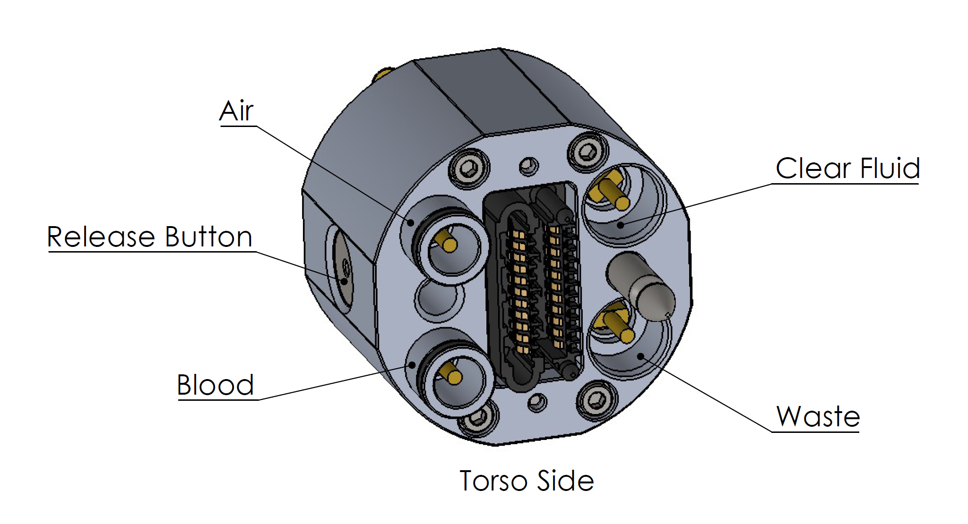
Figure 17: Fluid layout of torso-side USC (Left Leg)
Figure 18 shows an example of an AMM torso and head, with connectors for the four extremities.

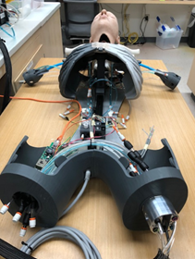
Figure 18: Example of an AMM systems showing standard connector for the arms and legs.
The AMM connector housing, fluid connector, data connector, and electrical connector interfaces are documented in detail in CDRL A004.

Electrical Power Interface Description
Electrical power and data shall be distributed among AMM Manikin Segments using Power over Ethernet (PoE) and the AMM USCs. The Torso Module shall perform as Power Sourcing Equipment (PSE) according to the IEEE standard 802.3at or 802.3bt. All extremity AMM Segment Modules shall perform as compatible Powered Devices (PDs) in accordance with IEEE 802.3at or bt standards.

A battery or line-voltage power supply may be placed independently in any of the body segments. Each such power supply shall provide power via assigned pins of the USC electrical connector for that segment. The Universal Segment Connector (USC) includes an electrical connector (TE Connectivity 292178-1) with 22 total conductors. Of these 8 are allocated for PoE, and 12 are allocated for power delivery into the Torso. For AMM, the 12 power conductors are split into 6 pairs, each providing up to 1A of power at 50V. Thus, a manikin system requiring up to 300W of total power can be powered from a single battery stored inside a limb. A power management and distribution capability implemented in the torso shall assure that no short-circuit, over-charging, or other unsafe conditions are created. Table aa summarizes the electrical interfaces.

Port type | Media | Pin | Voltage | Wire Type
Electric | Data | 8 Pins X 1A | 50-57 V | CAT 5 Ethernet Cable
Electric | Power In | 12 Pins X 1A | 48-52V | 26-28 AWG
Table 1: Electrical Interfaces
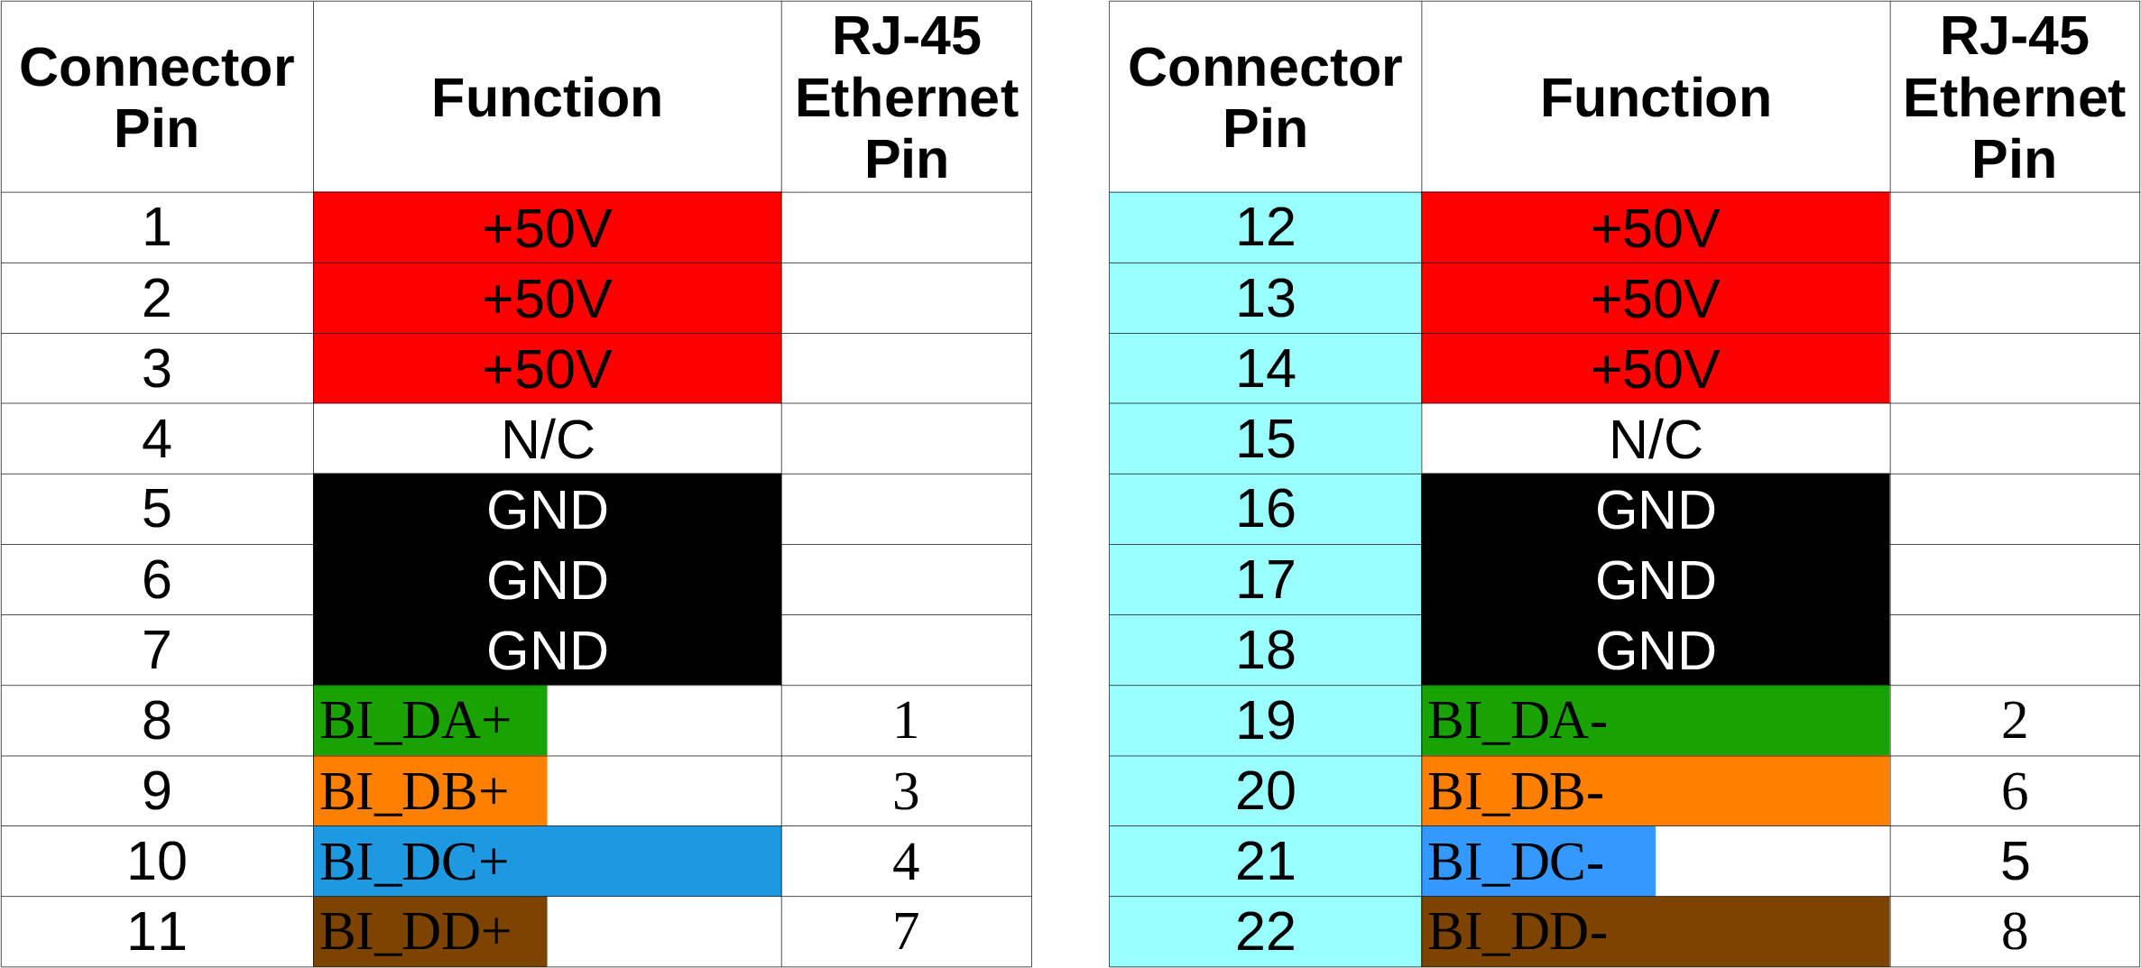
Table 2: Detailed pinout of electrical connector (TE Connectivity 292178-1)

Fluid Interface Description
An Advanced Modular Manikin system with physical body segments shall include a fluid source and distribution system that provides simulated blood, clear fluid, and compressed air to each segment at the rates, pressures, and capacities shown in the table below. It shall also provide a waste/discharge for liquids that meets the rate and pressure in Table bb.

 | Port type | Media | Flow Rate | Pressure
1 | Fluid | Blood Simulant | 1.5 l/min | 1.03 bar
2 | Fluid | Clear Fluid | 250 ml/min | 1.03 bar
3 | Fluid | Waste line |  | 1.03 bar
4 | Fluid | Compressed air |  | 1.03 bar
Table 3: Fluid Interfaces
All fluids flowing between segments shall flow through the USCs, using the Universal Segment Connectors described in CDRL A004.

Segment Geometry Requirements

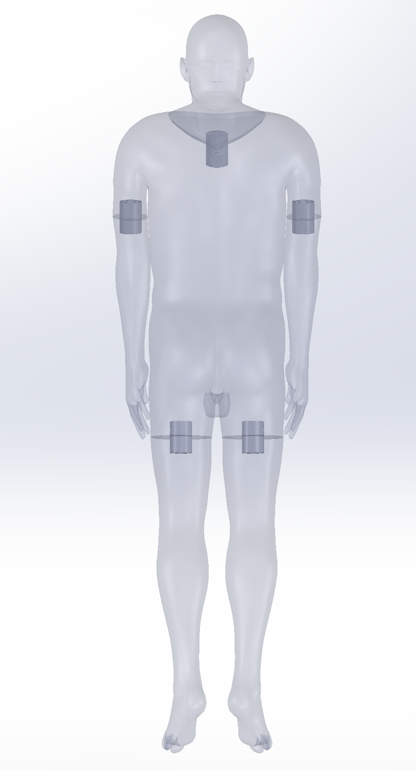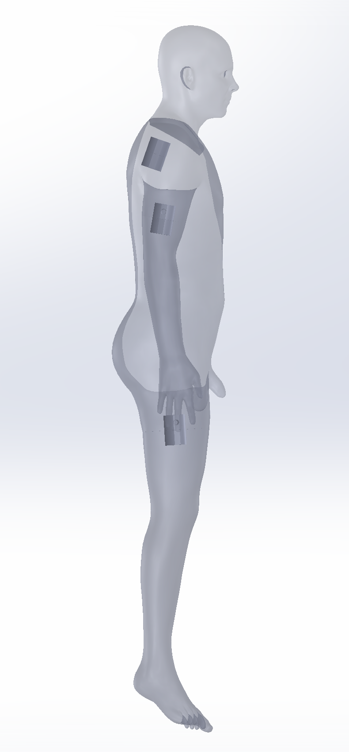
Figure 19: Potential implementation of segment connector locations.

Potential implementation of segment connector locations, orientations, and cut planes is detailed in CDRL A004. Universal segment connector (USC) locations are chosen using the following steps and are not interchangeable between different subjects’ anatomy. The AMM platform does not intend for Subject A’s module to be attached to Subject B’s torso. When developing a new system, the following process should be used to define cut planes and USC locations for upper and lower limbs. The release button side of a USC set shall always live on the torso side of the cut plane.

- The cartesian origin should be placed at the sacrum of the subjects anatomy
- Cartesian planes should be rotated such that the midsagittal plane is consistent with bilateral symmetry of the subject.
- Adjust the coronal plane as one sees fit depending on the subjects positioning when imaged. This will be used to aid in the orientation of segment connectors.
- Cut planes dividing the anatomy into modules shall be chosen by the developing party and should be placed as orthogonal to the limb as possible. The design referenced in CDRL A004 places the cut planes at the mid-femur and mid-humerus locations.
- The centroid of the resulting cross section shall be used as the center of the USC.
- The USC should be rotated such that the release button facing lateral from the subject (outwards) and parallel to the coronal plane.
*The head connector should be placed with the centerline residing on the midsagittal plane and oriented such that the release button faces posterior to the subject.

Human Interfaces

Command Line Interface
A command line interface (CLI) has been developed as part of the AMM Reference Implementation. In addition to all commands required to load and run a simulation, the command line interface includes a facility for arbitrarily injecting any AMM / DDS topic message on to the DDS bus for testing. The reference CLI interface is described in CDRL A001 section 4.4 and usage information has been provided in CDRL A005.

Dashboard
A simple web interface has been developed as part of the AMM Reference Implementation. This web dashboard allows a user to load scenarios, start/stop/pause and perform basic actions for controlling a simulation. A data browser is available to see the current physiology data in a running simulation. The reference web interface is described in CDRL A001 section 4.4 and usage information has been provided in CDRL A005.

Data Logging
Diagnostic logging is collected and aggregated by the Module Manager as part of the AMM Reference Implementation and stored in a sqlite database. The dashboard, described above, allows for viewing of this log in real-time or exporting the current state of the log in comma-separated (CSV) format.

Requirements Traceability
The origin and flow down/traceability of test requirements is shown in Figure 2. The origin of the AMM requirements is shown in the top line of Figure 20. This line identifies 3 requirement sources which are Clinical Use Cases, Concept of Manikin Operation and Industry Open Standards. From these study cases and documents the next line down shows the specifications created and CDRL A008.
Figure 20: Origin and Flow Down of Test Requirements
Each consecutive level of documents identifies how the documents are derived from the top-level specifications. These requirements were captured in the Environmental Condition and A001, A002, A007, A011. Finally, at the lowest level in Figure 20, the test requirements were created and documented based on performance requirements selected to verify.

