CDRL A008
System/Subsystem Specification (SSS) for
Advanced Modular Manikin Project
Phase II Program
Contract # W81XWH-14-C-0101
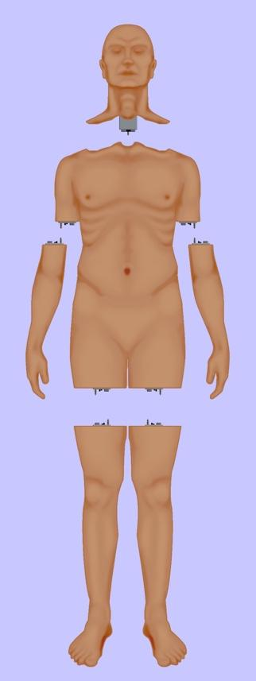

Date: February 3, 2020
Revision: Rev - 2
Unclassified

PRINCIPAL INVESTIGATOR: ROBERT M. SWEET, MD, FACS
REGENTS OF THE UNIVERSITY OF MINNESOTA
OFFICE OF SPONSORED PROJECTS
200 OAK ST SE
MINNEAPOLIS MN 55455-2009

This document is unclassified, and APPROVED FOR PUBLIC RELEASE; DISTRIBUTION IS UNLIMITED.

Revision History

Date of Revision | Description of Changes
24 Feb 2017 | Original Draft Submitted
26 Jan 2018 | Revised Draft Submitted
26 August 2019 | Document Submitted
03 Feb 2020 | Distribution Updated

Distribution Statement

This document was created under contract funding W81XWH-14-C-0101 from:

DEPARTMENT OF THE ARMY
US ARMY MEDICAL RESEARCH ACQUISITION ACTIVITY
820 CHANDLER STREET
FORT DETRICK MD 21701-5014

It contains no proprietary information, trade secrets, copy righted material or classified information. This document is unclassified, and APPROVED FOR PUBLIC RELEASE; DISTRIBUTION IS UNLIMITED.

Table of Contents
1 Scope 5
1.1 Identification 6
1.2 System Overview 6
1.3 Document Overview 6
2 Referenced Documents 7
2.1 Industry Documents/UW Documents 7
2.2 Government Documents 7
2.3 Order of Precedence 7
3 Functional Requirements 7
3.1.1 States and Modes of Operation 7
3.1.2 Statement of Objectives 7
4 System Architecture 10
4.1 Implementation 12
4.2 Implementation of Desired Capabilities in RI 13
5 AMM System and Subsystem Requirements 17
5.1 Power Requirements 17
5.2 Fluid Distribution Requirements 17
5.3 Hardware 18
5.3.1 Connector 18
5.3.2 Electronics 19
5.4 Software 19
5.5 System External Interface Requirements 20
5.6 System Internal Interface Requirements 21
5.7 System Internal Data Requirements 21
5.8 Adaptation Requirements 21
5.9 Safety Requirements 21
5.10 Security and Privacy Requirements 21
5.10.1 Cyber Security 21
5.11 System Environment Requirements 21
5.11.1 Standard Commercial Laboratory Environments – Non-Ruggedized Version 21
5.11.2 Field Training – Ruggedized Version 22
5.11.3 Environments Common to both Ruggedized and Non-Ruggedized AMM 23
5.11.4 Safety 24
5.11.5 Electrical Safety 24
5.12 Computer Resource Requirements 24
5.13 Computer Hardware Requirements 24
5.14 Hardware Utilization Requirements 24
5.15 Computer Software Requirements 24
5.16 Computer Communications Requirements 24
5.17 System Quality Factors 25
5.18 Design and Construction Constraints 25
5.19 Cleaning 26
5.20 Personnel-related Requirements 26
5.21 Training-related Requirements 26
5.22 Operators Manual 26
5.23 Logistics-related Requirements 26
6 Reliability, Availability and Maintainability 27
6.1 Reliability and Maintainability Measures 27
6.2 Reliability 27
6.3 Maintainability 27
6.4 Built in Test (BIT) and Fault Isolation 27
6.5 Precedence and Criticality of Requirements 27
7 Quality Assurance Provisions (QAP) 28
7.1 AMM Manikin Documentation 28
7.2 Software Quality Provisions 28
7.3 Supplier Quality Provisions 28
7.4 Test Quality Provisions 28
8 Requirements Traceability 28
9 Test Requirements 29
9.1 Platform Verification Testing 29
9.2 Physical/Software Functional Testing 30
9.3 Validation Testing 31
10 Appendix 1: Acronyms 32

Figure 1: Functional Overview of AMM Platform 5
Figure 2: AMM Block Diagram 11
Figure 3: Software Architecture 20
Figure 4: Plan for Verification Testing of AMM in Phase II 29
Figure 5: Plan for Physical Verification of Manikin 30
Figure 6: Universal Standard Test Station 30

Table 1: Universal Segment Connector throughput 18
Table 2: Requirements Traceability Matrix 28

Scope
This document defines the standards for 1.0 release of the Advanced Modular Manikin (AMM) platform and its formal deliverables. The formal deliverables consist of the platform specification, an open source* Reference Implementation (RI) of the Computer Software Configuration Items (CSCIs), a reference implementation of the Universal Segment Connector (USC) and other hardware defined by the Hardware Configuration Items (HWCIs), the data models that ensure interoperability between the core and modules, and the documents that describe their design, operation, and extensibility through the addition of AMM Modules. Modules are defined as independent building blocks that provide incremental capabilities to the core or provide training opportunities for different medical and trauma related conditions. The focus of this specification is on the platform, a much broader definition than a physical manikin, as illustrated in Figure 1, and on how it can be extended by medical simulation developers by adding:

- Modules that provide incremental capabilities to the core, including authoring tools, after action review tools, different physiology engines.
- Modules that add training opportunities, including IV/IO arms, intubation heads, laparotomy abdomens, virtual stethoscopes. These can be physical, virtual, or hybrid part task trainers.

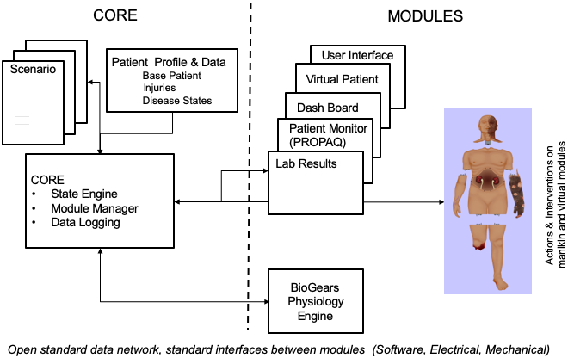
Figure 1: Functional Overview of AMM Platform

Identification

This is the Advanced Modular Manikin (AMM) System/Subsystem CDRL Item A008 of Contract # W81XWH-14-C-0101, Phase II which describes the AMM requirements.

This CDRL is formatted to the requirements of Data Item Description Number DI-IPSC-81431A as required and tailored as recommended.

System Overview
The AMM platform is a modular, distributed, interoperable system that enables physical, virtual, augmented and hybrid modules to work together as an integrated system. The traditional “core”, i.e. computer and state engine, can be in any one of the traditional manikin segments, i.e. torso, leg etc., or external to the human form, as it would be if the system is only running a virtual instance or if the targeted scenario, i.e. patient case, does not allow them to be internal due to the set of interventions that have to be performed on the body. The platform is architected as a system of systems that allow modules to function either as part of an integrated, whole body simulation or as autonomous part task trainers.

The published AMM standards guide the development and integration of AMM compatible modules. The reference designs provided for the final demo including electronics and central supplies were created to demonstrate the operation of the platform and are published as a developer’s tool kit with sources to acquire them from.

The developers of the platform have agreed to publish the AMM platform under the following open source licensing option:

* Creative Commons Attribution 4.0 International (CC BY 4.0) https://creativecommons.org/licenses/by/4.0/deed.ast.
Share — copy and redistribute the material in any medium or format
Adapt — remix, transform, and build upon the material for any purpose, even commercially.
The licensor cannot revoke these freedoms as long as you follow the license terms.

This document does not cover modules that were created under separate funding and by other entities to demonstrate the functionality of the AMM Platform under separate funding and are not part of the Open Source agreement.

Document Overview
This document is the System/Subsystem Specification (SSS) CDRL Item A008 of Contract # W81XWH-14-C-0101, Phase II. The outline and subject matter content are based on DID DI-IPSC-81431A as required by the contract. The DID has been tailored as appropriate. This document is unclassified and contains no proprietary information, trade secrets, copyrighted material or classified information. Unlimited distribution.

Referenced Documents

Industry Documents/UW Documents
Document Number | Title
AMM_IDD_A007--DRAFT | Interface Design Description (IDD)
AMM_ICD_A011--DRAFT | Interface Control Document (ICD)

Government Documents
Document Number | Title
# W81XWH-14-C-0101 | AMM Phase II Contract, DOD
MIL-STD-810 | Environmental Engineering Considerations and Laboratory Tests

Order of Precedence
In the event of a conflict between the text of this document and the references cited herein, the text of this document takes precedence. Nothing in this document, however, supersedes applicable laws and regulations unless a specific exemption has been obtained.

Functional Requirements
In addition to the requirements outlined in the original solicitation, the team visited multiple user sites on both the military and civilian sides, ranging from first responders to specialist surgeons to solicit their input and identify missing capabilities during Phase I of the program to establish the use cases that are addressed by the AMM platform.

States and Modes of Operation
The AMM platform shall operate per the states and modes listed below:
- Transport/Storage
- Off
- On
  - Initiate selected scenario
  - Stop scenario
  - Reset for next training session/learner

Statement of Objectives
The AMM platform is designed to support the Statement of Objectives (SOO) of the AMM contract:
- General Capabilities
  - Interchangeable peripheral attachments, including:
    - Head & Neck
    - Upper Extremities
    - Lower Extremities
    - Pelvic/groin anatomy
    - Interactive skin
    - Injury moulage system(s)
    - Wireless controller(s)/monitor(s)
    - Other areas
  - Climate-related tolerances: specify operable range of the core modular manikin system.
  - User-based maintenance and high reliability
  - State of the art pedagogical & assessment capabilities
    - Automated data collection and wireless progress monitoring and performance analysis
    - Wireless student identification
    - Autonomous operation
    - Easy scenario creation
- Open Architecture and Open Source Connectivity – These developments are to be researched and prototyped in Phase 1. Phase 2 will mature these technologies into a complete modular manikin. It is anticipated that the phase 2 performer will work with a national/international standards body to create open source standards for the following (NOTE: if applicable in the proposed design):
  - Universal Mechanical/Electrical/Hydraulic/Signal Attachments
    - Common limb, pelvic /groin and head attachment points and mechanisms that permit a variety of peripheral joints/pelvis/head including the possibility for motorized and articulating joints.
    - Power bus
      - Common power from core modular manikin
      - Ability for peripherals to provide power to the core manikin
    - Common fluid attachment points
    - Data bus
    - Robust wireless capability for peripherals. Consideration of 802.15.4 and 802.11 communications capability is highly encouraged.
    - USB Human interface device class
    - It is requested that phase 2 performer will make attachment kits available for sale to third parties at a reasonable cost to encourage third party development of peripherals.
  - Software Interoperability
    - Open API for peripherals to communicate with system
    - Extensible
    - Serial command line interface – human users need to query and command the system through serial ASCII text using common language commands and standard TTL serial connection
    - Peripherals that can assume primary control of the entire system
    - Accommodate public physiology research platform (DTME-PRP is a DoD program). Detailed information on DTME-PRP will be provided upon email request.
    - Accommodate software expansions
      - New simulations
      - Interactivity systems
- Core manikin capabilities – comparable to today’s mid-high-end commercial manikin systems. The proposal must specify what specific capabilities are to be included in each of the following areas:
  - Core manikin
  - Set(s) of limbs, pelvic/groin anatomy & head with general capabilities to be specified by the proposer but at a minimum consider
    - Range of motion (ROM) of limbs and head should be appropriate and accurate to human ROM and allow proper application of immobilization devices (cervical collars, spine boards, splints and traction devices).
  - Software
    - Operating System utilizing plug-play modular components
    - Basic Physiology Capabilities
    - Wireless & wired communications
    - State machine / interactive scenario capability
  - Core manikin features
    - Have the ability to change gender
    - Realistic airway
    - Palpable pulses
    - Breath & abdominal sounds
    - Chest rise and lungs capable of being ventilated either manually or automatically
    - Intubation (cricothyroidotomy, oral tracheal and nasal tracheal)
    - Anticipate future skills such as IV cannulation
    - Intraosseous (IO) infusion capability at the sternum, humeral head, and lower extremities (FAST 1 and EZ-IO)
    - Should allow infusion of “fluids” via vascular and intraosseous routes
    - Needle decompression, chest tube and other procedural provisions
    - Wound packing (at least one site)
    - Physiology (mathematical algorithm) system
    - Electronic monitoring capability
    - Other features common to today’s mid-high-end commercial manikin systems
    - Anticipate future skills such as nasogastric (NG) tube, orogastric (OG) tube, and Foley catheterization
    - Wireless interaction
    - State-based and physiology variable dependent scenario capability
    - Wireless audio out and listening capability
    - Other features as may be specified by proposer
  - Wireless instructor interface
    - Tablet or other
    - Interface will be used to control the manikin or observe scenario progress
- Anticipated capabilities of future peripherals that attach to this modular platform (These peripherals are anticipated future developments, not core modular manikin functions. These peripherals are not required as part of the work specified in this RFP. However, the core modular manikin must anticipate connection with these types of peripherals).
  - Hemorrhage simulation
  - Realistic tissue properties
    - Amputated limbs
    - Soft operable simulated tissues
    - Pelvic / Groin injuries
    - “Common” fractures for external fixation
    - Compartment syndrome
  - Abdominal skin and tissues (operable inserts) exterior to the visceral (or parietal) fascial layer that allows for wound packing and limited open surgical interventions.
  - Advanced realistic difficult airway: oral intubation, nasal intubation, and cricothyroidotomy options
  - Operable ‘display skin’
  - Physiology engine(s) compatibility
  - Animation & motion
  - Advanced head for procedures and for interaction/examination
  - Interaction & behavior to include virtual human capabilities with natural language understanding, nonverbal expressions & artificial intelligence guided verbal responses
  - Scalability from a simpler more rugged system to a more complex hospital environment one.
  - Advanced sensors for procedure / skill assessment

System Architecture
The AMM platform is a scalable, modular system capable of configurations to support user defined use cases. The basic AMM configuration is shown in the block diagram in Figure 2.
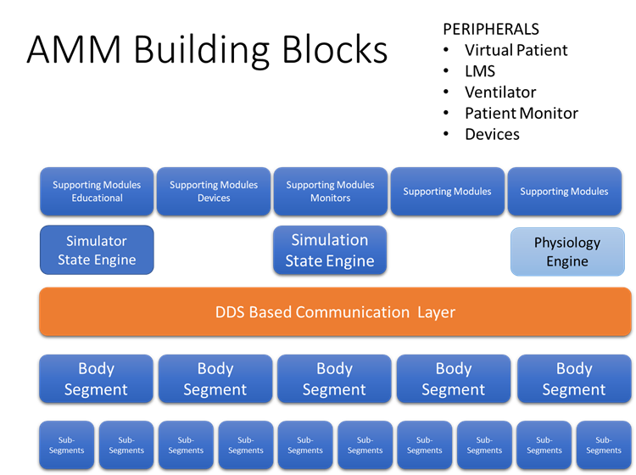
Figure 2: AMM Block Diagram

It is designed to be a system of systems, where each building block can be used on its own or be replaced with a different version created by the simulation community that is plug compatible.

The guiding principles have been:
- The representation of the body is a display for the state of the patient and an input device to the simulation
- The core data that is shared between modules are clinically relevant data
- Decoupled complexity: what can be resolved locally in the distributed architecture is resolved locally
- What does not impact operations at the next level up or at other modules is not communicated
- Distributed, modular, interoperable
- A hierarchical and scalable topology
- Multimodal: physical manikins, virtual reality, augmented reality, and hybrid modules coexist
- Persistent patient in the background, always can manage the patient if learning objectives require it

If we broadly look at health care education needs, we recognize approximately 2600 diseases, 5000 different History and Physical findings and over 1000 Technical and Lab results leading to an almost infinite combination of scenarios that can be encountered by providers. Developing one off trainers for the multitude of scenarios becomes an impossibility. In addition, most industry players have chosen to develop trainers for the most common problems in most cases replicating each other’s work.

To address this challenge this program has created a modular, distributed, interoperable platform with a small set of reusable building blocks that allow for new use cases to be rapidly addressed. Furthermore, by making the results of multiple large R&D efforts available as open source it significantly reduces the cost of creating new trainers with advanced capabilities.

Implementation
The program deliverables fall into two categories:
- Publicly available, provided under Creative Commons:
- Architecture documentation
- Developer documentation
- Core Software Components (CSC)
  - Module Manager
  - Patient Manager
  - Data Manager
- Open source Application Programming Interface (API) for core, peripheral, and interaction systems or devices
- Universal Segment Connectors (USC)
- Instructor tablet application
- Interface for BioGears Physiology Engine and new physiology engine capabilities funded through the AMM program
- Reference patient data sets, male and female
- Skin color standards
- Locations for segment connections, orientation information for USC’s
- Reference design and supporting data for the AMMDK boards that can be used as a beginning point for module development
- Reference design and supporting data for the Network Manager, based on the AMMDK design, but customized to be the core compute platform as a beginning point for system development
- Reference design for central supplies, i.e. air, and fluids and required quantities at the segment connectors to be compliant
- Data Models
- Open source data bus design based on DDS and required libraries to implement
- Detailed specifications on environmental tolerances and ruggedness

- Demonstration System: it includes all of the publicly available items, but in addition it has modules developed by industry and under other contracts that help demonstrate the broad capabilities of the platform and expansion capabilities. It includes:
- an AMM Core and one or more AMM-conformant modules. The USC connectors provide the physical connection, power, data, and resources (fluids) needed for intra-body segment connections. We have created a sample design for an inter-body segment connector to demonstrate scalability.
  - Complete manikin shell and skin with a working set of peripheral head, and limbs.
  - External stack for central supplies
  - AMM compliant Advanced Airway Trainer developed under award# W911NF-14-2-0042
  - Laparotomy module for torso developed with UW internal funds
  - Patient Monitor by Vcom3D (commercial)
  - Virtual IV Pump by Vcom3D (commercial)
  - Virtual Ventilator by Vcom3D (commercial)
  - Virtual urine output display with volume and color by Vcom3D (commercial)
  - Abdominal palpation module, AMM compatible, by ACDET (commercial)
  - Ultrasound FAST exam, by CAE (commercial)
  - Research reports on achievement and data supporting the validation or invalidation of the research hypotheses
  - Results of user, engineering, and quality assurance testing

Implementation of Desired Capabilities in RI
- General Capabilities
  - Interchangeable peripheral attachments, including:
    - Head & Neck – Advanced Airway Trainer module (AAT)
    - Upper Extremities – IV Arm
    - Lower Extremities – Simetri Leg for faciatomy
    - Pelvic/groin anatomy – Laparotomy Module
    - Interactive skin – demonstrated color and temperature changing skin during the Phase I final demonstration
    - Injury moulage system(s) - Data Models are in place, but currently no elegant technology to provide both location information and provide some level of data communication to support modular moulage appliances
    - Wireless controller(s)/monitor(s) – Numerous tablets
    - Other areas
Climate-related tolerances: specify operable range of the core modular manikin system. – To be addressed by commercial offerings, based on use case
  - User-based maintenance and high reliability– To be addressed by commercial offerings
  - State of the art pedagogical & assessment capabilities
    - Automated data collection and wireless progress monitoring and performance analysis – Data models created to support and demonstrated in RI
    - Wireless student identification – Data Models created specifically to support that requirement; no commercial systems currently available to use it
    - Autonomous operation – Designed in support of non-deterministic simulation, allowing scenarios to run their course
    - Easy scenario creation – Specifically asked not work on authoring tools, but defined scenario data structure for future development
- Open Architecture and Open Source Connectivity – These developments are to be researched and prototyped in Phase 1. Phase 2 will mature these technologies into a complete modular manikin. It is anticipated that the phase 2 performer will work with a national/international standards body to create open source standards for the following (NOTE: if applicable in the proposed design):
  - Universal Mechanical/Electrical/Hydraulic/Signal Attachments
    - Common limb, pelvic /groin and head attachment points and mechanisms that permit a variety of peripheral joints/pelvis/head including the possibility for motorized and articulating joints. – Limb and Head connections addressed with USC, internal to the torso we developed a sample connector for plug in modules
    - Power bus
      - Common power from core modular manikin – implemented power distribution with Power Over Ethernet (POE) over the Network Manager
      - Ability for peripherals to provide power to the core manikin -implemented connections for limbs to provide battery power to the Network Manager
    - Common fluid attachment points – Implemented in Universal Segment Connector and Torso Connector
    - Data bus – Implemented Data Distribution Services (DDS)
    - Robust wireless capability for peripherals. Consideration of 802.15.4 and 802.11 communications capability is highly encouraged.
    - USB Human interface device class
    - It is requested that phase 2 performer will make attachment kits available for sale to third parties at a reasonable cost to encourage third party development of peripherals. – Currently available through One World
  - Software Interoperability
    - Open API for peripherals to communicate with system
    - Extensible - Modular design and open source core and standards allows for the system to be expanded as needed
    - Serial command line interface – human users need to query and command the system through serial ASCII text using common language commands and standard TTL serial connection - We offer this through IP-based secure shell (SSH) connections. Additionally, the AMMDK/NC boards provide a serial-over-USB port for debug.
    - Peripherals that can assume primary control of the entire system - Instructor tablet can override some variables and states, but while the physiology engine is active, it has control of the patient state based on provider actions and clinical conditions
    - Accommodate public physiology research platform (DTME-PRP is a DoD program). Detailed information on DTME-PRP will be provided upon email request. – currently connected to BioGears, considering other physiology engines
    - Accommodate software expansions
      - New simulations – integrated multiple commercial simulators
      - Interactivity systems – exchanges data with integrated simulators
- Core manikin capabilities – comparable to today’s mid-high-end commercial manikin systems. The proposal must specify what specific capabilities are to be included in each of the following areas:
  - Core manikin - Demonstration system built and to be studied by the American College of Surgeons (ACS)
  - Set(s) of limbs, pelvic/groin anatomy & head with general capabilities to be specified by the proposer but at a minimum consider
    - Range of motion (ROM) of limbs and head should be appropriate and accurate to human ROM and allow proper application of immobilization devices (cervical collars, spine boards, splints and traction devices). - Demonstration one approach as part of the demonstration system, to be implemented by module developers based on their technology
  - Software
    - Operating System utilizing plug-play modular components - Part of Architecture
    - Basic Physiology Capabilities - BioGears connection, looking at others to expand capabilities
    - Wireless & wired communications - Implemented in RI
    - State machine / interactive scenario capability - Implemented in Architecture
  - Core manikin features
    - Have the ability to change gender – chose to create reference data sets for one male and one female patient, both translated for torso modules. Differences in habitus are significant enough that one manikin with interchangeable parts does not allow for correct training.
    - Realistic airway – Implemented in AAT
    - Palpable pulses – Implemented in IV Arm, both rate and strength controlled by physiology engine
    - Breath & abdominal sounds – Implemented in AAT
    - Chest rise and lungs capable of being ventilated either manually or automatically - Implemented in AAT
    - Intubation (cricothyroidotomy, oral tracheal and nasal tracheal) - Implemented in AAT
    - Anticipate future skills such as IV cannulation – IV Arm
    - Intraosseous (IO) infusion capability at the sternum, humeral head, and lower extremities (FAST 1 and EZ-IO) - Not part of Demonstration System, can be implemented by Module Developers, supported by Data Models
    - Should allow infusion of “fluids” via vascular and intraosseous routes - For Module Developer implementation
    - Needle decompression, chest tube and other procedural provisions - Needle decompression and chest tube implemented in AAT
    - Wound packing (at least one site) - Not part of Demonstration System, can be implemented by Module Developers, supported by Data Models
    - Physiology (mathematical algorithm) system - Connected to BioGears
    - Electronic monitoring capability - Instructor tablet
    - Other features common to today’s mid-high-end commercial manikin systems
    - Anticipate future skills such as nasogastric (NG) tube, orogastric (OG) tube, and Foley catheterization - NG and OG implemented in AAT, Foley capability being developed at UW under internal funding
    - Wireless interaction - Implemented
    - State-based and physiology variable dependent scenario capability - Implemented
    - Wireless audio out and listening capability - Implemented in AAT module
    - Other features as may be specified by proposer
  - Wireless instructor interface
    - Tablet or other – developed under AAT
    - Interface will be used to control the manikin or observe scenario progress – developed under AAT
- Anticipated capabilities of future peripherals that attach to this modular platform (These peripherals are anticipated future developments, not core modular manikin functions. These peripherals are not required as part of the work specified in this RFP. However, the core modular manikin must anticipate connection with these types of peripherals).
  - Hemorrhage simulation – Demonstrated in Laparotomy Module
  - Realistic tissue properties -
    - Amputated limbs – For Phase I had the MATT legs connected
    - Soft operable simulated tissues – Demonstrated in Laparotomy Module
    - Pelvic / Groin injuries – Demonstrated in Laparotomy Module
    - “Common” fractures for external fixation – Announced by Simetri
    - Compartment syndrome – Demonstrated by Simetri with fasciotomy leg
  - Abdominal skin and tissues (operable inserts) exterior to the visceral (or parietal) fascial layer that allows for wound packing and limited open surgical interventions.
  - Advanced realistic difficult airway: oral intubation, nasal intubation, and cricothyroidotomy options – Demonstrated in Advanced Airway Trainer
  - Operable ‘display skin’
  - Physiology engine(s) compatibility – BioGears is connected as a module, working on others
  - Animation & motion - Demonstrated during Phase I by connecting to MATT legs from KGS
  - Advanced head for procedures and for interaction/examination – AAT with cric procedure, collaborating with OHSU on craniotomy trainer
  - Interaction & behavior to include virtual human capabilities with natural language understanding, nonverbal expressions & artificial intelligence guided verbal responses - Received inquiries from multiple companies that were seeking DoD funding to develop such capability, have not heard back yet. Our data Models and Communication Protocol’s support that when it becomes available
  - Scalability from a simpler more rugged system to a more complex hospital environment one. – Demonstrated with ACS Study configuration
  - Advanced sensors for procedure / skill assessment – Many examples in RI

AMM System and Subsystem Requirements

Power Requirements
All power requirements for AMM are applied only to AMM Segment Modules, i.e. AMM Modules that are providing a physical representation of part of the simulated patient body. In cases where there are no AMM Segment Modules in use, there are no AMM power requirements.

For AMM Segment Modules, AMM uses Power over Ethernet (PoE) to distribute both power and data within a manikin. Both a Standard Power Profile and a Low Power Profile are defined for AMM. In order to comply with the Standard Power Profile, the Torso Module shall perform as Power Sourcing Equipment (PSE) according to the IEEE standard 802.3bt Type 4. The head and extremity AMM Segment Modules must perform as compatible Powered Devices (PDs). Thus, all extremity AMM Segment Modules shall comply with either IEEE 802.3at or 802.3bt standards. An AMM Segment Module with 802.3bt Type 4 compatibility is thus guaranteed up to 75W of power.

In order to comply with the Low Power Profile, the Torso Module must perform as Power Sourcing Equipment (PSE) according to the IEEE standard 802.3at. The head and extremity AMM Segment Modules must perform as compatible Powered Devices (PDs). Thus, all extremity AMM Segment Modules shall comply with IEEE 802.3at standards. The user is responsible for assuring that head and extremity modules do not exceed Power Sourcing capabilities.

The Universal Segment Connector (USC) includes an electrical connector (TE Connectivity 292178-1) with 22 total conductors. Of these 8 are allocated for PoE, and 12 are allocated for power delivery into the Torso. For AMM, the 12 power conductors are split into 6 pairs, each providing up to 1A of power at 50V. Thus, a manikin system requiring up to 300W of total power can be powered from a single battery stored inside a limb.

Fluid Distribution Requirements
The AMM Fluid requirements support the following media to extremity and head modules:
Blood
Clear fluids (ie sweat, peritoneal fluid, urine, tears, etc)
Air
The Fluids systems shall provide for recirculation for all extremity lines for:
Cleaning, purging/drying
Support for line cleaning and purging/drying
Fluid return (waste)
Double sided spill proof connectors at module interfaces (no leakage)
Minimize required complexity of modules
Reservoir refill via spill proof quick connect
Quiet operation pumps/valves/hoses/exhaust <=45 dB
Low pressure <75 psi air and fluids flow control via pump speed (flow starved circuit)

Table 1 has the specifications for power and fluid delivery through the Universal Segment Connectors

 | Port type | Media | Flow Rate | Pressure | Reservoir Capacity
1 | Fluid | Blood Simulant | 1.5 l/min | 1.03 bar | ≦ 6 l
2 | Fluid | Clear Fluid | 250 ml/min | 1.03 bar | ≦ 1 l
3 | Fluid | Waste line |  | 1.03 bar | ≦ 2 l
4 | Fluid | Compressed air |  | 1.03 bar | Continuous
 | Port type | Media | Pin | Voltage | Wire Type
5 | Electric | Data | 8 Pins X 1A | 50-57 V | CAT 5 Ethernet Cable
6 | Electric | Power In | 12 Pins X 1A | 48-50V | 22-28 AWG
Table 1: Universal Segment Connector throughput

The Fluidics system features shall include:

  - Supply of pressurized fluids to modules: blood, clear, air
  - Fluid return line from modules to waste tank or drain
  - Flushing/purging for all main fluid lines for cleaning and transportation
  - Air compressor and reservoir/main manifold assembly can be placed independently in any one module: extremities, head or torso, or external to the manikin
  - Double sided dry break connectors at module interfaces
  - Reservoir refill via spill proof quick connect
  - Cleaning module can be connected externally at main manifold
  - Intervention specific functionality is implemented in modules
  - Quiet operation pumps/valves/hoses/exhaust <=45 dB (noise inside a library or a babbling brook)

Hardware

Connector
The connector design shall provide both for the securing of the components (head, limbs) to the torso and the delivery of resources: power, data and fluids to the AMM configuration. The standard design for the USC has been published on the AMM web site and is currently available from one vendor for developers.

The connector shall provide the following:

• 200 lb. pull force fail safe release
• 60 lb. twist force fail safe in either direction
• Tool-less operation
• Blind connection (no interface access)
• Can be made with traditional and additive manufacturing
• Low cost – Cost threshold TBD
• Passive operation (no electromechanical actuation)
• Rugged – Qualification TBD, “soldiers can break anything vs. what is reasonable”

Electronics
Electronics for AMM have no specific requirements beyond power and environmental requirements outlined elsewhere in section 5.

Software

The planned software architecture is defined in Figure 3.
AMM Modules must transmit all data in conformance with the AMM Data Model. The AMM data model is defined and documented in the Interface Design Description (IDD). Software modules shall be connected that provide the minimum AMM Core Software functionality as defined in the IDD. Software modules shall be connected that provide appropriate displays and interfaces for the Learner to engage with as part of an educational encounter. These may include a virtual patient monitor, a virtual patient interactive display, virtual labs reports, etc. Software modules shall be connected that provide an appropriate User Interface for the Instructor to observe and interact with the educational encounter.

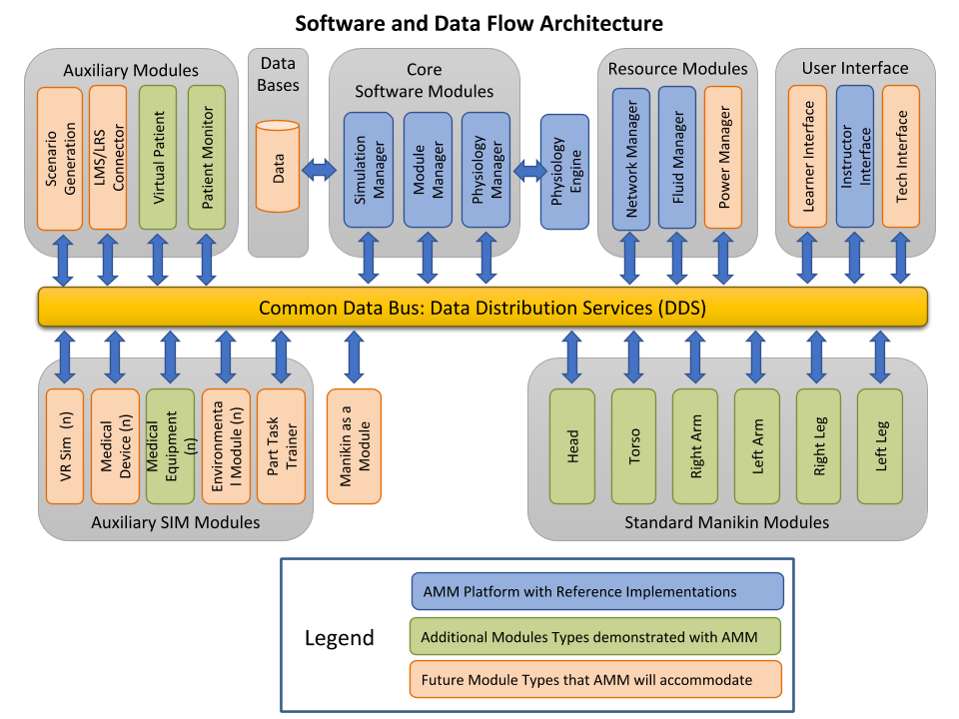
Figure 3: Software Architecture

System External Interface Requirements

The AMM Standard defines a single data interface for all inter-module communication, and a single interface for AMM Segment Module physical connections, as outlined elsewhere in Section 5. As such, any interfaces to external systems shall also comply with System Internal Interface Requirements and Data Requirements, below. Connections to external systems such as an LMS will require creating a custom AMM module for the purpose of connecting to the desired external service(s).

Interface Identification and Diagrams
The AMM shall provide a means to interface with any LMS used to assess and record student results through a Data Warehouse and the Data Model Definitions.
The external interface for the modules shall be defined per the ICD (CDRL A011) and the IDD (CDRL A007). The AMM shall have the capability to interface with any module that meets the AMM compatibility standard definition.

System Internal Interface Requirements
The AMM Standard defines a single interface for AMM Segment Module physical connections, as outlined elsewhere in Section 5. All inter-module communication and connections shall conform to these requirements.

The AMM Development Kit (AMMDK), provided as part of the open source Reference Implementation, does provide internal interfaces, as defined in CDRLs A001, A004, and A007. These interfaces are not part of the AMM Standard.

System Internal Data Requirements
The AMM Standard defines a single data interface for all inter-module communication, as defined in the IDD (CDRL A007). All AMM-compatible Modules shall conform to this standard.

Adaptation Requirements
N/A

Safety Requirements
The AMM Standard for the connectors shall address safe operation of a configuration, e.g. grounding and use in uncontrolled environments.

Security and Privacy Requirements

Cyber Security
The AMM Standard does not currently provide any cyber security requirements. The current design does not secure data between Modules in an AMM System. AMM Modules developers are encouraged to use industry best-practices in securing the computers used in their modules.

System Environment Requirements
This section defines the environmental requirements for both non ruggedized and ruggedized AMM system when in the operating mode and non-operating mode (storage). After exposure to these conditions, the AMM manikin shall operate without damage or degradation of performance nor unusual wear of internal and external components.

Standard Commercial Laboratory Environments – Non-Ruggedized Version
The following environmental conditions apply to a non-ruggedized version of the AMM manikin system. These environmental conditions are typical of laboratory or hospital type of environments. The manikin shall operate with degradation in performance when subjected to the following conditions:

Operating in Laboratory, Office or Hospital (Non-Ruggedized)
    - Temperature Range: 50 F to 95 F
    - Relative Humidity: 10% to 90% no condensation
    - Vibration: IEC 60068-2-6 Vibration test for normal handling
    - Shock: Not required
    - Sunshine: Not required
    - Moisture: Drip Test per IEC 60601 for Medical Equipment
    - EMI: MIL-STD 461 for commercial equipment
    - Fluids: Exposure to solvents and cleaning fluids, insecticides, disinfectants, fire extinguishants per MIL-STD-810 Table 504.2-1.

Non-operating storage in laboratory, office, hospital or warehouse. Operate after exposure these environments without degradation in performance. (non-ruggedized)
- Temperature Range: 0 F to 120 F
- Relative Humidity: 10% to 90% no condensation
- Vibration: IEC 60068-2-6 Vibration test for normal handling
- Shock: Not required
- Sunshine: Not required
- Moisture: Drip Test per IEC 60601 for Medical Equipment
- EMI: MIL-STD 461 for commercial equipment

Field Training – Ruggedized Version
The following environmental conditions apply to the ruggedized version of the AMM manikin system. These environmental conditions are typical of use in a field training exercise. The manikin shall operate with degradation in performance when subjected to the following outside conditions:

Operating outside in a field training environment – manikin laying on ground

    - Temperature Range: 32 F to 158 F (0C to 70C)
    - Relative Humidity: 10% to 95% no condensation
    - Limb Pull, 200 pounds (Pickup manikin by arm or leg for movement)
    - Rain: operation while exposed to rain without degradation of performance per MIL-STD-810G Method 506.6 Procedure I – Rain and blowing rain.
    - Sunshine: Direct Sun, 4 to 6 hours
    - Moisture: Drip Test per IEC 60601 for Medical Equipment
    - Blowing dust - tests ingress of dust particles that are smaller than 150 micrometers (μm). To test Procedure I, start with the wind at 8.9 meters/sec (1750 feet/min). Then feed the dust at an average concentration of 10.6 grains per cubic meter (0.3 grains per cubic foot). Maintain for at least six hours at standard ambient temperature, rotating the device to eventually expose all sides. Then raise to operating temperature, lower the wind speed, stop the dust, and test for another 6 hours, rotating the device as necessary.

    - Blowing sand tests ingress with particles that are between 150 μm and 850 μm. The test starts at operational temperature and requires much higher winds – 18 to 29 meters/sec (40-65 mph) in order to move the heavier particles. The sand concentration will vary widely depending on the target environment — the high end simulates being near aircraft, for example. The test is run for 90 minutes for each face the device has, stopping the sand and wind so it can be rotated safely.

Non-operating environment outside in a field training environment. Ruggedized version. The AMM manikin shall survive and operate afterwards

    - Shock: Bench Test 4-foot drop, all directions
    - Drop (transit) for aircraft and helicopters defined in Tables 516, Procedure IV from MIL-STD-810G without degradation of performance
    - Limb Pull or drag: 200 pounds (Pickup manikin by arm or leg for movement)
    - Relative Humidity: 10% to 95% no condensation
    - Rain: operation while exposed to rain without degradation of performance per MIL-STD-810G Method 506.6 Procedure I – Rain and blowing rain.
    - Sunshine: Direct Sun, 8 hours
    - Blowing dust - tests ingress of dust particles that are smaller than 150 micrometers (μm). To test Procedure I, start with the wind at 8.9 meters/sec (1750 feet/min). Then feed the dust at an average concentration of 10.6 grains per cubic meter (0.3 grains per cubic foot). Maintain for at least six hours at standard ambient temperature, rotating the device to eventually expose all sides. Then raise to operating temperature, lower the wind speed, stop the dust, and test for another 6 hours, rotating the device as necessary.
    - Blowing sand tests ingress with particles that are between 150 μm and 850 μm. The test starts at operational temperature and requires much higher winds – 18 to 29 meters/sec (40-65 mph) in order to move the heavier particles. The sand concentration will vary widely depending on the target environment — the high end simulates being near aircraft, for example. The test is run for 90 minutes for each face the device has, stopping the sand and wind so it can be rotated safely.
    - Immersion: 1 m of water, 20-minute soak
    - Acceleration: withstanding the accelerations for aircraft and helicopters defined in Tables 513.6-I and –II from MIL-STD-810G without degradation of performance.

Environments Common to both Ruggedized and Non-Ruggedized AMM

    - Fluid Exposure: Exposure to solvents and cleaning fluids, insecticides, disinfectants, fire extinguishants per MIL-STD-810 Table 504.2-1.
    - Transportation Shock: While in Shipping Container: mechanical shock defined in Table 516.7, Procedure II, from MIL-STD-810G
    - Transportation Vibration: While in Shipping Container: withstanding vibration for transport in aircraft and helicopters from 21-41 grms
    - Corrosion: water immersion per Table 507.6 (Humidity) and Table 506.6 (Rain) from MIL-STD-810G. without degradation of performance.
    - EMI: Conducted emissions, susceptibility and radiated emissions per MIL-STD-461 for commercial equipment
    - Safety

Safety
The AMM shall be designed and constructed for safe operation and maintenance. Safety features shall be provided to preclude inadvertent activation of devices that could impact safety. The risk due to human error under routine and non-routine conditions shall be minimized. The following precautions shall be implemented where possible.
- Flame retardant material shall be used where possible
- No sharp edges or pins that cause cuts during normal handling
- No Bio-hazard material (Safe to handle without gloves)
- No arcing of electronics in high oxygen environment (Patient Air)

Electrical Safety
Electrical circuitry and installation shall comply with the requirements of the National Electric Code (ANSI/NFPA 70).

Computer Resource Requirements
Computers used for AMM Modules must have sufficient computational resources to perform their designed functionality while conforming to the AMM Communication Requirements (Section 5.16) and AMM Power Requirements (Section 5.1).

Computer Hardware Requirements
Computer hardware requirements vary depending upon module needs. Computers used in AMM Segment Modules (parts of manikin simulating the patient’s body) must conform to the AMM Power Requirements (Section 5.1) and AMM Communication Requirements (Section 5.16). Computers not used in AMM Segment Modules have no AMM-derived hardware requirements.

Hardware Utilization Requirements
AMM imposes no hardware utilization requirements. Developers of AMM Modules must evaluate their hardware performance and ensure it meets the AMM Communication Requirements (Section 5.16).

Computer Software Requirements
AMM modules must have software sufficient to conform to the AMM Communication Requirements (Section 5.16) and AMM Data Models, as defined in CDRL A007.

Computer Communications Requirements
AMM Modules communicate via the DDSI-RTPS protocol version 2.3 (https://www.omg.org/spec/DDSI-RTPS/About-DDSI-RTPS/). RTPS uses UDP/IP(v4) as a transport layer, a requirement which AMM inherits. AMM uses the DDS Domain ID of “0” (zero). All DDS QoS values are default (per DDS version 1.4), except as defined in comments for each Topic in the AMM.idl specification file.

IP addressing is usually managed via DHCP. Most modules will be simple DHCP clients. If there are no Segment Modules connected and powered via PoE, IP addressing may be managed out of scope of AMM, such as by a commodity networking product. Modules that are purely implemented in software may rely on their host OS for IP addressing.

If the AMM system includes physical Segment Modules connected via ethernet and powered via PoE, the DHCP server must be managed by the PoE PSE device in order to facilitate power consumption monitoring. In the reference demonstration manikin, the Network Controller assumes this responsibility.

Because a simulation is run over a distributed network, syncing time between modules is important. AMM relies on the widely used NTP standard for this. In the case that an instance of an AMM network doesn’t have internet access, the computer acting as network router shall rely on its undisciplined local clock as the authoritative source.

System Quality Factors
The AMM system shall have the following Quality Factors
- Functionality to successfully perform a high-fidelity medical intervention
- Reliability to run scenarios error free, or recover from failures and continue to work
- Usability by medical trainers to teach proper intervention techniques
- Efficiency in collecting data during an intervention scenario and provide feedback to the trainer and student
- Maintainability of the system so multiple scenarios can be run with quick turnaround time and easy replacement of consumable parts.
- Portability of the system to allow rapid and easy transportation to multiple sites

Design and Construction Constraints
The following common Design and Construction Constraints shall apply:
- Common SAE tools shall be used for assembly and dis-assembly
- No bio – hazard materials allowed
- Connector keying shall be used when necessary to not allow dangerous inter connect of electrical components.
- Dis-similar metals shall be used that cause corrosion over time
- Metal structures shall be rust preventive treated where necessary to stop corrosion.
- Electronic circuits and connectors pins shall be short protected where possible.
- Electronic circuit boards should be conformal coated to protect from dirt, dust and water.
- Shorting of manikin electronics shall not allow shorting of batteries at any time.
- Flame retardant material shall be utilized when possible
- Use of consumable parts with little or no calibration of the system
- Self-calibration and recognition of modules

Cleaning
Instructions for cleaning of the AMM and modules after use shall be provided.

The AMM manikin external physical modules shall be able to be cleaned with common household cleaning fluids such as soap and water without damage to the modules. Disinfectants shall not harm or deteriorate the modules when applied to external surfaces. Commercial support electronics (Computers and displays) shall be cleaned in accordance with commercial recommendations.

A method of self-cleaning shall be provided for modules with internal storage exposed to fluids.

Personnel-related Requirements
The following skill levels are recommended for personnel in using the AMM manikin
- Packing, unpacking and setup of AMM manikin – Basic technician
- Setting up of training scenario – training in the use of manikin operation
- Running a training scenario – Trained in the use of AMM system and medical knowledge of intervention techniques – Doctor or Physician Assistant

Training-related Requirements
The AMM system shall provide via a website, or hard copy manual or electronic storage in the core module a training manual for operating the system.

Operators Manual
The operating manual shall include the following instructions:
- The manikin system shall have an operating manual that shows the proper way to setup, test and run training scenarios.
- The manuals shall also show the proper way to pack and unpack the manikin from packaging crates.
- The manuals shall show how to debug problems and recover from failures
- The manuals shall have a Frequently Asked Questions (FAQs)
- The manuals shall an error code index.
- The manuals shall show to replace or change out parts that are consumed during normal use. Disposable non-reuse parts.
- The manual shall identify recommended disposal methods at end of life of the module or manikin.
- The manual shall identify proper way to lift and modules and manikins

Logistics-related Requirements
The AMM manikin shall have the following logistics related requirements:
- All modules shall have an identification sticker
- Assembly of manikin modules to each other shall be accomplished with standard tools such as screwdrivers, wrenches and pliers. No custom tools required.
- The AMM manikin shall be able to ship via truck, train and planes.
- Standard off the shelf shipping commercial containers shall be used to ship the manikin. No custom-made containers.
- Weight restriction lift labels shall be used where necessary on shipping containers
- Any flammable parts shall be marked.

Reliability, Availability and Maintainability

Reliability and Maintainability Measures
Equipment shall be designed for user maintenance and servicing, parts, special tools and equipment.

Reliability
The minimum acceptable Mean Time Between Essential Function Failure (MTBEFF) for the AMM shall be TBD hours (90% operability) where a critical failure is defined as a failure of a mission-essential function. Maintainer must meet Mean Time To Repair (MTTR) of TBD minutes to the 90th Operational Availability (A0) percentile for unscheduled on-site maintenance.

Maintainability
Quantitative maintainability requirements for the AMM shall be a Maximum repair time (MMAX) of TBD minutes for unscheduled on-site maintenance and a Mean Preventive Maintenance Time (MPMT) of TBD minutes for scheduled maintenance.

Built in Test (BIT) and Fault Isolation
The BIT available in COTS equipment shall isolate failure to the lowest replaceable level. In the event that a BIT and fault isolation is not provided in a COTS product, the contractor shall develop troubleshooting procedures that will isolate faults to the lowest replacement level.

Precedence and Criticality of Requirements
The following list is a prioritized list of requirements for AMM.
- Safety to Operator (Electrical, Sharp Edges or Fire Hazard)
- High Fidelity and accurate anatomic structures
  - Size & Shape – anatomic accuracy
  - Color
  - Touch
  - Movement (if applicable)
  - Weight
- Able to Perform Scenario
  - Physiologic Models response correctly
  - Physical model
  - Virtual model
  - Respond in real time
  - Collect and store data
- Ease of Operator Use
- Training
- Shipment

Quality Assurance Provisions (QAP)
The following section defines the Qualification Provisions to be implemented as part of the AMM system.

AMM Manikin Documentation
The AMM design shall be documented using standard commercial practices. A drawing package will document the parts as manufactured. CAD drawings are the preferred format.

Software Quality Provisions
The AMM software shall be configuration controlled through tested and released versions of the software. Software issues will be identified and tracked to completion.

Supplier Quality Provisions
The supplier part, subsystems or modules provided shall have a documentation package that thoroughly documents the design, functionality, and operation.

Test Quality Provisions
The AMM program shall conduct verification testing and validation testing of the AMM Manikin. The AMM test program shall have the following artifacts:
- Test Requirements
- Test Procedures
- Test and Inspection Results Report

Requirements Traceability
The AMM requirements may be traced from the original proposal, through the specification, through the test requirements and through final verification and validation testing. The final test results should show the requirement has been met.

Table 2 traces the requirements for each configuration item to the overall technical requirements identified in the original solicitation.

CSCI | Reference Paragraphs in Specific Desired Capabilities
Module Manager | 2.b.ii. Extensible, 3.c.i. OS utilizing plug-play modular components
Simulation Manager | 3.c.iv. State Machine / Interactive Scenario Capability
Physiology Engine Manager | 2.b.v. DTME-PRP, 3.c.ii, Basic Physiology, 3.d.xii, Physiology System
REST Adapter | 1.d.i. Automated Data Collection
TCP Bridge | 2.b.ii. Extensible
Virtual Equipment | 3.d.xiii. Electronic Monitoring Capability
Command Executor | 2.b.iii, Command Line Interface
Fluidics Manager | 2.a.iii. Common Fluid System
Table 2: Requirements Traceability Matrix

Test Requirements

The tests shall consist of three different types. These types are:
- Platform verification testing
- Physical/software functional verification testing
- Educational validation testing

Platform Verification Testing
General principles include the tests that will result in conceptual model verification and design verification. Specific methods shall follow medical standard processes and include, but are not limited to, structured walk-throughs, expert evaluations, flow diagrams, continuity testing and consistency testing.

General principles:
Conceptual model verification
Design Verification

Specific methods:
Structured walk-through
Simplified models
Expert evaluation
Design flow diagrams
Continuity testing
Degeneracy testing
Consistency testing

The objectives for medical verification testing are shown in Figure 4. This testing shall start with item requirements and assessing realness, anatomical veracity, physiologic veracity and functional veracity.
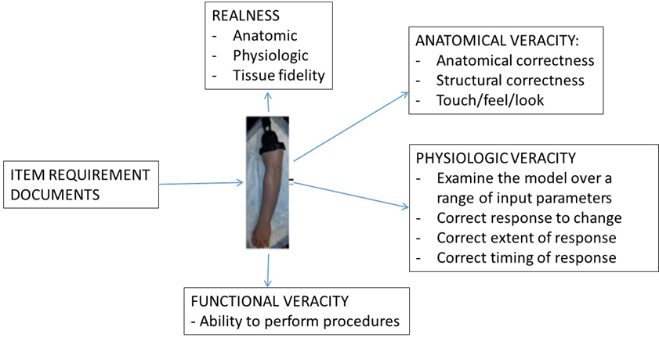
Figure 4: Plan for Verification Testing of AMM in Phase II

Physical/Software Functional Testing
The physical/engineering verification testing plan is shown in Figures 5 and 6. In Figure 5 the verification tests planned shall start at the component level and follow the build manikin through modules, system integration and one time environmental and functional testing.

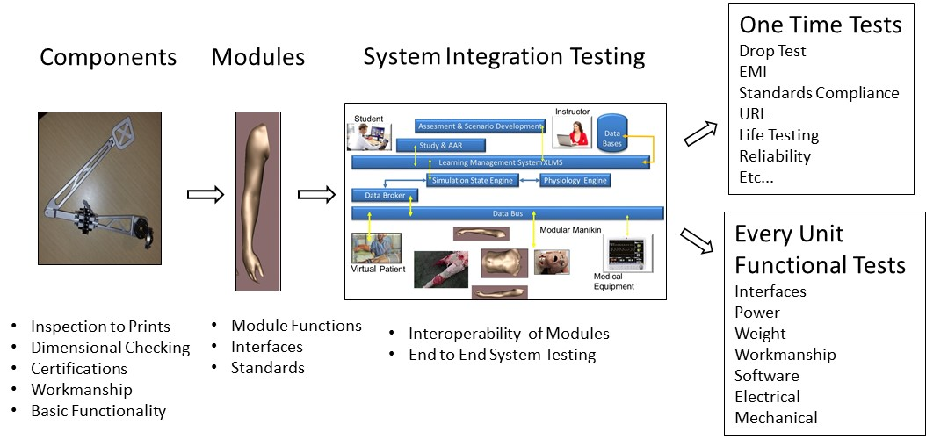
Figure 5: Plan for Physical Verification of Manikin

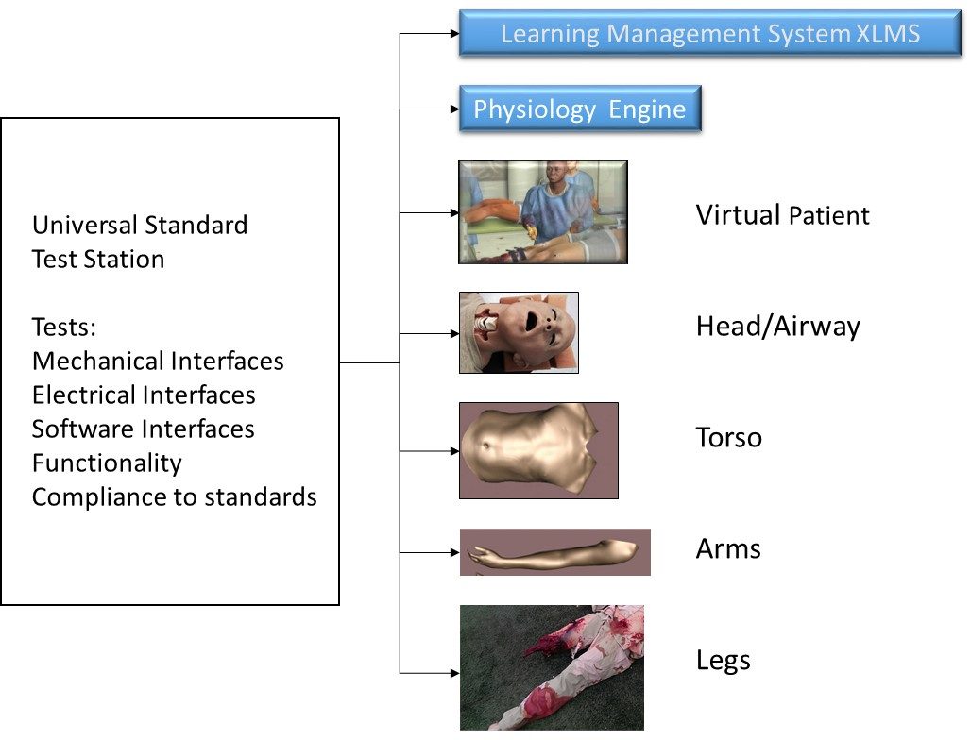
Figure 6: Universal Standard Test Station

Validation Testing
The validation testing can only be performed when commercial systems become available and will be specific to educational objectives targeted by them.

Appendix 1: Acronyms

Acronym |  | Meaning
A
ACDET |  | Company that provides modules to AMM
ACS |  | American College of Surgeons
AMM |  | Advanced Modular Manikin
AMMDK |  | Advanced Modular Manikin Development Kit
API |  | Application Programmer's Interface
C
CAE |  | CAE Health Care Company
CDM |  | Common Data Model
CDRL |  | Contract Documentation Requirements List
CORBA |  | Common Object Request Broker Architecture
CSCI |  | Computer Software Configuration Item
D
DID |  | Data Item Definition
DDS |  | Data Distribution Service
DICOM |  | Digital Imaging and Communications in Medicine
DTME-PRP |  | Developer Tools for Medical Education Public Physiology Platform
F
FMA |  | Foundational Model of Anatomy
G
GUI |  | Graphical User Interface
H
HID |  | Human Interface Device
HLA |  | High Level Architecture
HWCI |  | Hardware Configuration Item
I
I2C |  | Inter-Integrated Circuit
ICD |  | Interface Control Document
ICD-10 |  | International Classification of Diseases 10
IDD |  | Interface Design Description
IDL |  | Interface Definition Language
IGES |  | Initial Graphics Exchange Specification
IP |  | Internet Protocol
IVC |  | Inferior Vena Cava
J
JSON |  | JavaScript Object Notation
L
LMS |  | Learning Management System
LRS |  | Learning Record Store
N
NTP |  | Network Time Protocol
O
OMG |  | Object Management Group
OPB |  | Ontology of Physics for Biology
OS |  | Operating System
 | P
 | PhysDat |  | Physiology Data
 | PhysMod |  | Physiology Modification
 | PNG |  | Portable Network Graphics
 | PoE |  | Power over Ethernet
 | PSE |  | Power Sourcing Equipment
 | Q
 | QoS |  | Quality of Service
 | R
 | RenderMod |  | Render Modification
 | REST |  | Representational State Transfer
 | RI |  | Reference Implementation
 | RTPS |  | Real-time Publish-Subscribe
 | S
 | SDD |  | Software Design Description
 | SNOMED |  | International Health Terminology Standards Development Organisation
 | SPI |  | Serial Peripheral Interface
 | SPS |  | Software Product Specification
 | SSS |  | System/Subsystem Specification
 | STL |  | Sterolithography
 | SUM |  | Software User's Manual
 | SWCI |  | Software Configuration Item (a subset of CSCI)
 | U
 | USB |  | Universal Serial Bus
 | UI |  | User Interface
 | UUID |  | Universally Unique Identifier
 | X
 | xAPI |  | Experiential API
 | XML |  | Extensible Markup Language

