CDRL A010
Test/Inspection Report for the
Advanced Modular Manikin Project
Phase II Program
Contract # W81XWH-14-C-0101

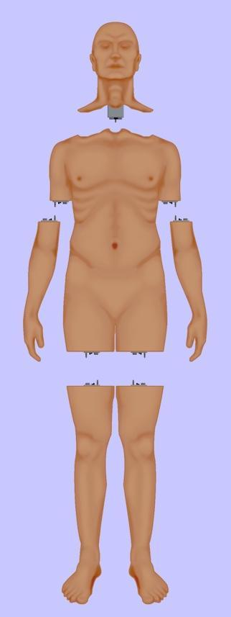
Date: February 03, 2020
Revision: Rev - 2
Unclassified

PRINCIPAL INVESTIGATOR: ROBERT M. SWEET, MD, FACS
REGENTS OF THE UNIVERSITY OF MINNESOTA
OFFICE OF SPONSORED PROJECTS
200 OAK ST SE
MINNEAPOLIS MN 55455-2009

This document is unclassified and APPROVED FOR PUBLIC RELEASE; DISTRIBUTION IS UNLIMITED

Revision History

Date of Revision | Description of Changes
24 Dec 2018 | Draft Document Submitted
25 Oct 2019 | Document Submitted
03 Feb 2020 | Distribution updated

Distribution Statement

This document was created under contract funding W81XWH-14-C-0101 from:

DEPARTMENT OF THE ARMY
US ARMY MEDICAL RESEARCH ACQUISITION ACTIVITY
820 CHANDLER STREET
FORT DETRICK MD 21701-5014

It contains no proprietary information, trade secrets, copy righted material or classified information. APPROVED FOR PUBLIC RELEASE; DISTRIBUTION IS UNLIMITED

Table of Contents

1 Scope 6
1.1 Identification 7
1.2 System overview 7
1.3 Document Overview 7
1.4 Executive Summary of Test Results to Date 8
2 Summary of Tests 8
2.1 ARA BioGears Physiology Model Testing 8
2.1.1 Test Objectives 8
2.1.2 Test Requirements 9
2.1.3 Test Equipment and Setup 9
2.1.4 Summary of Results 9
2.1.5 Conclusions 15
2.1.6 Recommendations 15
2.1.7 Authentication 15
2.2 Connector Testing 15
2.2.1 Test Objectives 16
2.2.2 Test Requirements 16
2.2.3 Test Equipment and Setup 17
2.2.4 Summary of Test Results 19
2.2.4.1 Connector Mate/De-mate Test Results 19
2.2.4.2 Connector Pull, Torque and Vibration Test Results 19
2.2.5 Conclusion and Recommendations 20
2.2.6 Authentication 20
2.3 Blood Simulant Testing 21
2.3.1 Test Objectives 21
2.3.2 Test Requirements 21
2.3.3 Test Equipment and Setup 21
2.3.4 Summary of Results 21
2.3.5 Conclusion and Recommendations 22
2.3.6 Authentication 22
2.4 Virtual Patient System Testing 22
2.4.1 Test Objectives 22
2.4.2 Test Requirements 22
2.4.3 Test Equipment and Setup 23
2.4.4 Summary of Results /Conclusions 23
2.4.5 Authentication 23
2.5 Fluid System 24
2.5.1 Test Objectives / Requirements 24
2.5.2 Test Equipment and Setup 24
2.5.3 Summary of Results 26
2.5.4 Conclusions 27
2.5.5 Recommendations & Ongoing Efforts 27
2.5.6 Authentication 27
2.6 Core Software Testing 27
2.6.1 Test Objectives / Test Requirements 29
2.6.2 Test Equipment and Setup 30
2.6.3 Summary of Results 31
2.6.4 Conclusions / Recommendation 32
2.6.5 Authentication 32

Figure 1: Functional Overview of AMM Platform 6
Figure 2: BioGears v6.3 testing with the saline .xml fix 10
Figure 3: BioGears v7.0 Blood epinephrine concentration for mild, moderate and severe pain. 11
Figure 4: BioGears v7.0 Heart rate response for pain stimulus. 12
Figure 5: Respiratory Rate 1/min graphed across time(min) for Severe Hemorrhage with whole blood transfusion at 20 min. 13
Figure 6: Lactate(mmol/L) graphed across time(min) for Severe Hemorrhage with whole blood transfusion at 20min. 13
Figure 7: pH graphed across time(min) for Severe Hemorrhage with whole blood transfusion at 20 min. 14
Figure 8: AMM Universal Module Connector. 15
Figure 9: Entropic connector (left), second party vendor connector (middle), hybrid connector (right). 16
Figure 10: Electrodynamic Shaker Setup. 17
Figure 11: left: CAD Model of Horizontal Fixture, right: CAD Model of Vertical Fixture. 18
Figure 12: Wiring Harness. 18
Figure 13: MTS Load Frame. 19
Figure 14 - Connector with screw that backed out during vibration 20
Figure 15 - Blood Simulant Test Setup 21
Figure 16: Vcom3D Virtual Patient testbed. 23
Figure 17: Fluid system specifications. 24
Figure 18: AMM fluid system component overview. 24
Figure 19: Fluidics supply system schematic showing external supply layout. 25
Figure 20: Laparotomy Module Fluidics Schematic. 25
Figure 21: Connector analogue with ports for blood, clear, air and waste (left); purge manifold (center); hemorrhage valve (right). 26
Figure 22: Fluidics System being controlled by the AMM boards. 26
Figure 23: Bleeding Vena Cava prototype module connected to Fluidics system, both running on identical sets of AMMDK CCB & Application Boards. 27
Figure 24: Module Manager Operational Overview. 28
Figure 25: Web Application Flow for UI Development. 29
Figure 26: Web Interface. 30
Figure 27: View of tablets. 31

Table 1: Summary of Test Results. 31

Scope

This document defines the standards for 1.0 release of the Advanced Modular Manikin (AMM) platform and its formal deliverables. The formal deliverables consist of the platform specification, an open source* Reference Implementation (RI) of the Computer Software Configuration Items (CSCIs), a reference implementation of the Universal Segment Connector (USC) and other hardware defined by the Hardware Configuration Items (HWCIs), the data models that ensure interoperability between the core and modules, and the documents that describe their design, operation, and extensibility through the addition of AMM Modules. Modules are defined as independent building blocks that provide incremental capabilities to the core or provide training opportunities for different medical and trauma related conditions. The focus of this specification is on the platform, a much broader definition than a physical manikin, as illustrated in Figure 1, and on how it can be extended by medical simulation developers by adding:

- Modules that provide incremental capabilities to the core, including authoring tools, after action review tools, different physiology engines.
- Modules that add training opportunities, including IV/IO arms, intubation heads, laparotomy abdomens, virtual stethoscopes. These can be physical, virtual, or hybrid part task trainers.

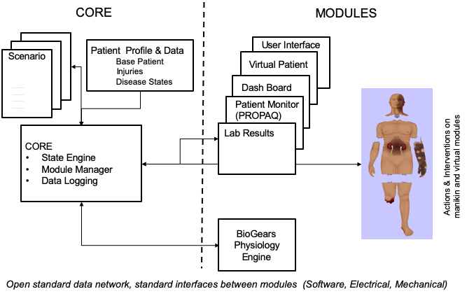

Figure 1: Functional Overview of AMM Platform

Identification
This is the Advanced Modular Manikin (AMM) Test Inspection Report CDRL Item A010 of Contract # W81XWH-14-C-0101. The DID has been tailored as appropriate. This document is unclassified and contains no proprietary information, trade secrets, copy righted material or classified information.

System overview
The AMM platform is a modular, distributed, interoperable system that enables physical, virtual, augmented and hybrid modules to work together as an integrated system. The traditional “core”, i.e. computer and state engine, can be in any one of the traditional manikin segments, i.e. torso, leg etc., or external to the human form, as it would be if the system is only running a virtual instance or if the targeted scenario, i.e. patient case, does not allow them to be internal due to the set of interventions that have to be performed on the body. The platform is architected as a system of systems that allow modules to function either as part of an integrated, whole body simulation or as autonomous part task trainers.

The published AMM standards guide the development and integration of AMM compatible modules. The reference designs provided for the final demo including electronics and central supplies were created to demonstrate the operation of the platform and are published as a developer’s tool kit with sources to acquire them from.

The developers of the platform have agreed to publish the AMM platform under the following open source licensing option:

* Creative Commons Attribution 4.0 International (CC BY 4.0) https://creativecommons.org/licenses/by/4.0/deed.ast.
Share — copy and redistribute the material in any medium or format
Adapt — remix, transform, and build upon the material for any purpose, even commercially.
The licensor cannot revoke these freedoms as long as you follow the license terms.

This document does not cover modules that were created under separate funding and by other entities to demonstrate the functionality of the AMM Platform under separate funding and are not part of the Open Source agreement.

Document Overview
This CDRL is formatted to the requirements of Data Item Description DI-NDTI-80809B as required. This document is the Test/Inspection Report for developmental tests performed on the BioGears Physiology Engine, Universal Hybrid Connector, Virtual Patient module, fluid system, and Core Software. All test results included in this document are either for required components of the core AMM system (that for compliance purposes must be included in the system) or components included as part of a reference implementation to demonstrate the functionality of AMM platform. For instance, components of the fluidics system may not be required for modules being developed for the platform as long as the connectors are AMM compatible. Contact the Technical Director for further information. The DID has been tailored as appropriate. This document is unclassified and contains no proprietary information, trade secrets, copy righted material or classified information.

Executive Summary of Test Results to Date

The following is an executive summary of the test reports included in this data item.

Tests Completed | Status | Remarks
ARA BioGears Physiology Engine | Initial Tests Complete | Ready for use in ACS Scenario
Connector | Successfully completed Mate/De-mate, pull and torque testing. | Vibration testing completed
Virtual patient | Successful first integration and demonstration | Improvements identified and implemented
Fluid System | Successful first integration and demonstration | Improvements identified and implemented
Core Software | Successful first integration and demonstration | Improvements identified and implemented

Summary of Tests

ARA BioGears Physiology Model Testing
ARA BioGears was the selected physiology engine for the AMM program. The physiology engine simulates the patient’s response to therapy, intervention, and drug administration. The AMM program developed a scenario where the patient has suffered trauma and needs medical treatment.

The BioGears physiology engine simulates the patient vitals and provide this detailed information to the instructor/trainee during the exercise. The BioGears physiology engine is initiated with starting conditions and then sends updates on the patient’s condition as the scenario unfolds.

The initial testing of the of the BioGears physiology engine dealt with how well it could simulate the patient’s condition during the scenario. Initial testing showed the model lacked significant capabilities which were then added. This report summarizes the testing completed on versions v6.1, v6.3, v7.0 including Sepsis and Pain.

Overall the BioGears v7.0 was significantly improved and the recommendation was made to include this in the ACS study.

Test Objectives
Over the past year BioGears has released 3 versions of the physiology engine (v6.1, v6.3, v7.0). Validation of the accuracy of each version as well as recommendations to improve the physiology engines was performed.

Test Requirements

Physiology conditions/states:

The 4 main physiology conditions/states that were verified for use in the AMM include:

1. Hemorrhage
2. Pain response
3. Mechanical Ventilation
4. Sepsis

Hemorrhage Testing: The verification efforts included testing 3 different severities. A hemorrhage rate of 50ml/min for mild hemorrhage, 100 ml/min for moderate hemorrhage and 500ml/min for severe hemorrhage. The scenarios were run for 3minues then a 1L normal saline infusion running at 300ml/min was started. Further testing was performed using packed red blood cells for resuscitation, in place of normal saline.

Mechanical Ventilation: The testing of mechanical ventilation utilized 3 ventilator settings including hypoventilation, hyperventilation, and standard mechanical ventilator (ARDSnet protocol) settings. The testing was run for 150min and the level of PaCo2 was recorded.

Test Equipment and Setup
BioGears released 3 versions of the physiology engine (v6.1, v6.3, v7.0). All three versions underwent extensive testing by the team at University of Minnesota.

Summary of Results

BioGears v6.1:
Hemorrhage Testing: Verification testing recorded the responses to hemorrhage via the heart rate. All levels of severity caused the development of tachycardia with a temporary response to a fluid bolus, as would be expected. Challenges / Limitations: Extensive tachycardia following 1L saline infusion suggestive of fluid overload was noted in the mild and moderate severity testing.

Mechanical ventilation: The mechanical ventilation testing utilized ARDSNet setting, hypoventilation and hyperventilation. The testing was run for 150 min and the level of PaCo2 was recorded.
Challenges / Limitations: The PaCO2 climbs substantially for ARDSnet mechanical ventilator setting which is suggestive of hypoventilation

BioGears v6.3:
Hemorrhage Testing: The testing was done with the same hemorrhage rates as the previous BioGears version and the results were compared for accuracy.

Challenges/ Limitations:
In this version, the hemorrhage severity scale ranges from 0-1 using the MCIS rating system and has a variable rate of bleeding depending on blood pressure and volume. This provided a challenge when trying to estimate the exact hemorrhage rates.
Both mild and moderate levels of severity developed an exaggerated and unrealistic heart rate response to 1L NS suggestive of fluid overload.

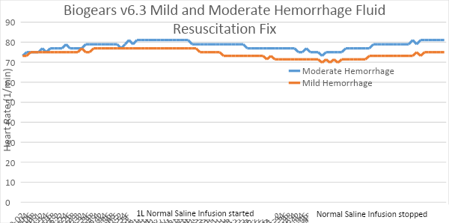
Improvements: An update to v6.3 was released with a potential fix to the issue of fluid overload. Testing of this version showed that the issue noted in the previous BioGears versions was resolved. The heart rate decreased appropriately in response to fluid resuscitation as seen in Figure 2. Heart rate (beats per minutes) is graphed across time (s) for mild and moderate hemorrhage treated with saline fluid infusion at 180 seconds. The testing shows the development of tachycardia due to hemorrhage, with an appropriate reduction in the Heart rate after fluid is administered.
Figure 2: BioGears v6.3 testing with the saline .xml fix

Heart rate (beats per minutes) is graphed across time (s) for mild and moderate hemorrhage treated with saline fluid infusion at 180 seconds.

Mechanical Ventilation: Identical settings were used to test v6.1 and v6.3. The settings were cross checked for accuracy.

Improvements: BioGears v6.3 appears to have significantly improved the issues with unrealistic accumulation of Co2. This was particularly clear with standard mechanical ventilation settings (titled ARDSnet settings).

BioGears v7.0
Extensive recommendations were provided, based on research from textbooks and peer reviewed journals, on the development of an acute pain model and a sepsis model. The latest v7.0 BioGears version includes these new actions.

Pain Response: To validate the pain action, the scenarios were ran using 3 different pain severities. The severity scale for the pain action ranged from 0-1. The testing used 0.3 for mild pain, 0.5 for moderate pain and 1.0 for severe pain. These scenarios were run for 5mins then an additional pain stimulus was added thereby “stacking the pain response”. The scenario was then run for an additional 5min after which 1mg of morphine was administered. Serum epinephrine levels and heart rate levels were recorded for each run and analyzed for accuracy.

- Epinephrine Level: All the pain severities have a rapid rise in blood epinephrine concentration on administration of the first pain stimulus and an additional increase in the epinephrine levels on administration of the second pain stimulus as expected. There is a decrease in the epinephrine concentration on administration of 1mg of morphine. (Fig 3)

- Heart rate: All pain severities have a rapid rise in the heart rate on administration of the first pain stimulus and an additional increase in the heart rate when the second pain stimulus is administered. Heart rate decreases on administration of morphine. (Fig 4)
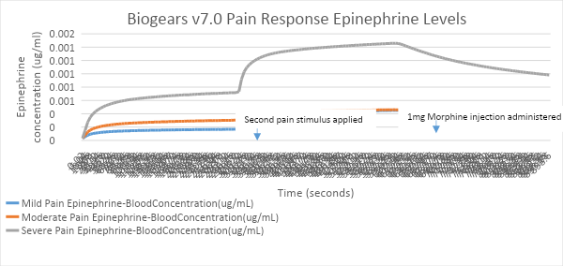
Figure 3: BioGears v7.0 Blood epinephrine concentration for mild, moderate and severe pain.
Epinephrine concentration (μg/ml) graphed across time (s) for mild, moderate and severe pain severities that are treated with 1mg of morphine at 600seconds

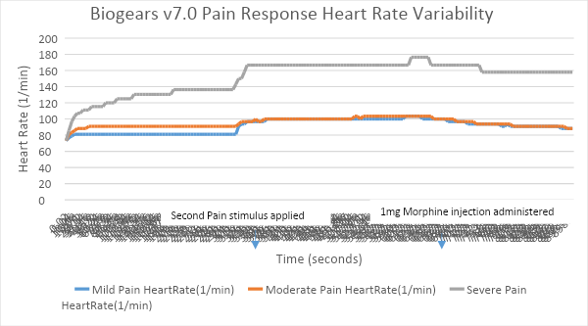
Figure 4: BioGears v7.0 Heart rate response for pain stimulus.
Heart rate (beats per minutes) is graphed across time (s) for mild, moderate and severe pain severities that are treated with 1mg of morphine at 600 seconds.

Test results of Respiratory and arterial blood pH during Hemorrhage

In addition BioGears implemented a fix in order to correct the respiratory rate as well as the arterial blood pH during severe hemorrhage. Previous testing had revealed that the respiratory rate did not increase as expected during severe hemorrhage and the blood pH did not change as expected. Testing done by VCom3d and reviewed by University of Minnesota showed that no significant improvements had been made to correct the issues highlighted.

VCom3d, independent of ARA, instituted various patches to the physiology engine to further improve it and efforts included verifying that the changes made were in line with expected physiology.

Respiratory Rate - The improvements made by Vcom3d were able to accurately model the expected change in the respiratory rate during severe hemorrhage. The respiratory rate increases with severe hemorrhage and decreases once the hemorrhage action is stopped and whole blood is transfused.
.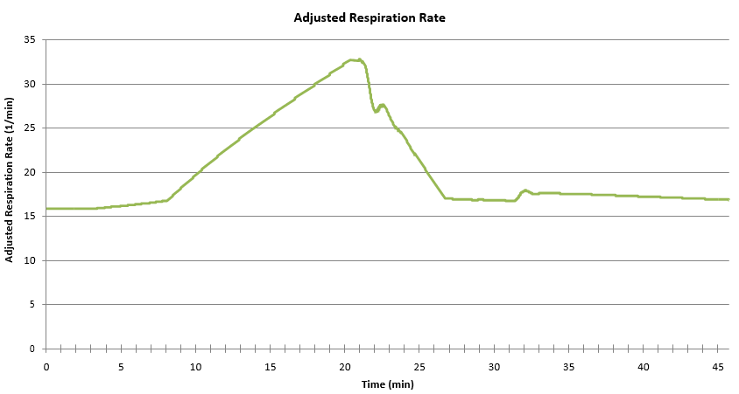
Figure 5: Respiratory Rate 1/min graphed across time(min) for Severe Hemorrhage with whole blood transfusion at 20 min.

Lactate - The lactate levels increase in severe hemorrhage and slightly decrease once the hemorrhage is stopped and whole blood is transfused. However, the lactate levels seem to further increase without any additional hemorrhage, and after the transfusion of whole blood. This is unusual as we would expect a gradual and sustained decrease in serum lactate after hemorrhage is stopped and whole blood is transfused.
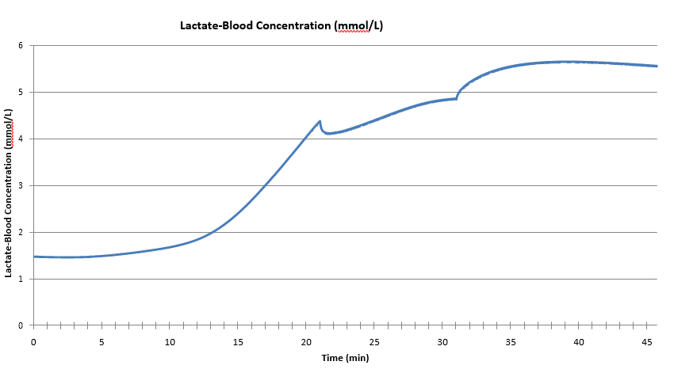
Figure 6: Lactate(mmol/L) graphed across time(min) for Severe Hemorrhage with whole blood transfusion at 20min.
Blood pH – The improvements made to the pH were also tested. There is a drop in blood pH during hemorrhage and an increase in the pH when whole blood is transfused, as would be expected. However, we would expect the decrease in pH to be much more robust to move the levels into acidosis. Additionally, the pH level further decreases to its lowest level after the hemorrhage is stopped and the whole blood is transfused. This runs counter to what would be seen clinically.
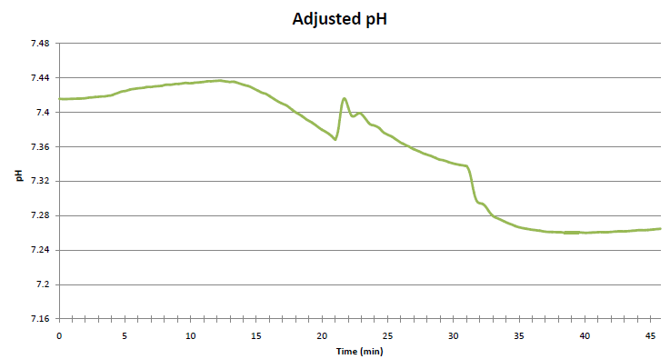
Figure 7: pH graphed across time(min) for Severe Hemorrhage with whole blood transfusion at 20 min.

VCom3d Test Bed – I.V. Pump Application
The following guidance was provided to VCom3d on the concentrations of the medications below, which will be added to the I.V. pump application for use in the ACS study.

Drug | Drug Amount | Diluent Volume
Propofol | 1000mg | 100
Morphine |  |  | 25mg/ml
Morphine |  |  | 5mg/ml
Midazolam | 125mg | 125
Rocuronium | 500mg | 250
Vasopressin | 40units | 40
Vasopressin | 100units | 100
Fentanyl | 50 | 1 | 50mcg/ml
Fentanyl | 25 | 0.5 | 50mcg/ml
Epinephrine | 16mg | 250ml
Epinephrine | 5mg | 250ml
Norepinephrine | 16mg | 250
Ketamine | 200mg | 100

Conclusions
Version V7.0 fixed deficiencies in the physiological response to the point where the model adequately predicts the expected patient response to allow testing by the ACS.

Recommendations
Use ARA BioGears physiology version v7.0 for ACS testing and obtain user feedback.

Authentication
The AMM clinician team of Drs. Konia and Kiberenge authenticated these results.

Connector Testing

There were four different tests performed on the AMM connector prototypes:
- Mate/De-mate
- Axial load test
- Three-point bending test
- Vibration test.

For details on the test protocols see CDRL Item A009 Test Procedure AMM W81XWH-14-C-0101.

The connector design is shown in Figure 8. The connector is a hybrid design containing both electrical and fluid line connections. The electrical connector is for power and Ethernet. There are 4 fluid lines with self-sealing connectors. A quick release push button is provided for disassembly.

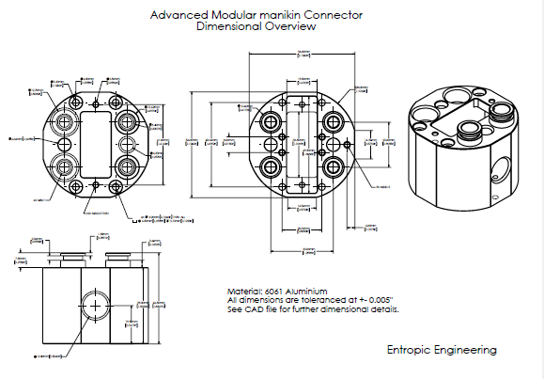
Figure 8: AMM Universal Module Connector.
All tests to be performed on three sets of connectors: one connector manufactured by Entropic Engineering, one connector manufactured by a second party vendor, and a hybrid connector with one half manufactured by Entropic, and the other half manufactured by the second party vendor (Figure 9).

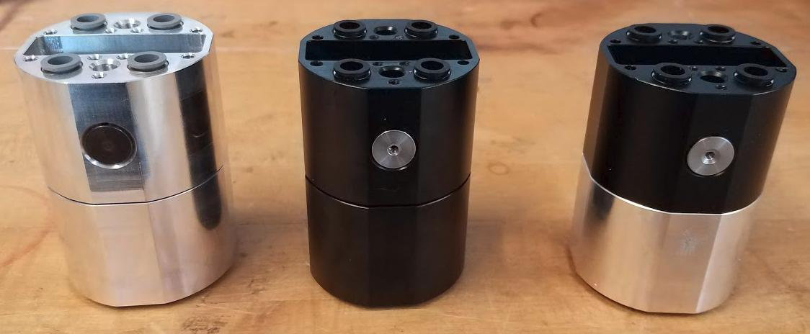
Figure 9: Entropic connector (left), second party vendor connector (middle), hybrid connector (right).

Test Objectives
The test objectives were to verify the connector can successfully operate without degradation in performance after being subjected to mate/de-mate, axial load pulling, three-point bending (torque) and vibration as experienced during the worst-case condition of helicopter transport while operating.

Test Requirements
The connector testing was performed at the University of MN Civil Engineering labs. This is a certified lab with the capabilities to perform pull, torque and vibration testing.

For each test, the criteria for success are as follows:

- Mated/De-mate
Mate/De-mate 2000 times without degradation in performance to latch or electrical pins or fluid connectors.

- Axial Load Test:
MECHANICAL The connector is able to withstand an axial load of at least 300 lbs.

ELECTRICAL: The electrical contacts inside the connector remain in contact under an axial load of 200 lbs.

FLUID: Fluid can be run through the connector’s fluid lines without leakage while the connector sustains an axial load of 200 lbs.

- Three Point Bending Test:
MECHANICAL: The connector is able to withstand a bending moment of 100 ft-lbs. without sustaining any mechanical failure or deformation

ELECTRICAL: The electrical contacts inside the connector remain in contact under an applied moment of 100 ft-lbs.

FLUID: Fluid can be run through the connector’s fluid lines without leakage while the connector sustains an applied moment of 100 ft-lbs.

- Vibration Test:
MECHANICAL The connector is able to experience vibrations of frequencies ranging from 10 Hz - 1.5 kHz without sustaining any mechanical failure or deformation

ELECTRICAL: The electrical contacts inside the connector remain in contact and operational while connector is subjected to vibration with frequencies ranging from 10 Hz - 1.5 kHz

FLUID: Fluid can be run through the connector’s fluid lines without leakage while the connector is subjected to vibration with frequencies ranging from 10 Hz - 1.5 kHz

All tests were performed on three different sets of connectors: (1) a connector manufactured by Entropic Engineering, (2) a connector manufactured by a second party vendor, and (3) a hybrid connector with one half manufactured by Entropic, and one half manufactured by the second party vendor.

Test Equipment and Setup

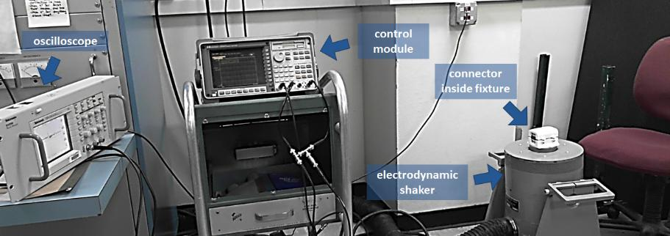
An electrodynamic shaker table located in the Aerospace Engineering senior design lab to be used for all vibration experiments. The apparatus is shown in Figure 10.
Figure 10: Electrodynamic Shaker Setup.
Connector Test Fixture

Two different fixtures were designed, and 3D printed for the purpose of the vibration test (Figure 11). Two fixtures were necessary in order to test the connector at all three orientations.
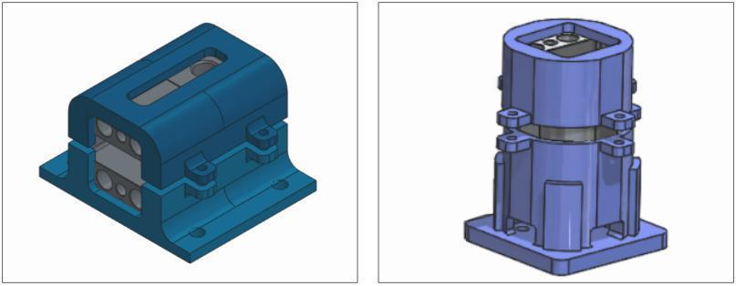
Figure 11: left: CAD Model of Horizontal Fixture, right: CAD Model of Vertical Fixture.

For all electrical tests, a wiring harness provided by Entropic Engineering was used. The wiring harness provides electrical access via an Ethernet cable, as well as via several loose wires, as shown in Figure 12. As described in section 3, two different electrical protocols were followed. In one protocol the loose wires were used to make a simple LED circuit. In the other protocol, the Ethernet cables were used to connect a Linux laptop to a Raspberry Pi.

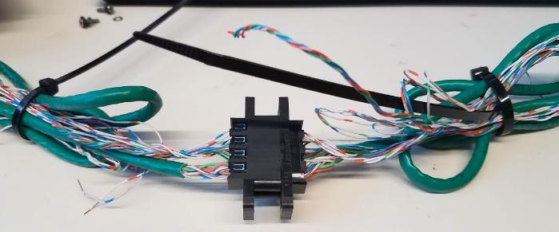
Figure 12: Wiring Harness.

An MTS load frame was used as the main test apparatus for all axial load tests. The load frame is held in the UMN CSE Anderson Student Shop, on the third floor of the UMN Civil Engineering building. Figure 13 depicts the test apparatus.

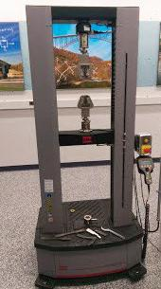
Figure 13: MTS Load Frame.

Summary of Test Results

Connector Mate/De-mate Test Results
The first test conducted was the mate/de-mate test. For this test the connector was mated and de-mated over 2000 times by hand. 2000 was chosen based on low cost standard connector specifications and the estimated number of times the AMM manikin modules would be connected and disconnected in a life time. Visual inspection of the connector showed some wear, but fluid and electrical lines were functional as well as the latch mechanism. The latch pins used were noted for rusting, so a new rust resistant latch pin material was selected and used on next version of prototypes.

Conclusion from this test was the connector design approach was good for the AMM application.

Connector Pull, Torque and Vibration Test Results

The following table summarizes the results from each of the tests.

2

Test Performed | Sub-Test | Connector | Test Spec. | Pass/Fail
 |  | Entropic | 300 lbs. | Pass
 | Mechanical | 2nd Party | 300 lbs. | Pass
 |  | Hybrid | 300 lbs. | Pass
 |  | Entropic | 200 lbs. | Pass
Axial Load | Electrical | 2nd Party | 200 lbs. | Pass
 |  | Hybrid | 200 lbs. | Pass
 |  | Entropic | 200 lbs. | Pass
 | Fluid | 2nd Party | 200 lbs. | Pass
 |  | Hybrid | 200 lbs. | Pass
 |  | Entropic | 100 ft-lbs. | Pass
 | Mechanical | 2nd Party | 100 ft-lbs. | Pass
 |  | Hybrid | 100 ft-lbs. | Pass
 |  | Entropic | 100 ft-lbs. | Pass
Bending | Electrical | 2nd Party | 100 ft-lbs. | Pass
 |  | Hybrid | 100 ft-lbs. | Pass
 |  | Entropic | 100 ft-lbs. | Pass
 | Fluid | 2nd Party | 100 ft-lbs. | Pass
 |  | Hybrid | 100 ft-lbs. | Pass
 |  | Entropic | 10 Hz - 1.5 kHz | Pass
 | Mechanical | 2nd Party | 10 Hz - 1.5 kHz | Fail*
 |  | Hybrid | 10 Hz - 1.5 kHz | Pass
 |  | Entropic | 10 Hz - 1.5 kHz | Pass
Vibration | Electrical | 2nd Party | 10 Hz - 1.5 kHz | Pass
 |  | Hybrid | 10 Hz - 1.5 kHz | Pass
 |  | Entropic | 10 Hz - 1.5 kHz | Pass
 | Fluid | 2nd Party | 10 Hz - 1.5 kHz | Pass
 |  | Hybrid | 10 Hz - 1.5 kHz | Pass

*This was considered a failed test because, during the vertical orientation test, one of the internal screws became unscrewed and fell out of the back of the connector (see figure). The proposed steps necessary to prevent this mode of failure in future connectors is to ensure that Loctite is used when mounting all screws in the connector. See Figure 14.

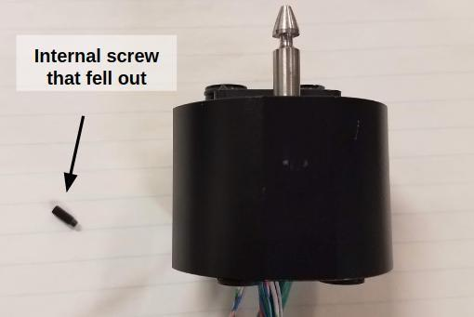
Figure 14 - Connector with screw that backed out during vibration

Conclusion and Recommendations
The AMM connector successfully passed all tests and the recommendation is use the connector on the AMM manikin modules interfaces where required.

Authentication
The connector vibration tests were authenticated by Rebecca Smith, Test Lead and John Hoschette Test Director.

Blood Simulant Testing

Test Objectives
The objectives were to select several commercial-off-the-shelf (COTS) blood simulants and test their properties and cleaning ability.

Test Requirements
The test requirements are to compare the properties of blood simulants. These include:
- Viscosity
- Shelf Life
- Cost per ounce
- Cleaning Solution
- Cleaning Fluid Blood
- Manufacturer Info

Test Equipment and Setup
The test setup is shown in Figure 15. The major components are: solenoid valve, tubing and pump and check valve.
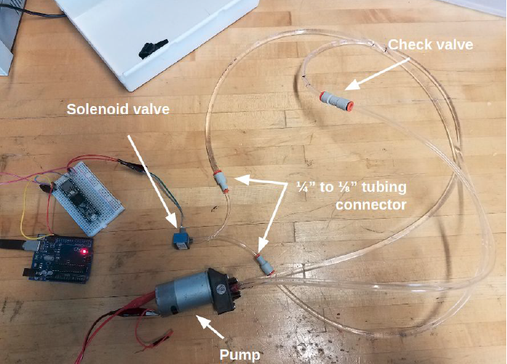
Figure 15 - Blood Simulant Test Setup

Summary of Results
Three different blood simulants were analyzed and compared. The results of these tests are summarized in the table below. The viscosity for each fluid was measured using a Ford 4 viscosity cup at room temperature. After the first test, the fluids were stored in an airtight container for 17 days. After 17 days had elapsed, the Ford cup viscosity test was repeated for each fluid. It was found that there was no significant change in viscosity between the first test and the second. Additionally, there was no noticeable change in appearance or texture for any
of the fluids.

Note: The viscosity measurements provided here are approximate, and it is suspected that the measured viscosity may be slightly higher than the actual viscosity. This was confirmed by the fact that when this method was used to measure the viscosity of water, the resulting measurement indicated a viscosity of 10 centipoise, when the widely accepted room temperature viscosity of water is near 1 centipoise. Nevertheless, the viscosity indicated in the table below can be used to demonstrate the viscosity of the three simulants tested relative to each other.

 | Stage Blood | SimuLab Blood | Laerdal Blood | Water | Real Blood
Viscosity (centipoise) | 40 cP | 15 cP | 40 cP | 1 cP | 3-4 cP
Shelf Life (minimum) | 17 days | 17 days | 17 days | N/A | N/A
Cost per ounce | $0.31/ounce | $7/ounce | $ 7.1/ounce | N/A | N/A
Cleaning Solution | Water | Water | Water | Water | N/A
Cleaning Fluid / Blood | 3:1 | 6:1 | 4:1 | 2:1 (approx.) | N/A
Manufacturer | NewRuleFX | SimuLab | Laerdal | N/A | N/A
Manufacturer | orders@newrule.com | 866-400-1260 | 877-523-7325 | N/A | N/A

Conclusion and Recommendations
We evaluated three currently available blood simulants under the same conditions in a simple test setup. Although none of them favorably compare in performance to real blood, the stage blood was recommended for use in AMM manikin by the testers. It was the lowest cost and easiest to clean up. In subsequent pilot runs performed with the alpha prototype, it was decided that the Stage Blood was not acceptable. Instead for the study the team chose to mix a dye with water which had the same viscosity as water. The recommendation is to run a separate development effort to establish a new blood simulant with closer performance characteristics to human blood, but will prevent clogging, molding etc. and not attack any of the materials used in the construction of the simulator.

Authentication
The connector vibration tests were authenticated by Rebecca Smith, Test Lead and John Hoschette Test Director.

Virtual Patient System Testing
The Virtual Patient was tested by clinicians at several stages of AMM Phase II development. Development of these virtual modules was not part of the AMM platform development, but it was essential to verify their performance in order to assure that they would support the ACS study.

Test Objectives
The objectives for testing the Virtual Patient Subsystem were:
- Evaluate Web interface / AMM dashboard for usability
- Evaluate the patient monitor for sufficiency and accuracy of visual and aural cues
- Evaluate the lab module for sufficiency and accuracy of reported values
- Evaluate the Virtual Patient module for sufficiency and accuracy of visual and aural cues

Test Requirements
- Evaluating patient monitor (Figure 15, 4A): The patient monitor system gave outputs for blood pressure, heart rate, respiratory rate, oxygen saturation, CO2 and central venous pressure. The system also has running waveforms for EKG, CVP and SpO2.
• Evaluating the labs module (Figure 15, 4B): The lab module system consists of various hematological tests including; complete blood count, metabolic panel and arterial blood gases.
• Evaluating the Web interface / AMM Dashboard (Figure 15, 4C): The Web interface consists of preloaded scenarios which were utilized to test the system.
• Evaluating the virtual patient (Figure 15, 4D): The virtual patient consists of a female patient with a left chest wound.

Test Equipment and Setup
The virtual patient benchtop testbed is shown in (Figure 16). The bench top testbed consists of four Samsung Pads which are connected wireless to an Internet hub/power supply. The BioGears physiology engine drives the patient monitors.

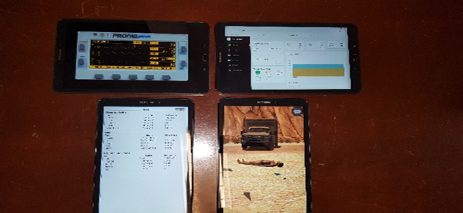

4A
4B
4C
4D
Figure 16: Vcom3D Virtual Patient testbed.

Summary of Results /Conclusions
Based on the clinicians’ evaluation of the Virtual Patients apps, the following changes were made to the configuration of the virtual modules:

- Additional lab values, including lactate and venous blood gases were included.
- An audible alert was included as each lab panel became available.
- A time-stamped history of up to three sets of lab results was added.
- Abnormal lab values were highlighted in red.
- A mechanical ventilator simulation was added.
- A triple IV pump was added.
- A urine gauge was added.
It was judged that this expanded capability would support the ACS study needs.

Authentication
This work was authenticated by Vcom3D personnel, Ed Sims Test Director, Dan Silverglate and Doug Raum. David Hananel UW.

Fluid System
The fluidics supply system is a reference design developed to demonstrate AMM capabilities. It is designed to provide pressurized fluids, air and liquid waste removal to all segments of the manikin. The fluids supplied are simulated blood and clear fluid. The latter can be customized to simulate sweat, peritoneal fluid, urine, or tears etc. depending on application. Pressurized air is also made available to all segments.

Test Objectives / Requirements
The following system level design capabilities are to be verified during testing.
- 7 psi system pressure for air and fluids based on available flexible reservoirs
- Double sided shutoff valve connectors at module interfaces
- Reservoir refill via quick connect
- Quiet operation pumps/valves/hoses/exhaust <=45 dB
- Low system pressure for air and fluids 15 psi max
- Constant pressure fluid supply via flexible accumulator/reservoir
- Single intermediate power source: compressed air
- Reservoir capacity 1000ml for simulated blood and 500ml for clear fluid

Requirements for flow rates of the different fluids are shown in Figure 17.

 | Fluid | Flow rate | Pressure | Reservoir capacity/other
1 | blood simulant | 1.5 l/min | 1.03 bar | <=6 l
2 | clear fluid (water) | 250 ml/min | 1.03 bar | <=1 l
3 | waste/discharge (liquid) | 500 ml/min | 1.03 bar | <=2 l
4 | compressed air | 5 l/min | 1.03 bar
Figure 17: Fluid system specifications.

Test Equipment and Setup
Figures 18 and 19 below show the component overview and schematic.

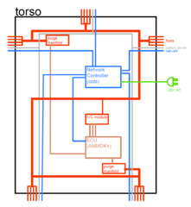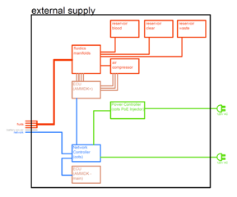
Figure 18: AMM fluid system component overview.
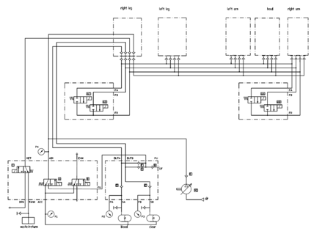
Figure 19: Fluidics supply system schematic showing external supply layout.
The fluidic design for the IVC hemorrhage model has been proposed. See Figure 20. This model is part of the laparotomy module which is being developed by UW.
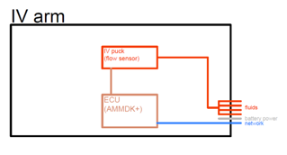
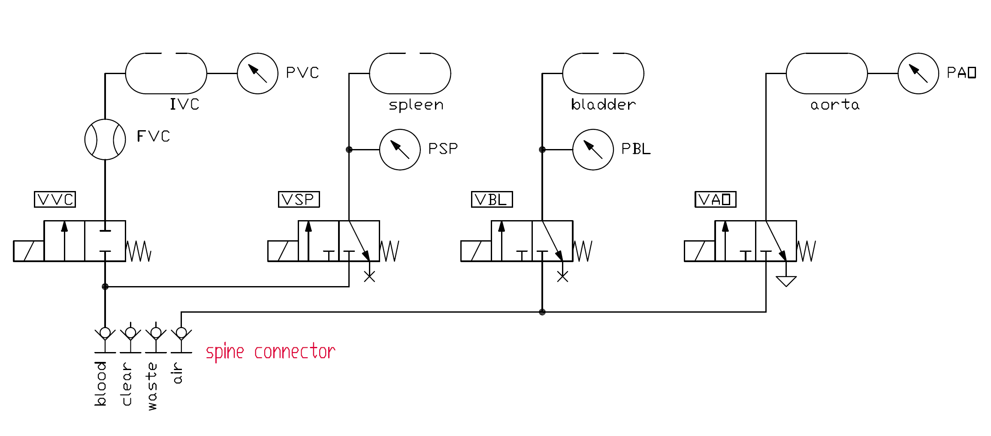
Figure 20: Laparotomy Module Fluidics Schematic.

Connector analogue is shown in Figure 21.

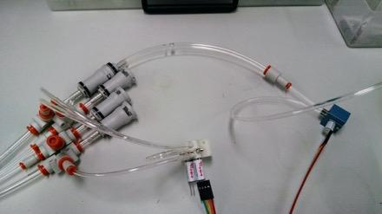
Figure 21: Connector analogue with ports for blood, clear, air and waste (left); purge manifold (center); hemorrhage valve (right).

Summary of Results
The electronics, fluidics and several software modules were successfully integrated as seen in Figure 22. To demonstrate the fluidics system capabilities a bleeding vena cava prototype module was shown Figure 23.

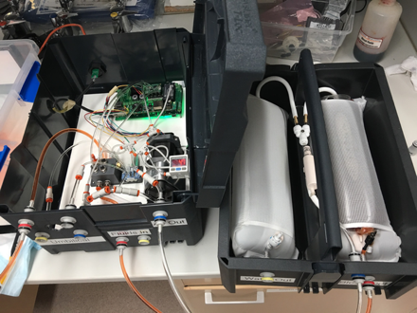
Figure 22: Fluidics System being controlled by the AMM boards.

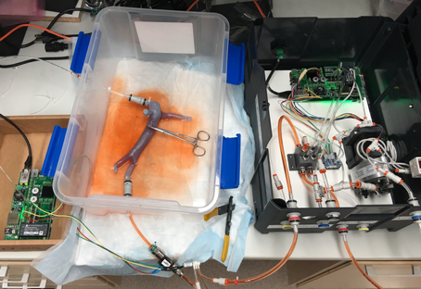
Figure 23: Bleeding Vena Cava prototype module connected to Fluidics system, both running on identical sets of AMMDK CCB & Application Boards.
The system only produced about 8 to 10 PSI. Fluid bags were tested successfully. The valves worked as planned. The control system software and hardware needed further refinement to automate start-up, operation, and shut down.

Conclusions
The basic approach for fluid management was confirmed. The electronics and software performed but encountered code errors. The errors were between the control computer and AMMDK boards. The basic feedback control system worked but further refinement is required.

Recommendations & Ongoing Efforts
The following recommendations were made:
- Develop accumulator/reservoir to allow the fluid system to obtain 15 psi
- Debug control software
- Integrate the fluid system into the manikin
- Investigate blood simulants
- Retest system with blood simulants

Authentication
This testing was authenticated by Entropic (Matt Pang and Ben Rigg) and Dr. Rainer Leuschke UW

Core Software Testing
Figure 24 below illustrates the primary functions of the Module Manager and its interaction with each Module as a scenario is loaded and then run. The Module Manager is a critical part of the CORE computing system.

The Module Manager is a core software component that coordinates the participation, initialization, configuration, and termination of AMM modules during the educational encounter. All AMM compliant modules must perform an appropriate handshake procedure which includes information about the module, the capabilities it provides, and the configuration data needed to provide those capabilities. The Module Manager is also responsible for loading scenarios and publishing the configuration data specific to each module to enable the capabilities required by the scenario. The Modules must validate their configuration and report the operational status of each of their enabled capabilities. The Module Manager will aggregate the operational statuses of all the modules to determine if all of the required capabilities of a scenario are available and operational.

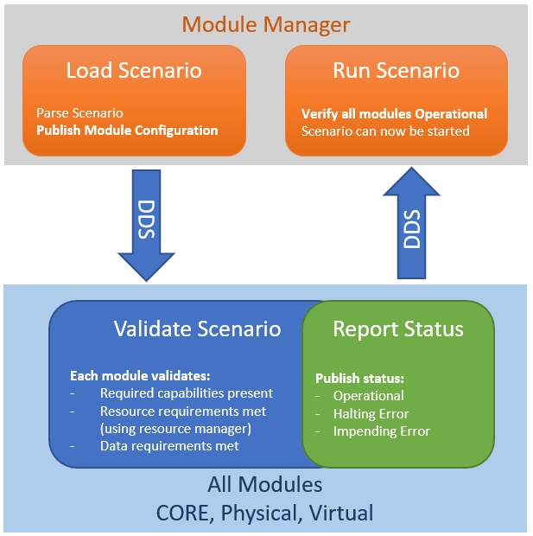
Figure 24: Module Manager Operational Overview.
Figure 25 illustrates the overall AMM core stack, highlighting the REST Adapter. The REST Adapter allows for curated access to the DDS bus using standard HTTP requests, allowing developers to build web applications and interfaces that can interact with AMM. Also shown as part of the core stack are the TCP bridge (used for network-connected modules, such as virtual equipment) and a generic serial bridge (used to connect to Arduino-type hardware), both of which are available in our AMM GitHub repository.
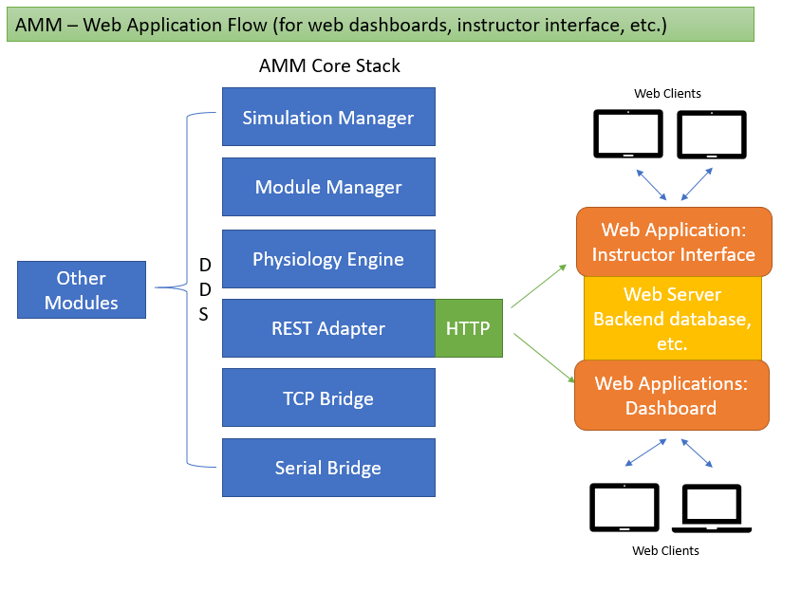
Figure 25: Web Application Flow for UI Development.

Test Objectives / Test Requirements
The following are the Test Objectives and Requirements to be verified

- Verify the Simulation Manager is a core software module that drives the simulation by publishing simulation ticks at a frequency of 50 Hz.

- Verify the Logger is a core software module that monitors DDS message traffic for the purposes of analysis, debugging, and general health of the system.

- Verify the REST Adapter is a web service that converts REST requests to DDS messages in support of web browser-based modules like the Instructor Tablet Dashboard.

- Verify the TCP Bridge is a socket server that handles TCP communications with socket clients and converts them to DDS messages in support of modules that cannot natively implement DDS but can open network sockets such as the virtual patient and virtual equipment.

- Verify the Serial Bridge is a service that handles communications with hardware over a serial interface and converts them to DDS messages in support of physical components with microcontrollers.

Test Equipment and Setup
Virtual modules were implemented and verified by Vcom3D under separate funding as web-based interfaces and Android Apps (see Figures 26 and 27), These included:
- Instructor Tablet (Web)
- Virtual Patient (Android App)
- Patient Monitor (Android App)
- Triple IV Pump (Android App)
- Lab Reports (Android App)
- Ventilator (Android App)
These modules, which conform to AMM data standards and communicate with DDS via the REST Adapter and TCP Bridge were integrated with the following Core components:
- AMM Module Manager
- AMM Simulation Manager
- AMM Logger
- AMM REST Adapter
- AMM TCP Bridge
- AMM Serial Bridge
- AMM Logger

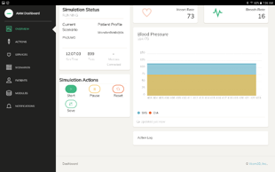 | 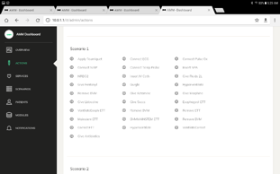
Web Interface: Dashboard | Web Interface: Scenario Actions
Figure 26: Web Interface.

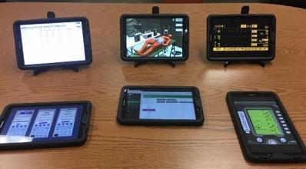
Figure 27: View of tablets.
The Prototype System described above was used to test successful inter-module communication and system integration by implementing and testing a multi-trauma surgical scenario that exercised major aspects of system operation.

Summary of Results
The results are summarized in the following table.
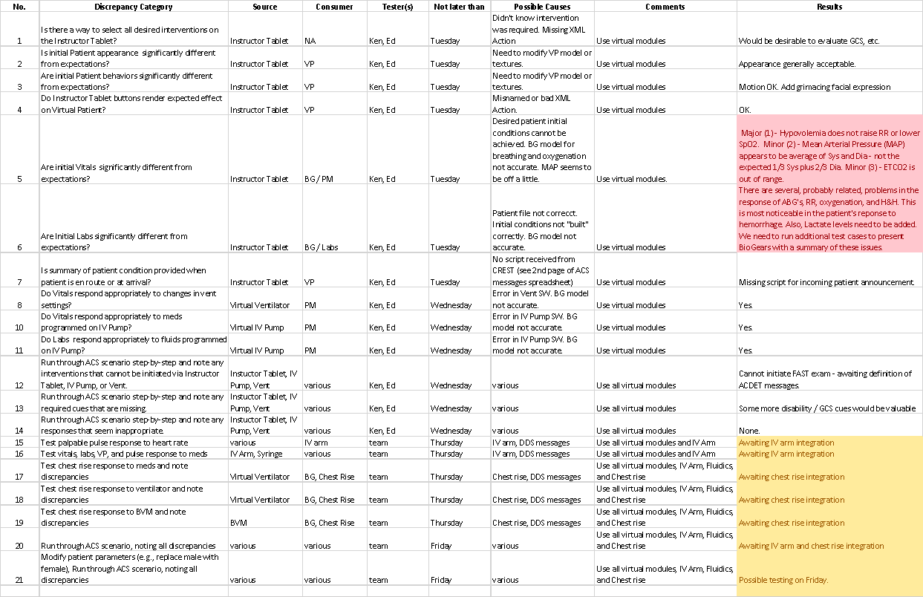
Table 1: Summary of Test Results.
Messages were successfully passed among the various modules via DDS. Thus, an IV catheter appeared on the virtual patient when the fluid sensor in the arm sensed flow, and the chest moved and heart beat at the respiration rate and heart rate computed by BioGears.

Most BioGears computed values responded appropriately, but some anomalies in respiration and blood gas values were noted, as identified in the attached spreadsheet. These issues are being reported to ARA, who are working with us to identify the source of the discrepancies.

Finally, some opportunities to improve the usability of the Instructor Tablet were identified. These mostly involve resizing and rearranging displays and controls.

Conclusions / Recommendation
- The AMM specifications and prototype system support communication between the core and both hardware and software modules with a Quality of Service (QoS) sufficient to support complex patient assessments and interventions.
- The AMM specifications and prototype system provide physiological and physical cue data that are representative of the data required by clinicians to make informed decisions about patient care. These data are provided in formats that can reasonably be consumed by AMM-conformant physical and virtual modules so as to provide this data to clinicians in familiar formats such as animated (or animatronic) patient behaviors, common lab panels, and patient monitor displays.
- The AMM specifications and prototype system are capable of receiving data from AMM-conformant virtual and physical modules that initiate changes in patient conditions. These data can be reasonably generated in the required formats by both Graphical User Interfaces (GUIs) or patient-embedded sensors using Commercial-of-the-Shelf (COTS) products and emerging technologies.

Authentication
This work was authenticated by VCOM3D personnel, Ed Sims Test Director, Dan Silverglate and Doug Raum; Ken Kiberenge, UMN; and David Hananel, UW.

