CDRL A011
Interface Control Document (ICD)
for Advanced Modular Manikin Project Phase II Program
Contract # W81XWH-14-C-0101

Date: February 3, 2020
Revision: Rev-2
Unclassified

PRINCIPAL INVESTIGATOR: ROBERT M. SWEET, MD, FACS
REGENTS OF THE UNIVERSITY OF MINNESOTA
OFFICE OF SPONSORED PROJECTS
200 OAK ST SE
MINNEAPOLIS MN 55455-2009

This document is unclassified, and APPROVED FOR PUBLIC RELEASE; DISTRIBUTION IS UNLIMITED.

Revision History

Date of Revision | Description of Changes
24 Dec 2018 | Original Draft Submitted
26 Aug 2019 | Document Submitted
15 Nov 2019 | Revised Document Submitted
03 Feb 2020 | Distribution Updated

Distribution Statement

This document was created under contract funding W81XWH-14-C-0101 from:

DEPARTMENT OF THE ARMY
US ARMY MEDICAL RESEARCH ACQUISITION ACTIVITY
820 CHANDLER STREET
FORT DETRICK MD 21701-5014

This document is unclassified, and APPROVED FOR PUBLIC RELEASE; DISTRIBUTION IS UNLIMITED.

Table of Contents
1 Scope 4
1.1 Identification 4
1.2 System Overview 5
1.3 Document Overview 5
2 Applicable Documents 6
2.1 Industry/UW Documents 6
2.2 Government Documents 6
2.3 Order of Precedence 6
3 Interface Definition 6
3.1 AMM Segments 6
3.2 AMM Universal Segment Connector (USC) 7
3.3 Electrical Power 10
3.4 Fluid Interfaces 11
3.5 AMM Common Data Bus 12
3.6 Human Interface 12
3.7 List of Industry Specifications 13

Figure 1: Functional Overview of AMM Platform 4
Figure 2: AMM Manikin Segments 7
Figure 3: AMM connector with release button. 8
Figure 4: Segment connector exploded view. 9
Figure 5: Example of an AMM systems showing standard connector for the arms and legs. 10

Table 1: Electrical Interfaces (TE Connectivity 292178-1) 11
Table 2: Fluid Interfaces 11
Table 3: List of Industry Specifications used by AMM 13

Scope
This document defines the standards for 1.0 release of the Advanced Modular Manikin (AMM) platform and its formal deliverables. The formal deliverables consist of the platform specification, an open source* Reference Implementation (RI) of the Computer Software Configuration Items (CSCIs), a reference implementation of the Universal Segment Connector (USC) and other hardware defined by the Hardware Configuration Items (HWCIs), the data models that ensure interoperability between the core and modules, and the documents that describe their design, operation, and extensibility through the addition of AMM Modules. Modules are defined as independent building blocks that provide incremental capabilities to the core or provide training opportunities for different medical and trauma related conditions. The focus of this specification is on the platform, a much broader definition than a physical manikin, as illustrated in Figure 1, and on how it can be extended by medical simulation developers by adding:

- Modules that provide incremental capabilities to the core, including authoring tools, after action review tools, different physiology engines.
- Modules that add training opportunities, including IV/IO arms, intubation heads, laparotomy abdomens, virtual stethoscopes. These can be physical, virtual, or hybrid part task trainers.

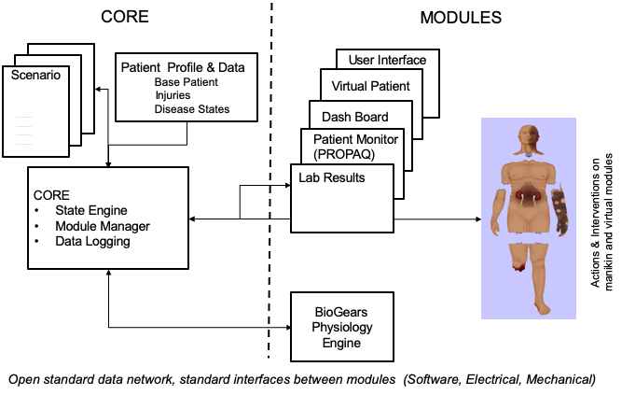
Figure 1: Functional Overview of AMM Platform

Identification
This is the Advanced Modular Manikin (AMM) Interface Control Document (ICD) CDRL Item A011 of Contract # W81XWH-14-C-0101, Phase II. It describes the hardware and software interfaces of the AMM platform and Reference Implementation (RI).
This CDRL addresses the requirements of Data Item Description Number DI-SESS-81248B as required. It is tailored to address the interfaces of AMM, which is not a specific training manikin, but a medical simulation platform, including specifications and a Reference Implementation (RI). As an AMM design principle, interfaces between AMM modules, including mechanical, fluid, data, and electrical, are required by the AMM standards, whereas interfaces within a module may be determined by individual developers, as long as interface requirements between modules are met.

System Overview
The AMM platform is a modular, distributed, interoperable system that enables physical, virtual, augmented and hybrid modules to work together as an integrated system. The traditional “core”, i.e. computer and state engine, can be in any one of the traditional manikin segments, i.e. torso, leg etc., or external to the human form, as it would be if the system is only running a virtual instance or if the targeted scenario, i.e. patient case, does not allow them to be internal due to the set of interventions that have to be performed on the body. The platform is architected as a system of systems that allow modules to function either as part of an integrated, whole body simulation or as autonomous part task trainers.

The published AMM standards guide the development and integration of AMM compatible modules. The reference designs provided for the final demo including electronics and central supplies were created to demonstrate the operation of the platform and are published as a developer’s tool kit with sources to acquire them from.

The developers of the platform have agreed to publish the AMM platform under the following open source licensing option:
* Creative Commons Attribution 4.0 International (CC BY 4.0) https://creativecommons.org/licenses/by/4.0/deed.ast.
Share — copy and redistribute the material in any medium or format
Adapt — remix, transform, and build upon the material for any purpose, even commercially.
The licensor cannot revoke these freedoms as long as you follow the license terms.

This document does not cover modules that were created under separate funding and by other entities to demonstrate the functionality of the AMM Platform under separate funding and are not part of the Open Source agreement.

Document Overview
This Interface Control Document (ICD) is an “Umbrella Document”. It describes how AMM interface requirements are controlled, by referencing other CDRLs, especially the Interface Description Document (IDD), and industry standards that provide detailed interface descriptions.
Many of the AMM interfaces use industry standards, whose specifications are developed and maintained by other organizations. A list of industry standards, either required by the AMM specification, or implemented by the Reference Implementation, and their applicable versions is included in Section 3.7 of this ICD. AMM-specific Software Interfaces are documented in detail in the Interface Design Document (IDD, CDRL A007), while AMM-specific Hardware Interfaces are documented in the AMM drawings (CDRLs A003 and A004). Finally, User Interfaces are documented in the Software User’s Manual (A005) and Operator’s User Manual (A006), as described in Sections 3.1 through 3.6 of this document.

Applicable Documents

Industry/UW Documents
Document Number | Title
AMM CDRL A008 | AMM System/Subsystem Specification
AMM CDRL A007 | Interface Design Documents
AMM CDRL A004 | Product Drawings/Models and Associated Lists

Additionally, a list of Industry Specifications referenced by this and other AMM CDRLs, is included as Table 3.

Government Documents
Document Number | Title
# W81XWH-14-C-0101 | AMM Phase II Contract, DOD
DI-SESS-81248B | Data Item Description: Interface Control Document (ICD)

Order of Precedence
In the event of a conflict between the text of this document and the references cited herein, the text of this document takes precedence. Nothing in this document, however, supersedes applicable laws and regulations unless a specific exemption has been obtained.

Interface Definition

AMM Segments
The AMM specification provides for AMM systems that can be virtual simulations, unsegmented manikins, systems of manikin segments, or mixtures of virtual and manikin systems. In order for a segmented manikin to be AMM-compliant, segments shall meet specifications for geometry; electrical, data, and fluids connectivity; and connect using the Universal Standard Connector (USC).

A physical AMM system shall include one or more of the following segment types: torso, left arm, right arm, left leg, right leg, and head, as shown in Figure 2. No more than one of each segment type shall be included at a given time. In other words, an AMM system may include all of the segment types, torso, left and right arm, left and right leg and head but may not include additional heads or arms etc. in a single system at a given time.
Figure 2: AMM Manikin Segments

The AMM Segment Interfaces are defined as follows:

• Head (including airway) – Torso
• Left Arm - Torso
• Right Arm - Torso
• Left Leg - Torso
• Right Leg - Torso

The placement of segmentations for the AMM standard male and female bodies shall be as described in CDRL A004.

AMM Universal Segment Connector (USC)
The segments of an AMM system shall be connected using connectors that conform to the AMM Universal Segment Connector (USC) specifications. USC connector, shown in Figures 3 and 4, shall provide the mechanical connection between the torso and other segments. Each module shall use the USC to distribute power, fluids and data among the segments. The Universal Segment Connector is described in detail in drawings 10200, 10201, 10203, and 10205 in CDRL A004 Section 1.4.
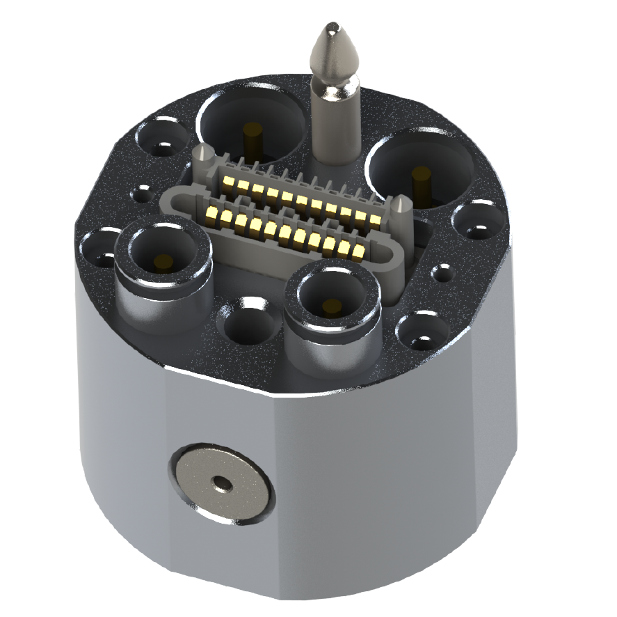
Figure 3: AMM connector with release button.

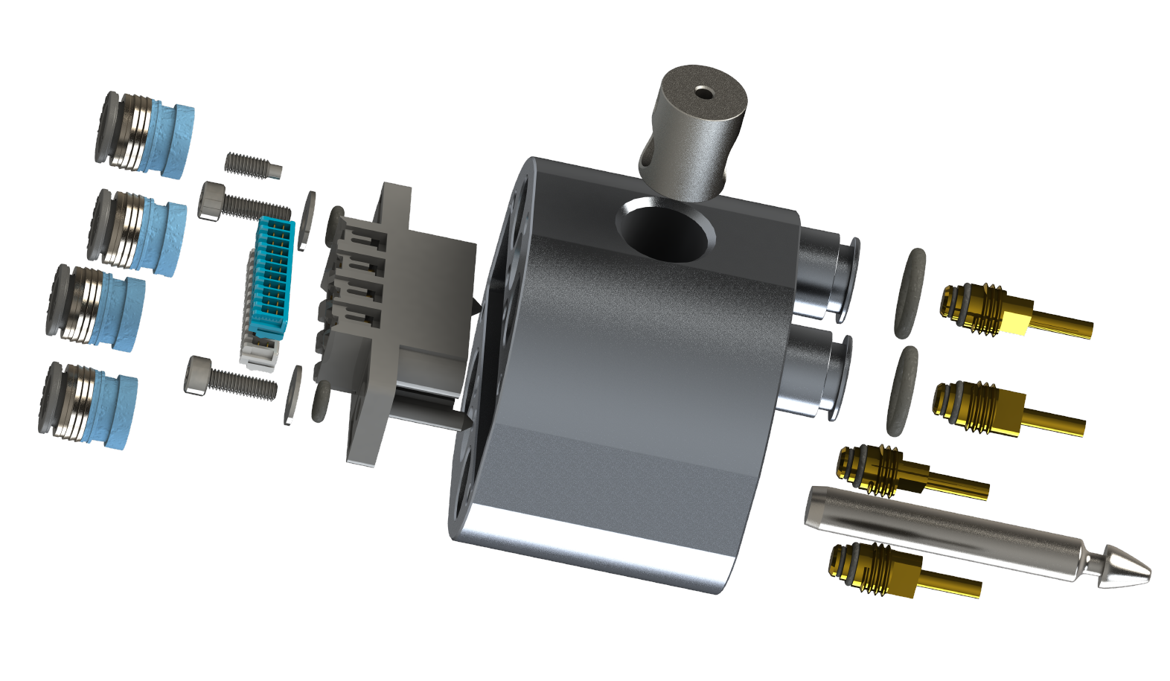
Figure 4: Segment connector exploded view.

A complete connection consists of two connectors that mechanically mate. The connection is established by pressing the two connector sides together until they mechanically lock. The connection is released by pressing the button (102105_release_button) and pulling the segments apart. The connector shall be installed such that the release button is located on the torso side of the connection.

The connector may be structurally integrated into a segment in any suitable manner that leaves the connection plane clear of obstruction and allows access to the release button on the torso side. The AMM C.O.R.E. reference implementation includes an example of an adapter for structural integration of the connector. See CDRL A004 Section 1.4 Reference Design Dwg. No. 104060.

Figure 5 shows an example of an AMM torso and head, with connectors for the four extremities.

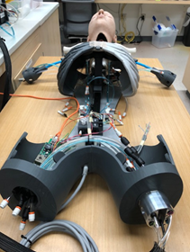
Figure 5: Example of an AMM systems showing standard connector for the arms and legs.
The AMM connector is documented in detail in CDRL 4 Section 1.4 Reference Design Dwg No. 102101

Electrical Power
Electrical power and data shall be distributed among AMM Manikin Segments using Power over Ethernet (PoE) and the AMM USCs. The Torso Module shall perform as Power Sourcing Equipment (PSE) according to the IEEE standard 802.3at or 802.3bt. All extremity AMM Segment Modules shall perform as compatible Powered Devices (PDs) in accordance with IEEE 802.3at or IEEE 802.3bt standards.

A battery or line-voltage power supply may be placed independently in any of the body segments. Each such power supply shall provide power via assigned pins of the USC electrical connector for that segment. The Universal Segment Connector (USC) includes an electrical connector (TE Connectivity 292178-1) with 22 total conductors. Of these 8 are allocated for PoE, and 12 are allocated for power delivery into the Torso. For AMM, the 12 power conductors are split into 6 pairs, each providing up to 1A of power at 50V. Thus, a manikin system requiring up to 300W of total power can be powered from a single battery stored inside a limb. A power management and distribution capability implemented in the torso shall assure that no short-circuit, over-charging, or other unsafe conditions are created. Table 1 summarizes the electrical interfaces.

Port type | Media | Pin | Voltage | Wire Type
Electric | Data | 8 Pins X 1A | 50-57 V | CAT 5 Ethernet Cable
Electric | Power In | 12 Pins X 1A | 48-50V | 22-28 AWG

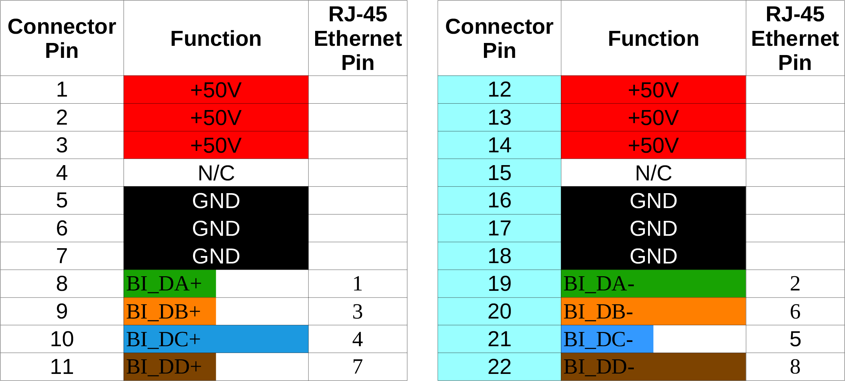
Table 1: Electrical Interfaces (TE Connectivity 292178-1)

Fluid Interfaces
An Advanced Modular Manikin system with physical body segments shall include a fluid source and distribution system that provides simulated blood, clear fluid, and compressed air to each segment at the rates and pressures shown in the table below. It shall also provide a waste/discharge for liquids that meets the rate in Table 2.
 | Port type | Media | Flow Rate | Pressure
1 | Fluid | Blood Simulant | 1.5 l/min | 1.03 bar
2 | Fluid | Clear Fluid | 250 ml/min | 1.03 bar
3 | Fluid | Waste line | default: gravity feed | n/a
4 | Fluid | Compressed air | 5 l/min | 1.03 bar
Table 2: Fluid Interfaces
All fluids flowing between segments shall flow through the USCs, using the Universal Segment Connectors described in drawings 10200, 10201, 10203, and 10205 in CDRL A004 Section 1.4 Reference Design. The segment connector provides push-to-connect connections for ¼” OD tubing on the segment side.

AMM Common Data Bus
All inter-module communication shall be published and subscribed to via the AMM Common Data Bus, which is implemented using the Data Distribution System (DDS) standards. The protocols and data models for the Common Data Bus shall conform to those specified in CDRL A007, Interface Description Document (IDD), section 3.1.

All data model specifications are also published at https://github.com/AdvancedModularManikin/specification, with a detailed Developer’s Guide available at https://advancedmodularmanikin.github.io/. These shall reflect the evolving nature of the AMM specifications and should always be viewed as the current standard specification.

Human Interface
An AMM system shall provide user interfaces for controlling and monitoring all system modules via the AMM Common Data Bus. While the Reference Implementation (RI) provides development tools to create extensive user interfaces, the specific formatting and content of these interfaces is not prescribed by the AMM standards. The RI provides a simple command-line interface data logging capability suitable for developers and a simple web interface suitable for instructors/simulation operators.

The AMM command line interface is published at https://github.com/AdvancedModularManikin/command-line-module.

The reference web interface is published at https://github.com/AdvancedModularManikin/amm-web.

List of Industry Specifications
The AMM Specification and Reference Implementation (RI) build on a number of industry specifications. The current version, controlling organization, and links to these specifications are shown in Table 3.

Specification | Version | Organization | Reference
CDM | 7.2.0 | ARA/BioGears | https://www.biogearsengine.com/documentation/_c_d_m.html
DDS | 1.4 | OMG | https://www.omg.org/spec/DDS/
DDSI-RTPS | 2.3 | OMG | https://www.omg.org/spec/DDSI-RTPS/
FMA | 5.0.0 | UW | https://bioportal.bioontology.org/ontologies/FMA
HID | 3.2 | USB Implementers Forum | https://www.usb.org/documents
I2C | 6 | de facto
ICD-10 | 10 | World Health Organization | https://www.who.int/classifications/icd/factsheet/en/
IEEE 802.3af |  | IEEE | http://www.ieee802.org/3/
IEEE 802.3at |  | IEEE | http://www.ieee802.org/3/
IEEE 802.3bt |  | IEEE | http://www.ieee802.org/3/
IEEE 802.11 |  | IEEE | http://www.ieee802.org/11/
IEEE 802.11 |  | IEEE | http://www.ieee802.org/11/
IDL | 3.5 | OMG | https://www.omg.org/spec/IDL/3.5/
IGES | 5.3 | National Bureau of Standards | https://www.iso.org/committee/45252.html
JPEG |  | ISO/IEC | https://jpeg.org/jpeg/
OBJ |  | de facto | https://www.fileformat.info/format/wavefrontobj/egff.htm
OPB | 1.07 | UW | https://bioportal.bioontology.org/ontologies/OPB
PNG | 1 | ISO/IEC | https://www.iso.org/standard/29581.html
RTPS |  | OMG | see DDSI-RTPS
SNOMED CT | 1 | SNOMED International | http://www.snomed.org/
SPI |  | de facto
STL |  | de facto | https://all3dp.com/what-is-stl-file-format-extension-3d-printing/#pointone
USB | 3.2 | USB Implementers Forum | https://www.usb.org/documents
XML | 1.0 5ed | W3C | https://www.w3.org/TR/REC-xml/

Table 3: List of Industry Specifications used by AMM

